Guess Paper – 2010
Class – X
Subject – Science (Physics)

LIGHT
Q.When light falls on a surface of an object ,What will happen to it?1
Q.What type of image is formed in a plane mirror.1
Q.What should be the position of
Q.What kind of mirrors are used in shopping stores to watch activities of customers.?
Q.Where should an object be placed in order to use a convex lens as a magnifying glass.?1
Q. Differentiate between real image and virtual image.2
Q .Define 1 diopter of Power of a lens.1 '
Q.Define principal focus of a concave mirror.1
Q.What is the least distance of vision of a normal human eye.1
Q.What is the value of focal length of a plane mirror.1
Q.What is the nature of light.1
Q .Draw a ray diag. to show the complete path of the light ray that travels through rectangular
Glass slab:2
Q.No matter how far how you stand from a mirror your image appears erect. The mirror is likely to be?Ans.Plane or convex1
Q.One half of a concave lens is covered with black paper.Will this lens produces a complete image of the object. Explain your answer.2
Q.A doctor has prescribed a corrective lens of power + I .5Dfind the focal length of the lens. Is the Prescribed lens diverging or converging .Ans.0.67m Converging lens.2
Q.What is the velocity of light in vacuum.1
CONCEPT TUTOR POINT Cell:9983118799
Q.Which mirror has a larger field of view:? 1
QWhat is the basic cause of refraction?1
Q.The refractive index of water is 1.33 and the speed of light in air is 3 x 10⁸ ms⁻¹.Calculate the speed of light in water.2
Q.What will happen to a ray of light when it falls normally on a surface of a glass slab.1
Q.If a ray passes through the optical centre of a concave lens. What is the deviation associated?1
Q.A ray of light passing through centre of curvature of a concave mirror retraces its path on
reflection why?1
Q.Light enters from air to glass having refractive index 1.50.What is the speed of light in the glass.?The speed of light in vacuums 3 x 10 ⁻⁸ms⁻¹ Ans 2 x 10⁸ m/s.2
Q.Which type of mirror is used by dentists to see large images of the teeth of patients.1
Q.For what position of the object will a convex lens form a virtual and erect image.1
Q.A 5cm tall object is placed perpendicular to the principal axis of a convex lens of focal length 20cm .The distance of the object from the lens is 30 cm Find i)position ii) nature iii) size of the image.Ans. v = 60cmI =-10, real inverted.3
Q.An object 5 cm high is placed 20 cm in front of a concave mirror of focal length 15cm.At 'What distance from the mirror, should a screen be placed to obtain a sharp image? Calculate the size of the image formed.Ans v = -60,I = -15 m..3
QA concave lens of focal length 15 cm forms an image 10 cm from the lens. How far is the object placed from the lens ?Draw the ray diag.Ans30 cm.3
Q.The refractive index of water is 4/3and for glass is 3/2"with respect to air.What is the refractive index of glass with respect to water ? Ans .1.125, 2
Q.A convex lens of focal length 40 cm is placed in contact with a concave lens of focal length 25 cm.What is the power of the combination.
Q.How will you distinguish. between a plane mirror, a concave mirror and a convex mirror' (Without touching them)2
QDefine refraction of light.State the laws of refraction.Does a glass slab disperse the light?Relate, the emergent and incident angle of light.3
Q. Show that the refractive index of a medium 1 with respect to medium 2 is reciprocal to the refractive index of medium 2 with respect to 1 i.e. n12 = 1 / n21 2

The human eye and the colourfull world CONCEPT TUTOR POINT 9983118799
Q.What is angle of prism.1
Q.Why are the danger signal lights are red in colour.?2
Q.Define power of accommodation.1
Q .Why are the danger signal lights red in colour?1
QExplain why stars seems like twinkling. The sun is visible before the actual sunrise and after the actual sunset:3
Q. How do we see colours.2
Q.Why does the sky appear dark instead of blue to an astronaut?1
Q.Why do the planets not appear twinkling like the stars.2
Q.Why there is an advance sunrise and delayed sunset?3
Q.Why is the colour of sky appears reddish at the time of sunset or sunrise?2
QA coin kept in a bowl is not visible when seen from one side. But, when water is poured in the bowl, the coin becomes visible.2
QFind the nature position and relative size of the image formed by convex lens,Concave mirror for various position of the object with ray diag.2
Q. what is short sightedness or myopia ?What causes short sightedness?How is short sightedness corrected?5
Q.Draw a labeled diag of human eye .Define power of accommodation and colour blindness.5
Q.Why' does the colour of the sky appears blue.2
Q.Define Tyndall effect,Far Point ,Near point,Catract.3
Q. What is Presbyopia?3
Q.What is ment by dispersion of light.? Describe the formation of rainbow in the sky with the help of a diagram.
Q.A myopic person has been using spectacles of power - 1 D for clear vision.During old age he also need to use separate reading glasses of power +2 D.Explain what may have happened to his eye sight.3
Ans.v= -50cm.His near point is 50 cm away from his eyes.
Q.Far point of a myopic person is 40 cm.What type of lens should he wear so as to see the distant objects clearly?Calculate the focal length and the power of the lens he should use.3
Ans.-2.5D
Magnetic effect of.electric curent
Q.Write advantage of AC over DC. 2
Qa)What are magnetic field lines'? How is the direction of a magnetic field at a point is determined? .3
Q.What is the function of an earth wire? Why is it necessary to earth metallic appliances.?2
QExplain the principle of an A.C generator along with its labeled diagram.5
Q.Explain why house appliances are connected in parallel combination.2
Q.State Fleming left hand and Right hand rule.2
Q.Define Electro magnetic induction. 2
Q. You are given following current-time graphs from two different sources:3

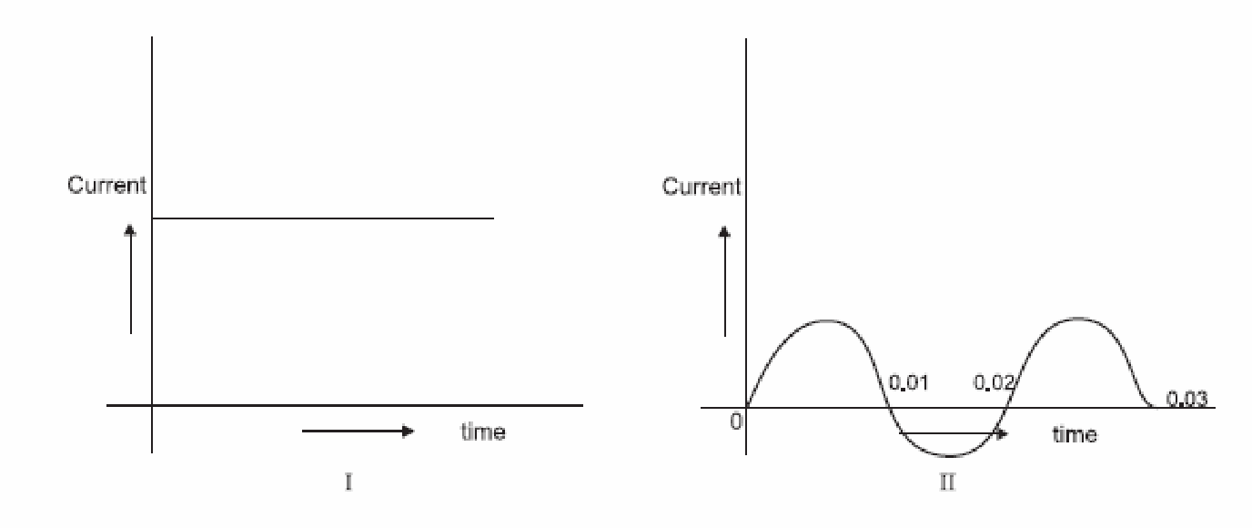

(i) Name the type of current in two cases.
(ii) Identify any one source for each type of these currents. (iii) What is the frequency of current in case II in India?

QDraw the pattern of lines of forces due to magnetic field associated with a current carrying straight conductor .State how the magnetic field produces changes 1 )With an increase in current In the conductorand,ii)In the distance from the conductor.3
Q.An alternating electric current has a frequency of 50 Hz.How many times does it changes its
direction in one'second. Ans. 100 .1
Q.An electron enters a uniform magnetic field at right angles as shown in the fig. In which direction will this electron move? State the principle applied by you in finding the direction of motion of the electron.2
Electron

Ans . Electron will move in out ward direction .Rule:Fleming’s left hand rule.
]Q. What will be the frequency of an alternating current if its direction changes after every
0.0lsec. Ans. 50 Hz' 1
Q.Draw the schematic labeled diagram of a domestic wiring circuit which include.
1)A main fuse
2) A electric meter
3)One light point
4)a power out put socket
b) In this circuit, on which wire of the circuit is the main on/off switch is connected? 5 .
Q.With the help of a neat diagram describe how you can generate induced current in a solenoid.3
Q.What is an electromagnet?List any of its two uses.Draw a labeled diag to show how an electromagnet is made.3
Q. You are provided with a bar magnet,a cardbord piece and iron filings I)Suggest an activity to show the pattern of magnetic field of lines ii)Draw a rough sketch of field lines which you will observe .3
Q. Draw the pattern of field lines due to a solenoid carrying electric current. Mark the north and south poles in the diagram.3
Q.Write an activity to show the force acting on current carrying conductor placed in a magnetic field.3
QWhat is electric fuse ,Why it is used as a safety device.?2
Sources of.energy CONCEPT TUTOR POINT Cell:9983118799
Q.Though a hot iron emits radiations,yet is not visible in the dark. Why? 2
Q. What kind of radiations is emitted by a hot iron.1
Q.Name the component of sunlight prolonged exposure to which may cause skin cancer. .
Q.State two advantages and two limitations of solar energy.2
Q. What is a good source of energy.2 ,
Q.The wavelengths of three radiations are 8 x10⁻⁵cm,4x 10⁻⁵ cm, 2x 10⁻⁵ cm respectively .Which of these three radiations will be visible.Ans B because visible range is 4 x 10⁻⁷ to 7 x 10⁻⁷ met.1
Q.Arrange the following in decreasing order of wavelengths ultra violet rays,visible light ,X rays, ,infra red rays .Ans.I.R :> V .L>U.V.R> X.R1
Q.A decoration light chain consist of red, blue., green and yellow coloured bulbs in series. which
type of bulbs give off light of shortest wavelength.? Ans.blue.1
Q.What is geothermal energy.1
Q.Write the full form of the following. LPG,CNG,OTE,OTEC,.SPV
Q.Write short notes on wind farm.3
Q.Differentiate between renewable and non renewable' sources of energy.Give two
example of each.2
Q. What is Wind energy1
Q.What is green house effect.1
Q.Describe the construction and working of a solar cooker. Write its limitations and advantages.3
Q.What is Bio gas?Name the major constituents of bio-gas.Describe the construction and working of gobar gas plant.5
Q.Why is hydro energy is said to be an indirect source of solar energy?Describe the steps involved in converting hydro energy in to electrical energy.What fraction of our countries total energy needs are met through hydroenergy.5
Q.Write construction and working of wind mill.3
Q .Although hydrogen gas has a very high calorific value still it is not used as an industrial fuel.State four resons for this.2
Q.Define nuclear fission and fusion reactions.2
Q.Write two advantages and two hazards of using nuclear energy.2
Q.Write any two advantages of gobar gas chulha over tradiational chulha.2
Q.How is the energy . 'released inside a nuclear reactor handled for useful purposes.2
Electricity
Q. 1)What is the shape of the graph obtained by plotting potential difference applied across a conductor against the current flowing through it .1
Q.What is ment by the statement, “potential difference between points A and B in an electric field is 1 volt.”? 1
2)What is the slop of this V- I graph at any point represents.2
Q Two students perform the experiments on series and parallel combinations of two given resistors R1 and R2 and plot the following V-I graphs.

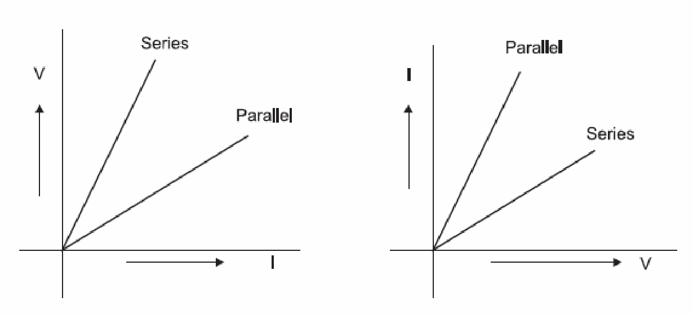

Which of the graphs is (are) correctly labelled in terms of the words ‘series’ and parallel’ Justify your answer.3
Q. A TV set picture tube shoots out a beam of electrons. The current due to this beam is 10 mA. How many electrons will strike the TV screen every second?2
Q.a)Express Ohms law by a mathematical formula.5
b) Draw a circuit diag. to verify ohm’s law.
c)Present the relationshiop between the voltage and current flowing through it graphically.
QWhy is much heat less is generated in long electric cables than in filaments of electric bulbs. ?Q.Define one watt hour.2
Q,Length of a resistance is doubled .What will be its specific resistance?1
QWhat is the value of charge on an electron in coulomb.1
Q.Name the two materials whose resistivity first increase and then decreases with rise in temperature.1
Q. What is an electric current? What is the S.I unit of an electric current.1
Q Express Ohm's law by a mathematical formula. Define S.I unit of resistance .Derive an
Expression for equivalent resistance of three resistances R_{l},R₂,R₃, connected in parallel. 3
Q.Why is an ammeter is likely to be burnt out if you connect it in parallel. 2
Q. A circuit has a fuse of 5A. What is the maximum number of 100 watt (220V) bulbs that can be safely used in the circuit.?2
Ans 11
Q. Which one has more resistance 100 watt bulb or 60 watt bulb.1
Q.Two bulbs 40 watt and 60 watt are connected in series combination and this combination is connected with A.C source of 220 volts .Which bulb will glow brighter and why.?2
Q If four 60 w bulbs are used for 5 hours a day,a tubelight of is used for 6 hours a day and a refrigerator of 1500 w is used for 2 hours a day,Calculate the cost of electricity
in a month of30 days,Ifthe cost of one unit is 2.25Rs. Ans.Rs 307. 8 .3
Q.If a student by mistake, connects a voltmeter in series and an ammeter in parallel combination of a circuit, what will happen.3
Q A torch bulb is rated 2.5V and 750mA.Calculate I) its power ii) Its resistance and iii) the energy consumed, if this bulb is lighted for 4 hours.Ans ,1.875w,3.330hm,27000j 2
Q Three resistors of resistors of 4 Ώ,2 Ώ ,X Ώ , resistances are connected in series to a cell such that the p.d at the end of resistors is 1.5 V and the current flowing in circuit is 1/6 A. Draw a circuit diagram and calculate the value of X. 3 Ans 3.
Q.A piece of wire is redrawn by pulling it until its length is doubled.Compare the new resistance with the original value 2. Ans 1:4

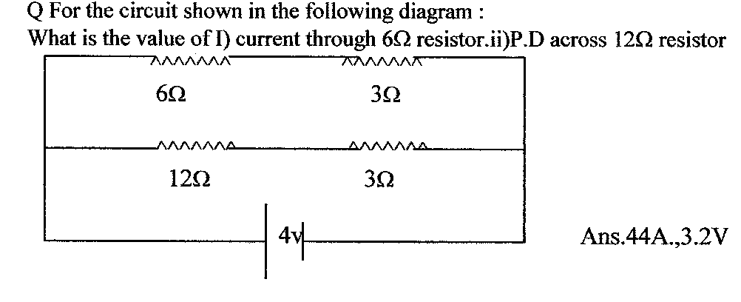
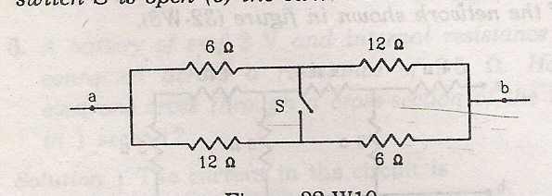Find the equivalent resistance between the points a,b when key s is 1) open 2) closed and A,B
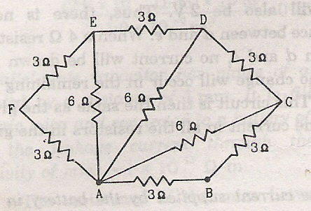
Paper Submitted by:
Name : yashwant sharma
Email : sharma_yashwant@ymail.com
Phone No. +919983118799

