Guess Paper – 2011
Class –XII
Subject –Physics
MARKS: 70 TIME: 3 HRS
GENERAL INSTRUCTRUCTIONS:
- All questions are compulsory.
- There are 30 questions in total. Questions 1 to 8 carry one mark each, questions 9 to 18 carry 2marks each, questions 19 to 27 carry 3 marks each and questions 28 to 30 carry marks each.
- There is no overall choice. However, an internal choice has been provided in one question of two marks, one question of three marks and all three questions of five marks each. You have to attempt only one of the given choices in such questions.
- Use of calculators is not permitted.
- Use following physical constants wherever necessary:
C= 3x 10⁸ m/s, h = 6.6 x 10⁻³⁴Js, e= 1.6 x 10⁻¹⁹C Boltzmann’s constant k=1.38x10⁻²³J/K mass of neutron = 1.6 x 10⁻²⁷C

1.Name the device which works under the principle of velocity selector?
2. Define 1 Ampere the unit of a.c current and how does it vary from d.c current?
3.Is the magnitude of displacement current less, equal or greater than the conduction current?explain
4. a)Why secondary rainbow is fainter than the primary rainbow? b) why clouds are appearing white?
5. In a wave picture of light, the intensity of light is determined by square of amplitude of wav e. What determines the intensity of light in photon picture of light?
6. The maximum K.E of emitted photo electron is 15eV. Find its stopping potential.
7.Draw a graph to show the variation of impact parameter (in alpha particle scattering)with scattering angle Ѳ.
8. Name a communication channel which can offer a transmission bandwidth in excess of 100 GHZ.
9. Using Gauss Theorem find the electric field at the surface of a charged conductor.
10. a) How should be the nature of trajectory of electrons in a conductor in the i)absence of ii)presence of electric field?
b) On what factors does internal resistance of a cell depend upon?
11.A Potential difference is applied at the ends of copper wire of 1m long. Calculate the average drift velocity of electons. Compare it with the thermal velocity at 27•C (σ_{cu} =5.81x10⁷ siemens and no.density of conduction electrons = 8.5 x 10²⁸/m³)
12 Find the magnitude and direction of Torque acting on rectangular current loop placed in uniform magnetic field as shown in fig
B
B
I=12A
I=12A
Ѳ=^{30˚˚}
(length and breadth of rectangular loop is 10cm and 5cm respectvely.Magnetic field B = 300G.current in coil(fig 1 )is clockwise and plane of coil is X-Y axis. Current in coil(fig2)is anticlockwise and plane of coil 30˚ out of X-Y axis.)
13. a)Find an expression for net induced emf produced in a coil when both primary and secondary coil carries varying c urrent
b) Find the direction of induced current in circular coil when varying current I flows through linear conductor from the given fig.
I
14 a) Long distance radio broad casts use short wave bands why? b) optical and radio telescopes are built on the ground but x-ray astronomy is possible only from satellites orbiting the earth why?
15a) The graph shows activity of a sample Radon-220. Calculate the value of decay constant b)define the SI unit of radioactivity.
A_{0 A0/2}

0 8 16 24 32
t

16. a) Name the special type of material preferred for making solar cell why? B)Draw the intensity graph for the selected materials for making solar cell.
17 a) why is modulation necessary? B) Draw frequency spectrum for AM .
18 Draw a block diag of simple detector of AM wave and hence explain how it is detected.
19. A 4µF capacitor is charged by 200 V supply. It is then disconnected to another uncharged capacitor of 2 µF capacitor. How much electrostatic energy of capacitor is lost in the form of heat and em radiations. (OR)
Explain with relevant diagram the principle working of a device which is used to generate a High P.d of ˜10⁶V which then used for triggering nuclear reaction.
20 a) If a charge +Q is fixed at a distance ‘d’ in front of infinite metal plate, draw the electric lines of force between them.
b) Find the angle between resultant Electric field along axial and equatorial line of dipole.
c) find the number of electric lines of force that radiate outwards from 9x10⁻¹²C of charge in vaccum.
21 In the potentiometer circuit shown the balance point is at x. State with reason, where the balance point shift when a) Resistance R in increased keeping all parameters constant. B) Resistance S is increased keeping R constant.c) Cell P is replaced by another cell of E.M.F lower than that of cell Q.
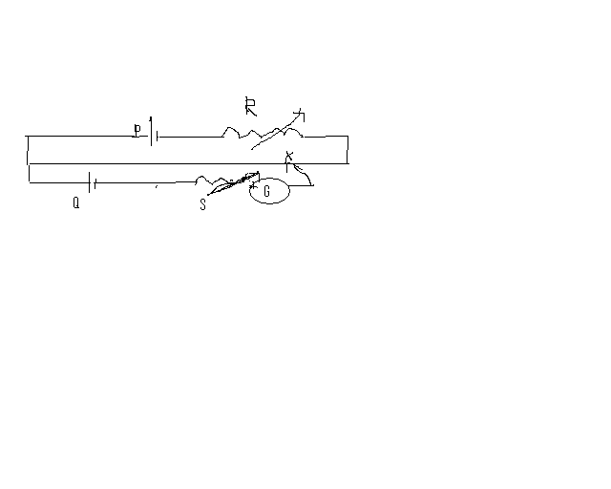
22. A) A charge q moving in straight line is accelerated by a P.D of V volts. It enters a uniform magnetic field B perpendicular to its path. Deduce in terms of V an expression for radius of circular path.
b) Fig shows a small magnetized needle A placed at point B .The arrow shows the direction of magnetic moment. The other arrows shows different position of another identical magnetized needle B i) in which configuration is the system stable and unstable equilibirium.
B₂
23. Using Ampere’s circuital law find an expression for magnetic field atλ√
B₁
B₃
B₄
A
(r<a &r>a)due to long straight thick wire of radius ‘a ‘ of finite wire
Of cross section carrying current I.
24. a) draw a ray diagram to show the image formation by compound
Microscope at near point vision. Write its Magnifying power.
b) How does modern Microscopes vary from this microscope and why is it used nowadays?
25.Light incident normally on a plane mirror attached to a galvanometer coil retraces back as shown. A current in the coil produces a deflection of Ѳ= 3.5˚of the mirror. What is the displacement of the reflected spot of light on a screen placed 1.5m away?
d
1.5 m
Ѳ
b)A rectangular glass slab is placed on red and blue color
Dot. It has been viewed obliquely through a microscope
By an observer. Which of the two will be appearing closer to
Observer’s eye? Justify.
mirror
26 X-rays of wavelength λ fall on photo sensitive surface , emitting electron. Assuming that the work function of the surface can be neglected, P.T the debroglie wavelength of electron emitted will be √(hλ)/√(2mc) where the symbols have usual meanings .
27. a) what happens to neutron proton ratio after the emission of alpha decay?
b) Explain β – decay and its neutrino hypothesis c) Draw energy level diagram showing the emission of β-particles followed by γ-decay.
28 Using phasor diagram derive an expression for the Impedence of a series LCR circuit and hence deduce an expression for Resonance condition of LCR circuit. Draw resonance graph and mark the bandwidth region. (OR)
Derive an expression for energy of L_C oscillation and explain how these oscillations are produced.
29. What is diffraction ?. Draw a neat diagram of single slit experiment and explain how will you obtain a condition for maxima and minima. obtain an expression for linear width of central maxima. Draw its intensity pattern. (OR)
What is interference? Draw a neat diagram of YDSE and hence deduce a condition for intensity maxima and minima in terms of path and phase difference. Draw its intensity pattern.
30 Explain the principle working of transistor Oscillator with neat circuit diagram. Write the equation of Bharkusen’s criterian. (OR) Explain the working of base biased transistor CE configuration and draw its transfer characteristics

MRS.SIVESHWARI BHASKER.M.Sc.,B.Ed., M.Phil.,
(meghabhasker@gmail.com)
SENIOR PGT PHYSICS , CHETTINAD VIDYASHRM.

