Guess Paper – 2011
Class –XII
Subject –Physics
Time allowed: 3 Hours Maximum marks: 70
General Instructions:
- All questions are compulsory.
- There is no overall choice. However, an internal choice has been provided in one question of two marks, one question of three marks and all questions of five marks. You have to attempt only one the choices in such questions.
- Question numbers 1 to 8 are very short answer type questions, carrying one mark each.
- Questions numbers 9 to 18 are short answer type questions carrying two marks each.
- Question numbers 19 to 27 are also short answer type questions, carrying 3 marks each.
- Question numbers 28 to 30 are long answer type questions, carrying five marks each.
- Use of calculators is not permitted. However, you may use log tables, if necessary.

      - An electron beam projected along +X axis, experiences a force due to a magnetic field along the + Y-axis. What is the direction of the magnetic field?
      - The instantaneous current from an ac source is I = 6 sin 314t. What is the rms value of the current?
      - A bulb connected in series with a solenoid is lit by ac source. If a soft iron core is introduced in the solenoid, will the bulb glow brighter?
      - Which part of the electromagnetic spectrum is used in operating RADAR? Give its wavelength range.
      - Two thin lenses + 6D and -2D are in contact. What is the focal length of the combination?
      - The ionization potential of hydrogen is 13.6 V. calculate the energy of its first excited state.
      - How does the collector current change in a junction transistor, if the base region has larger width?
      - How does the conductivity change of a semiconductor with increase of temperature?
      - Define the term temperature coefficient of resistivity. Draw a graph showing the variation of reistivity with temperature for copper.
      - 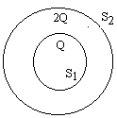S₁ and S₂ are two hollow concentric sphere enclosing charges Q and 2Q respectively as shown in fig.
- What is the ratio of electric flux through S₁ & S₂?
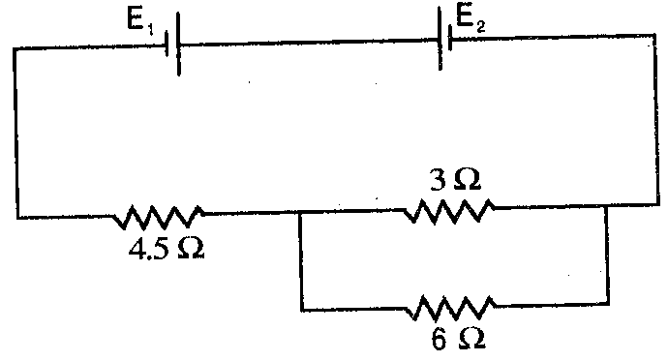
- How will the electric flux through the sphere change, if a medium of dielectric constant 5 is introduced in the space inside S₁ in place of air?
      - Two cells E₁ and E₂ in the given circuit diagram have an emf of 4V and 8V and internal resistance 0.5Ω and 1.0Ω respectively. Calculate the current flowing through the resistance of 3Ω.
      - How will a dia & ferro magnetic material behave when kept in a non-uniform external field? Give two examples each.
      - Write two applications of each, microwaves and infrared rays.
      - A double concave lens of glass of RI 1.6 has radii of curvature of 40cm, 60cm. Calculate its focal length. Also find the focal length of the lens if the lens is immersed in a liquid of RI 1.3.
      - Show that the de-Broglie wavelength λ of electrons of energy E is given by the relation λ =
      - X rays of wavelength λ fall on a photosensitive surface emitting electrons. Assuming that the work function of the surface can be neglected. Prove that the de- Broglie wavelength of electrons emitted will be .
      - Define half life. Derive the relation between half life and decay constant.
      - Give reason:
- Long distance radio broad casts use short wave bands. Why?
- The small ozone layer on top of the stratosphere is crucial for human survival.
      - Define electric dipole. Derive an expression for eclectic potential on the axis of dipole.
      - State Guass’s theorem in electrostatics. Derive an expression for electric field intensity produced by charged thin sheet using this theorem.
      - Write the principle of potentiometer. Explain with diagram how you will compare the emf of two cells using potentiometer.
      - Derive a relation between root mean square value and peak value of alternating current.
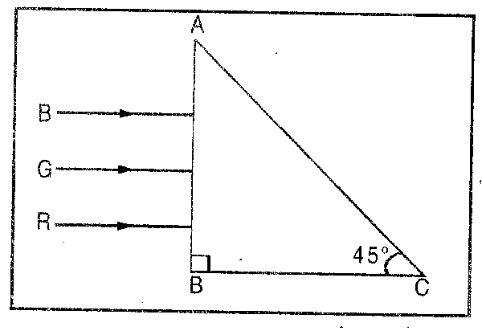
      - Three rays of light red (R), green (G) and blue (B) are incident on the face AB of a right angled prism ABC. The refractive indices of the material of the prism for red, green and blue wavelengths are 1.39, 1.44 and 1.47 respectively. Trace the path of the rays through the prism. How will the situation change if these rays were incident normally on one of the faces of an equilateral prism?
      - Define mutual inductance. Obtain the mutual inductance for a combination of two circular coils, one of small radius r₁ and the other of very large radius r₂ when placed co-axially with centres coinciding.
      - Draw a labeled ray diagram to show the image formation by an astronomical telescope when final image is forms at least distance of distinct vision. Derive an expression for its magnifying power.
      - Calculate BE /N for ₂₆ Fe ⁵⁶ using the data m(₂₆ Fe ⁵⁶ ) = 55.934932u, m_{n} = 1.008665u, m_{p} = 1.007825u and 1u = 931 MeV.
      - What is meant by modulation? Define amplitude modulation used for a message signal using a sinusoidal continuous carrier wave. Draw block diagram.
      - Trace the rays of light showing the formation of an image due to a point object placed on the axis of a spherical surface separating the two medias of refractive indices n₁ and n₂. Establish the relation between the distance of the object, the image and the radius of curvature from the central point of the spherical surface.
Hence derive the expression of the lens maker’s formula.
OR
Define the term wave front. Draw the wave front and corresponding rays in the case of a (i) diverging spherical wave, (ii) plane wave.
Using Huygen’s postulates explain the refraction of a plane wave front at a plane surface and hence verify Snell’s law.
      - Explain the formation of depletion layer and potential barrier in a p-n junction diode. With the help of a labeled circuit diagram, explain the use of a p-n junction diode as a full wave rectifier. Draw the input and output waveforms.
OR
- With the help of a diagram explain the working of n-p-n transistor as an oscillator.
- The output of an OR gate is connected to both the inputs of a NAND gate. Draw the logic circuit of this combination of gates and write its truth table.

      - (a) State Biot savart’s law.
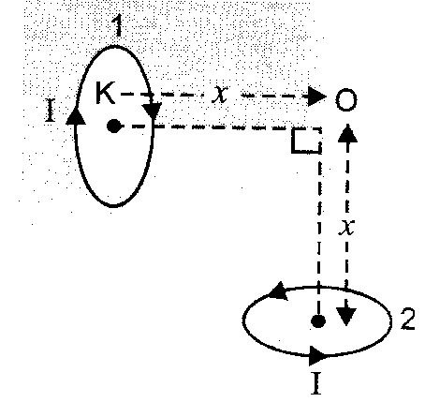
  - Using Biot Savart’s law derive an expression for magnetic field intensity on the axis of a circular coil carrying current.
  - To small circular loops marked 1 and 2 carrying equal currents are placed with the geometrical axis perpendicular to each other as shown in fig. find the magnitude and direction of the net magnetic field produced at the point O.
OR
Draw a schematic diagram of a cyclotron. Explain its underlying principle and working, stating clearly the function of the electric and magnetic fields applied on a charges particle.
Deduce an expression for the period of revolution and show that it does not depend on the speed of charged particle.

By: Atul Kumar
PGT, St marks sr sec public school
Harsh VIhar Delhi 110093
M: 9717537820
E mail: atulmscphy@gmail.com

