Guess Paper 2011
Class – XII
Subject –Physics

Time allowed: 3 Hours Maximum marks: 70
General Instructions:
- All questions are compulsory.
- There is no overall choice. However, an internal choice has been provided in one question of two marks, one question of three marks and all questions of five marks. You have to attempt only one the choices in such questions.
- Question numbers 1 to 8 are very short answer type questions, carrying one mark each.
- Questions numbers 9 to 18 are short answer type questions carrying two marks each.
- Question numbers 19 to 27 are also short answer type questions, carrying 3 marks each.
- Question numbers 28 to 30 are long answer type questions, carrying five marks each.
- Use of calculators is not permitted. However, you may use log tables, if necessary.

      - A force F experienced by a particle of charge q moving with velocity v in a magnetic field B is given by . Which pair of vectors is always at right angles to each other?
      - The closed loop PQRS is moving into uniform magnetic field acting at right angles to the plane of the paper as shown in the figure. State the direction in which the induced current flows in the loop.
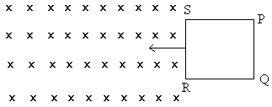
      - What will be the values of input A and B for the Boolean expression?
      - Sketch the out put from a NAND gate having inputs A and B as shown following
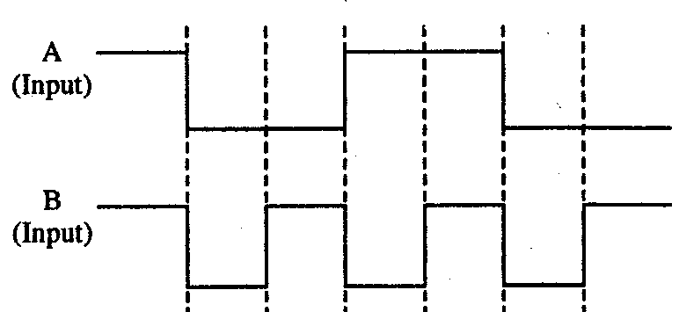
      - The energy of an electron in n ^{th} orbit is given by En = eV. Calculate the energy required to excite an electron from ground state to the second excited state.
      - Which of the following has the shortest wavelength: microwaves, ultraviolet rays and X-rays.
      - What will happen to the image formed by a mirror if half of it is covered with a black paper?
      - The frequency of AC is being increased in a circuit containing bulb and a capacitor in series. How will the brightness of the bulb be affected?
      - Derive an expression for electric potential on the axis of a dipole.
      - A cylindrical metallic wire is stretched to increase its length by 5%. Calculate the percentage change in its resistance.
      - Define resistivity and conductivity of a conductor. Write their SI units.
OR
Draw graph for ohmic and non ohmic conductor. Write one example of each.
      - A proton and an α particle enter a uniform magnetic filed perpendicularly with the same speed. How many times is the time period of the α particle than that of proton?
      - What is an electromagnetic wave? Write two properties of an electromagnetic wave.
      - A ray of light passes through an equilateral glass prism, such that the angle of incidence is equal to the angle of emergence. If the angle of emergence is ¾ times the angle of the prism, calculate the refractive index of the glass prism.
      - The threshold frequency of a metal is ν₀. When the light of frequency 2ν₀ is incident on the metal plate, the max velocity of electron is v₁. When the frequency of the incident radiation is increased to 5ν_{0,} the max velocity of electron emitted is v₂. Find the ratio of v₁ & v₂.
      - Define the term stopping potential for photoelectric effect. Show graphically how the stopping potential, for a given metal, varies with frequency of the incident radiation.
      - Why is the mass of a nucleus always less than the sum of the masses of its constituents, neutrons and protons? If the total number of neutrons and protons in a nuclear reaction is conserved. How then is the energy absorbed or evolved in the reaction? Explain.
      - (a) Why short wave communication over long distance is not possible via ground wave?
        - What is the difference is FAX and in e-mail?
      - Two capacitors of capacitance 3μF and 6μF are charged to potentials of 2V and 5V respectively. These two charged capacitors are connected in series. Find the potential across each of the two capacitors now.
      - State Kirchhoff’s rule for current distribution in an electrical network.
Using this rule determine the value of the current I₁, I₂ and I₃ in the circuit given below.
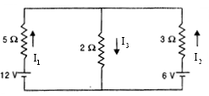
      - Given L = 5 H, C = 80 μF and R= 40 ohm are connected in series with a variable frequency 230V source. Determine (i) the source frequency which drives the circuit in resonance. (ii) Obtain the impedance of the circuit and the amplitude of current at the resonating frequency. (iii) Determine the rms potential drops across the capacitor and an inductor.
      - A parallel plate capacitor is charged to a potential difference V by a d.c source. The capacitor is then disconnected from the source. If the distance b/w the plate is doubled, state with reason the change in: (i) electric field b/w the plates (ii) capacitance (iii) energy stored in the capacitors.
OR
State Gauss’s theorem. Using Gauss theorem, derive an expression of electric field intensity at any point outside a hollow charged conducting sphere.
      - Calculate the rate at which the flux linked with the generated area changes with time when a rod of length is rotated in a uniform, field induction B.
      - The refractive index of the material of a concave lens is n. It is immersed in a medium of refractive index n₁. A parallel beam of light is incident on the lens. Trace the path of the emergent rays in each of the following cases- (a) n₁ > n (b) n₁ < n (c) n₁ = n
      - A double convex lens made of glass of refractive index 1.5 has both radii of curvature of magnitude 20 cm. an object 2 cm high is placed at 10cm from the lens. Find the position nature and size of the image.
      - Define nuclear force. Write any four properties of nuclear force.
      - Explain how the amplitude modulation is carried out with block diagram.
      - Draw a labeled diagram of a moving coil galvanometer. State the principle on which its works. Deduce an expression for the torque acting on a rectangular current carrying loop kept in uniform magnetic field. Write two factors on which the current sensitivity of a moving coil galvanometer depends.
OR
Drive an expression for the magnitude of force per unit length b/w two infinitely long parallel straight current carrying conductors. Hence define SI unit of current.
A galvanometer with a coil of resistance 12 Ω shows a full scale deflection for a current of 2.5mA. How will you convert the meter into (a) an ammeter of range 0 to 7.5A? (b) Voltmeter of range 0 to 10V?
      - State the condition of diffraction of light to occur. Write two-difference b/w diffraction and interference. In the diffraction at a single slit experiment, how would the width and the intensity of central maximum change, if slit width is halved and visible light of longer wavelength is used?
OR
Obtain an expression for magnifying power of a compound microscope with suitable diagram.
Why must both the objective and eyepiece of a compound microscope have short focal lengths?
      - (a) Write a short note of LED.
        - Give two advantages of LED over conventional incandescent lamps.
        - The output of an unregulated dc power supply needs to be regulated. Name the device that can be used for this purpose and draw the relevant circuit diagram and explain it.
OR
- Define the term potential barrier and depletion region for a p-n junction diode.
- Explain with the help of a circuit diagram, the use of a p-n diode as a full wave rectifier. Draw the input and output waveforms.

By: Atul Kumar
PGT, St marks sr sec public school
Harsh VIhar Delhi 110093
M: 9717537820
E mail: atulmscphy@gmail.com

