SAMPLE PAPER - 2008
CLASS – XII
SUBJECT - MATHEMATICS
Max.Marks:80 Time: 3 hours

General Instructions :

- All questions are compulsory.
- The question paper consists of 30 questions divided intofour sections A, B , c and D
- Section A contains 10 questions of 1 marks each, Section B is of 5 questions of 2 marks each , Section C is of 10 questions of 3 marks each. and section D contains 5 questions of 6 marks each.
- There is no overall choice. However, internal choice has been provided in one question of two marks two questions of three marks each and one question of six marks.
- In question on construction, the drawing should be neat and exactly as per the given measurements.

SECTION A

1. Find the value of ‘k’ if (x-2) is a factor of x³-4x²+kx-4.
2. If the point (2a-8x+4, 3b-4x+8) passes through origin. Find ‘x’
3. Find one rational and one irrational number between 3.14 and
4. State the remainder theorem of polynomials.
5. Find the area of an equilateral Δ with perimeter 36 cm.
6. The radius of cone is 9cm and its height is 12cm find its CSA and volume
7. Find the median of the following data:
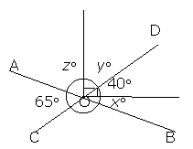
46,64,87,41,58,77,35,90,55,33,92.
8. 1000 tickets of a lottery are sold and there are 5 prizes. If Sanjay has purchased 2 tickets find the probability of winning a prize.
9. Ray OB bisects AOB and ray OD is opposite to ray OB. Prove that AOD = COD
10. The diagonal of a cube is 27 cm. Find its surface area and volume.
11. In figure AOB and COD are 2 lines. Find x,y,z.
12. Represent on the number line. [ figure only]
13. A card is drawn from a well shuffled pack of cards. Find the probability that a card is drawn is neither a red nor a queen.
14. The mean of 31 results is 60 and if mean of first 16 observations is 58 and last 16 observations 62 find the 16th observation
[OR]
For what value of ‘x’ will the mode of the following be 7?
3,5,6,7,5,4,7,5,6,x,8,7.
15. AD is one of the medians of ΔABC. Show that ar(ABX)=ar(ACX)

16. ABCD is a quadrilateral such that AB//CD AD=BC. Show that AC=BD.
17. Draw the graph of the equation 3x-4y=12. Find if x=4,y=2 is a solution or not graphically.
18. Simplify: (a²-b²)³(c²-a²)³(c²-a²)³
_ ______________
(a-b)³ (b-c)³ (c-a)³
19. The following data has been arranged in ascending order:
12, 14, 17, 20, x, 26,28,32,36. If the median is 23, find ‘x’. If 32 is replaced by 23, find the new mean.
20. The perimeter of a right Δ is 144cm. and its hypotenuse is 15cm. find its other 2 sides and its area.
21. Construct a ΔABC with BC=5cm, B= 30⁰ and AC-AB=2cm. (steps required)
22. Show that the figure obtained by joining mid points of sides of a rhombus is a rectangle.
23. Simplify:
24. A teak of wood log is cut first in the form of a cuboid of volume 1.104 cm³. How many rectangular planks of size 2.3X0.75X0.04 be cut in a cuboid
(OR)
3 Metal cubes of edges 6cm,8cm,10cm are melted to form a cube. Find its surface area, volume and diagonal.
25. Factorise 2x⁴-6x³+3x²+3x-2.

26. Show that the angle subtended by an arc at centre is twice the angle subtended by it at any point on circle. Using it find BDC,ABC, if O is centre.
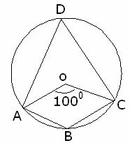
A
C
P
O
32⁰
47⁰
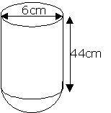
27. Two equal chords of a circle AB and CD when produced meet at a point E. If O is the centre prove AE=EC.
28. Find the capacity of the figure in liters: (fig 3)
( OR)
A wooden toy is in the form of a cone mounted on a hemisphere. Diameter of base is 6am and height is 4cm. Find the cost of painting at the rate of Rs. 5 per 1000cm². ( take 3.14)

29 a) In the given figure AC=AE,AB=AD and BAD=EAC. Show BC=DE.
70
A
B
D
C
E
x
y

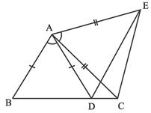
A
B
P
Q
C
R

b) Plot the points (-2,1), (2,-2) and(5,-2) on the graph and join them. Which figure do you obtain?
30. The following are the scores of two groups of class IX in Hindi test. Prepare a frequency polygon on the same axes. Whose performance is better
CLASS INTERVAL GROUP A (F) GROUP B (F)
39-42 6 3
35-38 11 4
31-34 15 5
27-30 18 10
23-26 23 15
19-22 15 14
15-18 2 9

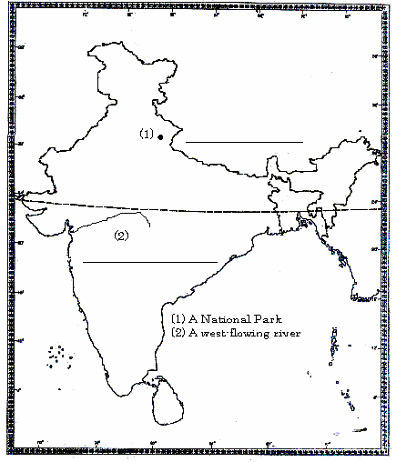
A
B
C
D
E
y
x
50⁰
65⁰

