Sample Paper - 2008
Class – X
Subject – Mathematics

1. Express 0.6 as a rational number in simplest form.
2. Can we have two medians of a data?
3. Can a quadratic polynomial have no zero?
4. On comparing the ratios ‘ and without drawing them, find out whether the lines representing the following pair of linear equations intersect at a point, are parallel or coincide
5x - 4y + 8=0; 7x + 6y – 9 = 0

sin 18°
5. Evaluate : cos 72°
6. A tangent PQ at a point P of a circle of radius 5 cm meets a line through the centre 0 at a point Q so that OQ = 12 cm. Find the length of PQ.
7. Find the length of the tangent drawn to a circle with radius 7 cm from a point 25 cm away from the centre of the circle.
8. Without using trigonometric tables, evaluate
cosec 89° — sec 1°.
9. In the given figure, XY BC. Find the length of XY.

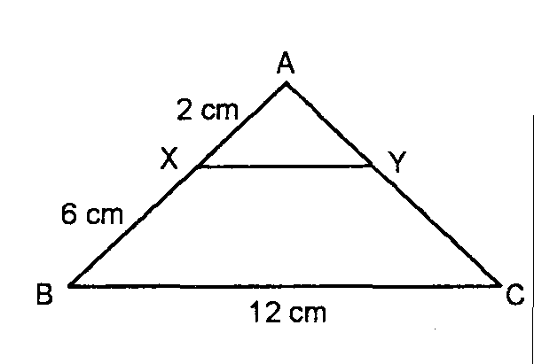
10. Prove that: tanA (1 - sinA) = sinA cosA.
Section B
11. The 10th term of an AP is 52 and 16th term is 82. Find the 32nd term and the general term.
12. Two unbiased coins are tossed simultaneously. Find the probability of getting at most one head.
13. In the adjoining figure. 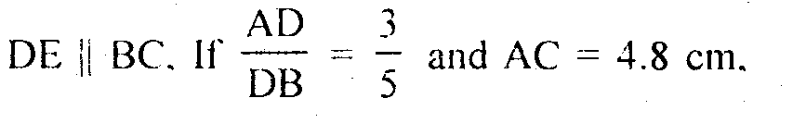 find AE.

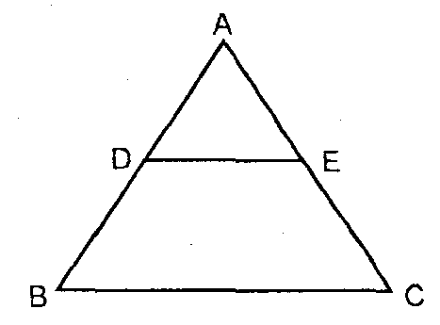
14. Show that the points (1, —1). (5. 2) and (9, 5) are collinear.
15. A quadrilateral ABCD is drawn to circumscribe a circle. Prove that AB + CD = BC + DA.
Section C
16. Determine graphically the vertices of the triangle whose sides are
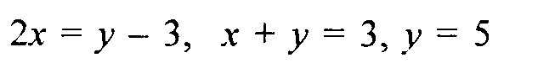
OR
Solve the following system of linear equations for x and y.
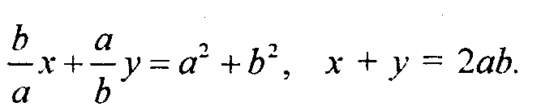
17. If the roots of the equation (b - c) x² + (c - a) x + a - b = 0 are equal, prove that
2b = a + c.
18. Divide 32 into four parts which are in AP such that the ratio of the product of extremes to the product of means is 7 : 15.
OR
If the sum of m terms of an AP is the same as that of n terms, show that the sum of (m + n) terms of the AP is 0.
19. In an acute angled triangle ABC, . Prove that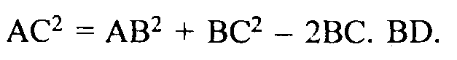
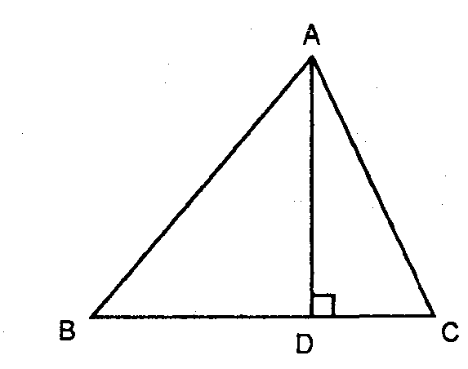
20. Draw a pair of tangents to a circle of radius 5 cm, which are inclined to each other at an angle of 60.
21. Obtain all the zeroes of the polynomial x⁴ -7x³ + 17x² – 11x + 6 , if two of its zeroes are 3 and 1.

22. The sum of n terms of an AP are 2n² + 5n. Find the 15th term of an AP.

(OR)

The points (-3,1) and (0,-2) are two vertices of a triangle. Find its third vertex if the centroid is (5,-2).

23.Prove that cosA___ + sin A__ = sinA + cosA
1 – tan A 1 – cotA

24.Construct a triangle of sides 5cm , 6cm , 7cm and another similar triangle which has 5/3 times the sides of the first triangle.Write the steps of construction.

25. In an equilateral triangle of side 12cm , a circle is inscribed touching its sides. Find the area of the portion of triangle not included in the circle.

Section D
26. Solve the following system of linear equations graphically
4x - 5y - 20 = 0
3x + 5y - 15 = 0
Determine the vertices of the triangle formed by the lines representing the above equation and the y-axis.
27. A man standing on the deck of a ship, which is 10 in above water level. He observes the angle of elevation of the top of a hill as 60° and the angle of depression of the base of the hill as 30°. Calculate the distance of the hill from the ship and the height of the hill.
OR
Two poles of equal heights are standing opposite each other on either side of the road, which is 80 in wide. From a point between them on the road, the angles of elevation of the top of the poles arc 60° and 30° respectively. Find the height of the poles and the distance of the point from the poles.
28. Calculate the mode of the following frequency distribution.
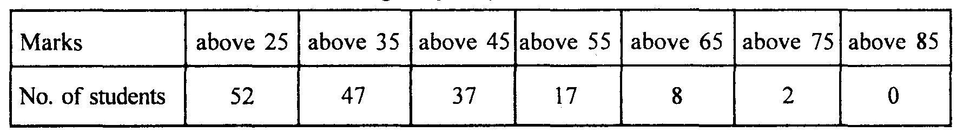

29. Two trains leave a railways station at the same time. The first train travels due south and the second train due north. The first train travels 5 km/h faster than the second train. If after 2 hours, they are 50 km apart, find the average speed of each train.
OR
The hypotenuse of a right angled triangle is 20 cm. If the difference between the lengths of the other two sides is 4 cm, find the other sides.
30. If a line is drawn parallel to one side of a triangle to intersect the other two sides in distinct points, the other two sides are divided in the same ratio. Prove.

