Sample Paper – 2008
Class – X
Subject – Mathematics

Section – A
- For what value of k ,does the equation 3x² – 4 k x + 12 = 0 have equal roots?
- Sides of two similar triangles are in the ratio 4 : 9. What are the Areas of these triangles?
- Evaluate $\frac{2\text{tan}{\text{30}}^{0}}{1−{\text{tan}}^{2}{\text{30}}^{0}}=?$
- Find the value of k, if the points (2, 3), (6, - 3) and (4, k) are collinear.
- In the figure given below, AQ and AR are a tangent to the circle drawn from an external point A. CB is third tangent touching the circle at P. If AQ=15 cm, and CP=4cm.What is the length of AC.
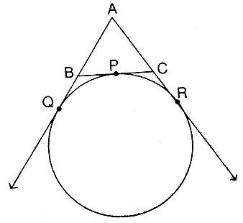
- A pair of dice is tossed once. What is the probability of getting a doublet (same number on both dice)?
- For the polynomial$3x^{2}−5x+1$, what is the sum of zeros?
- Find the condition that if the linear equations $\text{lx}+\text{my}=n$ and $\text{ax}+\text{by}=c$have unique solution.
- State the Euclid’s Division Lemma.
- A right circular cylinder is shown in figure which encloses a sphere of radius r. Find the curved surface area of the cylinder.
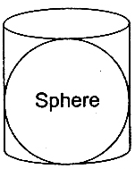
Section – B
- Without using trigonometric table, evaluate: $\frac{\text{sin}{\text{50}}^{0}}{\text{cos}{\text{40}}^{0}}+\frac{\text{cos}\text{ec}{\text{40}}^{0}}{\text{sec}{\text{50}}^{0}}−4\text{cos}{\text{50}}^{0}\text{cos}\text{ec}{\text{40}}^{0}$
- In given figure A, B and C are points on OP, OQ and OR respectively such that $\text{AB}‖\text{PQ}$ and $\text{AC}‖\text{PR}\text{.}$ Show that $\text{BC}‖\text{QR}\text{.}$
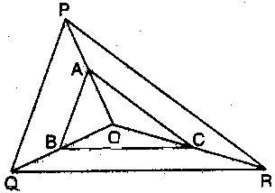
- What is the probability that a leap year contains (a) 53 Sundays (b) 53 Sundays and 53 Mondays?
Or
Two coins are tossed simultaneously. Find the probability of getting (a) two heads (b) at least one head.
14. Find the sum of the AP 10/3, 4/3 . -2/3….. upto 25 terms.
15. Find the probability that in the throw of 3 coins we get:
(a) atmost 2 heads
(b) atleast 1 head
(c)exactly two tails.
(d) head on first and tail on the third.

Section – C

- Prove that $\sqrt{7}$ is an irrational numbers.
- In given figure XY and $X^{'}Y^{'}$are two parallel tangents to a circle with centre O and another
tangent AB with point of contact C intersects XY at A and $X^{'}Y^{'}$ at B. Prove that $∠\text{AOB}={\text{90}}^{0}$
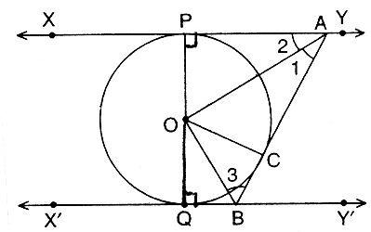
Or
In given figure PQR is a right angled triangle with PQ = 12 cm and QR = 5 cm. A circle with centre
O and radius x is inscribed in$Δ\text{PQR}$. Find the value of x.
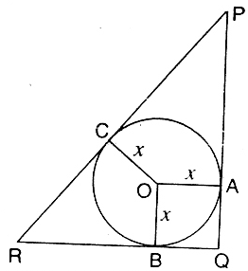
- On dividing $x^{3}−3x^{2}+x+2$ by a polynomial$g(x)$, the quotient and remainder were $x−2$ and $−2x+4,$ respectively. Find$g(x)$.
- If cosθ + sinθ = √2 cosθ , show that cosθ – sin θ = √2 sinθ
Or
If sinθ + sin²θ = 1 , prove that cos²θ + cos⁴θ = 1
20. Solve x and y: 6( ax + by ) = 3a + 2b ; 6( bx – ay ) = 3b – 2a
Or
A man travels 370km partly by train and partly by car. If he covers 250km by train and the rest
by car, it takes him 4 hours. But if he covers 130km by train and the rest by car, it takes him 18
minutes longer. Find the speed of the train and that of the car.
21. In given figure, ABCD is a square whose each side is 14 cm. APD and BPC are semicircles. Find
the area of the shaded region.
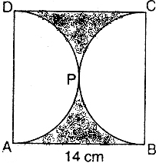

22.Find the length of the medians of the triangle whose vertices are (1,-1) (0,4) and (-5,3).
OR
If the roots of the equation (a² + b²)x² – 2(ac + bd)x + (c² + d²) = 0.
23 .Derive section formula.
24. Prove that tangents drawn from an external point to a circle are equal.

25. Construct a triangle with sides 5 cm, 6 cm and 7 cm and then another triangle whose
sides are 7/5 of the corresponding sides of the first triangle.

Section – D

- From a point on the ground 40m away from the foot of a tower, the angle of elevation of the top of the tower is 30⁰. The angle of elevation of the top of a water tank (on the top of the tower) is 45⁰. Find the height of the tower and the depth of the tank.
Or
A 10m high flagstaff is fixed on the top of a tower .the angle of elevation of the top of the flag-
staff as observed from o point P on the ground is 60⁰,the angle of depression of the point P from
the top of the tower is 45⁰. Find the height of the tower.
- A metallic bucket is in the shape of a frustum of a cone mounted on a hollow cylindrical base given in the figure. If the diameters of two circulars ends of the bucket are 45cm and 25 cm, total vertical height is 30 cm and that of the cylindrical portion is 6 cm, find the area of the metallic sheet used to make the bucket. Also find the volume of water it can hold.
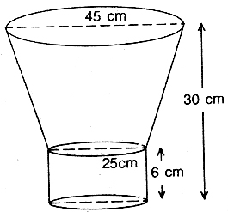

Or
A toy is in the shape of a right circular cylinder with a hemisphere on one end and a cone on the
other .The height and radius of the cylindrical part are 13cm and 5cm respectively. The radii of
the hemispherical and conical parts are the same as that of the cylindrical part .Calculate the
surface area of the toy if the height of the conical part is 12cm. (Л = 22/7)

- Prove that the ratio of the areas of two similar triangles is equal to the ratio of the squares of the corresponding sides. Using the above theorem, prove that the area of the equilateral triangle described on the side of a square is half the area of the equilateral triangle described on its diagonal.
29. If the mean of the following frequency distribution is 53, find the value of ‘f₁ and f₂’
Class: 0 – 20 20 – 40 40 – 60 60 – 80 80 – 100 total
Frequency: 15 f₁ 21 f₂ 17 100
30. Draw the graph of 2x – y + 2 = 0 and 2x + y – 6 = 0, Calculate the area bounded by these lines
and x- axis.

* * *

