PHYSICS
Class : XII
M M :70 Time :3 h

General Instructions:
- All questions are compulsory.
- There is no overall choice. However, an internal choice has been provided in one question of two marks, one question of three marks and one question of five marks. You have to attempt only one of the choices in such questions.
- Question numbers 1 to 5 are very short answer questions, carrying one mark each.
- Question numbers 6 to 12 are short answer questions, carrying two marks each.
- Question numbers 13 to 24 are short answer questions, carrying three marks each.
- Question number 25 to 27 are long answer questions, carrying 5 marks each
- Use of calculators is not permitted. However, you may use log tables if necessary.
- You may use the following values of physical constants wherever necessary :
c = 3 x 10 ⁸ ms ^{–1}
h = 6.6 x 10 ^{–34} Js
e = 1.6 x 10 ^{–19} C
μ ₀ = 4π x 10 ^{–7} T m A⁻¹

1. Calculate the current gain  of a transistor, if the current gain α = 0.98. 1
2. Discuss the importance of FM over AM. 1
3. When are voltage and current in LCR series AC circuit in phase? 1
4. An electron and a photon are of the same wavelength, which moves faster? 1
5. Why are the transmission of signal using ground waves restricted to frequency about 1500 kHz? 1
6. An ac source of 100 V, 50 Hz is connected across a 20 Ω resistor and a 2 mH inductor in series. Calculate (i) impedance of the circuit , (ii) rms current in the circuit. 2
7. With the help of diagrams, differentiate between (i) Pulse Amplitude Modulation (PAM) and (ii) Pulse Position Modulation. 2
8. Monochromatic light of wavelength 589nm is incident in air from air to water surface. What are the values of wavelength, frequency and speed of (i) reflected light and (ii) refracted light. 2
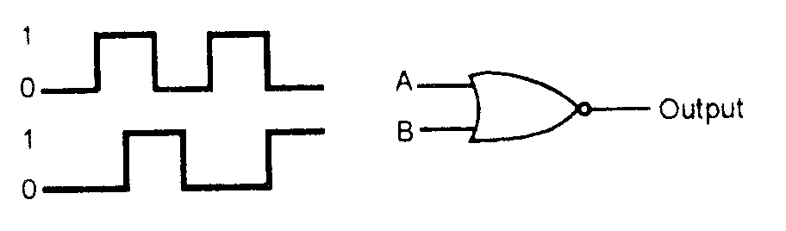
9. In the figure , circuit symbol of logic gate and input wave forms are given. Name the logic gate and give its output wave form: 2

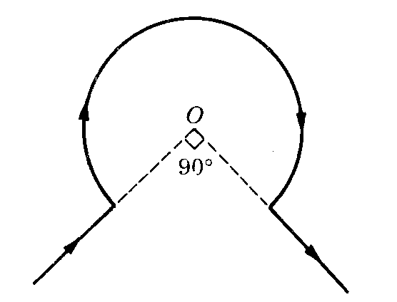
10. The wire shown in the figure carries a current of 60 A. Determine the magnitude of magnetic field at the center O. Given radius
of the bent coil is 2 cm.

OR
An ammeter of resistance 100 Ω can measure a maximum current of 5 mA. What will you do to measure a maximum current of 5A from it. 2

11. Draw a well labeled diagram of a button cell and write its important use. 2
12. Three capacitors when connected in series have net capacitance C₁ and when connected in parallel have net capacitance C₂. What is the ratio of C₁ / C₂? 2

13. By using a diagram explain the elements of the Earth’s Magnetic field. 3
14. State the Biot Savart’s law and apply it to calculate the magnetic field intensity at a point due to a straight current carrying conductor. 3

15. Explain the Davisson and Germer experiment to justify the wave nature of electron. 3
16. Draw a ray diagram for Compound Microscope and derive an expression for its magnification.

OR
Draw a graph to show the variation of angle of deviation D with that of angle of incidence i for a monochromatic ray of light passing through a glass prism of refracting angle A. Hence deduce a relation to calculate the refractive index of the material of prism. 3

17. The nucleus of ₁₀ Ne ²³ decays by  emission. Write down the  decay equation and determine the maximum kinetic energy of emitted electrons, Given that : m( ₁₀ Ne ²³ ) = 22.994466u & m(₁₁ Na ²³ ) = 22.089770 u. 3

18. Draw the graph showing the variation of binding energy per nucleon with the mass number of different nuclei. State two inferences from this graph. 3

19. Two cells of emf 6V and 12V and internal resistance 1 Ω and 2Ω respectively are connected in parallel so as to send current in the same direction through an external resistor of 15 Ω . (i) Draw the circuit diagram.
(ii) Using Kirchoff’s laws calculate : (a) Current through each branch of the circuit & (b) Potential difference across 15 Ω resistance. 3

20. Discus the phenomenon of Remote Sensing technique. 3

21. Explain the Hertz Experiment for the production and detection of electro magnetic waves. 3
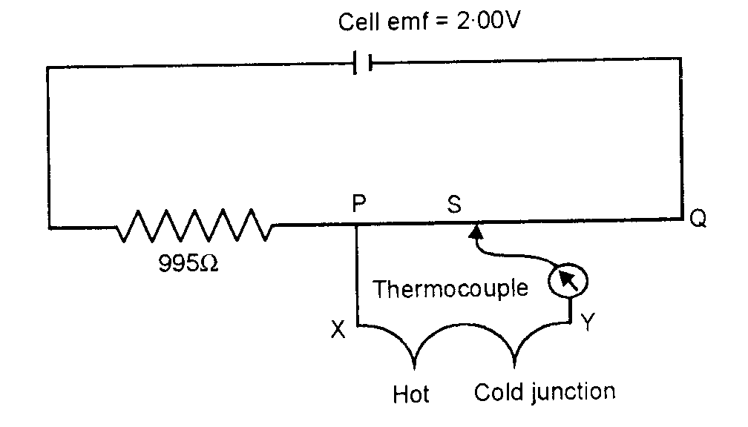
22. The circuit diagram shows the use of a potentiometer to measure a small emf produced by a thermocouple connected between X and Y. The cell of emf 2V, has negligible internal resistance. The potentiometer wire PQ is 1.00 m long and has resistance 5 Ω.The balance point S is found to be 400mm from P. Calculate the value of emf V, generated by the thermocouple. 3

23. State the Gauss’s law of electrostatics and hence using this theorem derive an expression for the electric field intensity due to a charged spherical shell. 3

24. Two similarly and equally charged spheres A and B repel each other with a force of 2 x 10 ^{–5} N. A third identical sphere C is touched with A and then placed at the mid point between A and B. Calculate the net electric force on C. 3
25. Explain the principle of working of a transformer.
11 kW of electric power can be transmitted to a distant station at (i) 220 V or (ii) 22000 V. Which of the two modes of transmission should be preferred and why? Support your answer with possible calculations. 5

26. What is meant by linearly polarized light? Which type of waves can be polarized. Briefly explain the method of obtaining plane polarized light.
Two polaroids are placed at 90⁰ to each other and the transmitted intensity is zero. What happens when one more Polaroid is placed between these two bisecting the angle between them? 5

27. With the help of a labeled diagram, explain how an npn transistor can be used as an amplifier in common emitter configuration. Explain how the input and the output voltages are out of phase by 180⁰ .

OR
Discuss the action of a pnp transistor and hence justify that it is a current operated device. 5

