Guess Paper - 2008
Class- X
Subject - Mathematicss

General instructions:- (1) All questions are compulsory.

(2) Question paper consists of 30 questions divided into four sections A, B,C and D. Section A contains 10 questions of 1 marks each, Section B is of 5 questions of 2 marks each, Section C is of 10 questions of 3 marks each and Section D contains 5 questions of 6 marks each.
(3) There is no overall choice. However, internal choice has been provided in two questions of two marks each, two questions of three marks each and two questions of five marks each.
(4) In questions on construction, the drawing should be neat and exactly as per the given measurements.
(5) Use of calculators is not permitted. However you may ask for mathematical tables.

Section – A
1. Express 0.6 as a rational number in simplest form.
2. Can we have two medians of a data?
3. Can a quadratic polynomial have no zero?
4.If the sum of first n terms of an AP is $\frac{n}{2}(3n+5)$, find its 25th term.
5. Express $\frac{\text{13}}{\text{3125}}$ in terminating decimal
6. In the given figure, XY BC. Find the length of XY
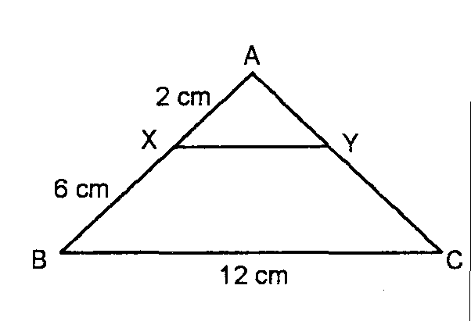

- If sum of the zeroes of the quadratic polynomial is 12 and product of them is 5, find the polynomial.
- PA and PB are tangents to the circle drawn from an external point P. CD is a third tangent touching the circle at Q and intersecting PA and PB at C and D respectively. If PB = 10 cm and CQ = 2 cm, what is the length of PC?

- Prove that: tanA (1 - sinA) = sinA cosA

- If the equation x² + 4x + k = 0 has real and distinct roots, find k.

Section – B
11. From a pack of 52 cards, a card is drawn at random. Find the
probability that the drawn card neither is a face card nor a
red card. If two red cards and two black cards are removed
from the pack, find the probability of getting a black card or
a red card.
OR
Three coins are tossed simultaneously, find the probability of getting at least one head if one coin is biased and has both the faces as head.

12Show that the points (1, —1). (5. 2) and (9, 5) are collinear

13 The 10th term of an AP is 52 and 16th term is 82. Find the 32nd term and the general term.
14. . Prove $\sqrt{\frac{1+\text{sin}A}{1−\text{sin}A}}=\text{sec}A+\text{tan}A$
15. Two vertices of an equilateral triangle are (0,0) and (3,$\sqrt{3}$).
Find the third vertex.
Section-C

- If one zero of the polynomial p(x)=3x³ – 5x² – 11x – 3 is $−\frac{1}{3}$, then find the other zeros of the polynomial.
OR
Two trains leave a railway station at the same time. The first train travels due west and the second train due north. The first train travels 5 km/h faster than the second train. If after two hours, they are 50 km apart, find their average speeds.

- The sum of n terms of two AP’s are in the ratio 7n+1:4n+27. Show that ratio of their 11th term is 4:3.

- Solve by factorization $\frac{m}{n}x^{2}+\frac{n}{m}=1−2x$.
- Draw a pair of tangents to a circle of radius 5 cm, which are inclined to each other at an angle of 60.
- Prove that $\frac{\text{sec}θ+\text{tan}θ−1}{\text{tan}θ−\text{sec}θ+1}=\frac{\text{cos}θ}{1−\text{sin}θ}$.

21. If the sum of m terms of an AP is the same as that of n terms, show that the sum of (m + n) terms of the AP is 0.
22. Prove that median divides the triangle in to two equal parts

23. Find the area of the shaded region
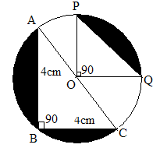

24. The wheels of a car are of diameter 80 cm each. How many complete revolutions does each wheel make in 10 minutes, when the car is traveling at a speed of 66 km/h?

25 Find the co-ordinates of the points on y-axis which is equidistant from the points (3,2) and (5,-2).

Section-D

- The hypotenuse of a right angled triangle is 20 cm. If the difference between the lengths of the other two sides is 4 cm, find the other sides.
- From a window ( h metres high above the ground) of a house in a street, the angles of elevation and depression of the top and the foot of another house on the opposite side of the street are θ and ϕ respectively, show that the height of opposite house is h(1+tanθ cotϕ).
- A toy is in the form of a cone mounted on a hemisphere of diameter 7cm. The total height of the toy is 14.5 cm. Find the volume and total surface area of the toy.
OR
A shuttle cock used for playing badminton has the shape of a cone mounted on a hemisphere.
The external diameters of the frustum are 5cm and 2 c, the height of the entire shuttle cock is 7 cm. Find its external surface area.
- Calculate the mode of the following frequency distribution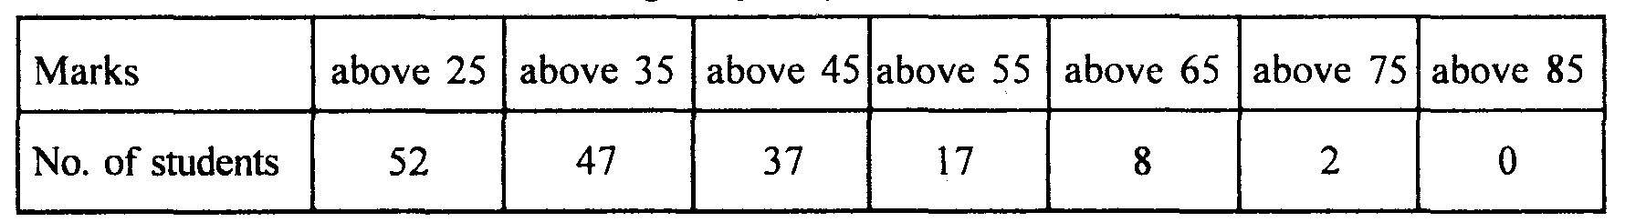
- Cards marked with numbers 3,4,5,……. 50 are placed in a box and mixed thoroughly, one card is drawn at random from the box. Find the probability that the number on the drawn card is (I) divisible by 7 (II) a number which is a perfect square..
* All the best *

