PHYSICS
Class : XII
M M :70 Time :3 h

General Instructions:
- All questions are compulsory.
- There is no overall choice. However, an internal choice has been provided in one question of two marks, one question of three marks and one question of five marks. You have to attempt only one of the choices in such questions.
- Question numbers 1 to 5 are very short answer questions, carrying one mark each.
- Question numbers 6 to 12 are short answer questions, carrying two marks each.
- Question numbers 13 to 24 are short answer questions, carrying three marks each.
- Question number 25 to 27 are long answer questions, carrying 5 marks each
- Use of calculators is not permitted. However, you may use log tables if necessary.
- You may use the following values of physical constants wherever necessary :
c = 3 x 10 ⁸ ms ^{–1}
h = 6.6 x 10 ^{–34} Js
μ ₀ = 4π x 10 ^{–7} T m A⁻¹

1. What percentage of a given mass of radioactive substance will be left undecayed after five half life periods? 1

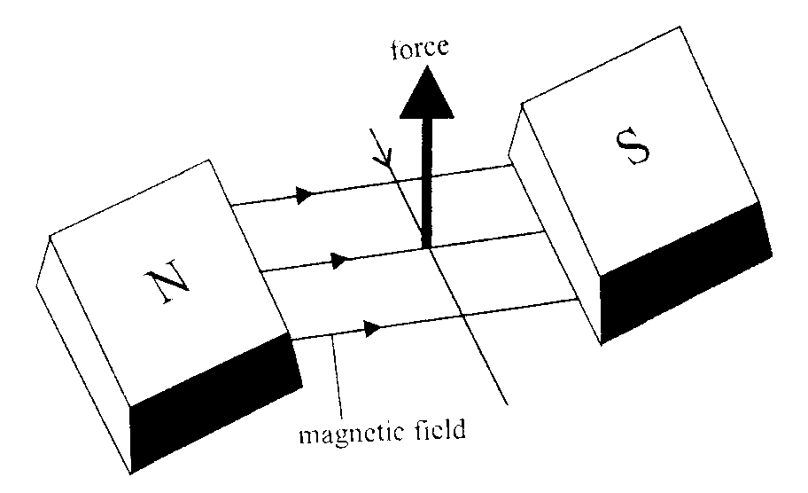
2. Name the physical quantity which has its unit JT⁻¹. Is it a scalar or a vector quantity? 1
3. As shown in the figure, a charged particle enters a uniform magnetic field and experiences an upward force as indicated. What is the charge sign on the particle? 1

4. Name a appropriate communication channel, needed to communicate a signal of bandwidth 100 kHz over a distance of 8 km. 1
5. Two plane sheets of charge densities +σ and -σ are kept in air as show in the figure. What are the electric field intensities at the points A and B? +σ 1
.B
-σ .C
6. State the Gauss’s law of electrostatics. Using this theorem, prove that no electric field intensity exists inside a hollow charged conducting sphere. 2
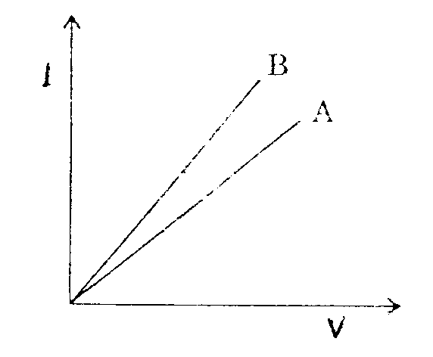
7. The voltage current graphs for two resistors of the same material and same radii with lengths L₁ and L₂ are shown on the figure. If L₁ > L₂, state with reason, which of these graphs represents voltage – current change for L₁? 2

8. A ray of light passes through an equilateral prism ( refractive index 1.5 ) such that angle of incidence is equal to angle of emergence and the latter is equal to ¾ of the angle of prism. Calculate the angle of deviation.

OR
Explain why does a convex lens behave as a converging lens when placed in water ( μ = 1.33 ) and as a diverging lens, when immersed in carbon disulphate ( μ = 1.6 ). 2
9. A coil of enameled copper wire of resistance 50 Ω is embedded in a block of ice and a potential difference of 210V is applied across it. Calculate the rate at which ice melts. Latent heat of ice is 80 cal g⁻¹. 2
10. A pn junction diode when forward biased has a potential drop of 0.5 V which is assumed to be independent of current. The current in excess of 10 mA through the diode produces a large Joule heating which damages ( burns ) the diode. If we want to use a 1.5 V battery to forward bias the diode, what should be the value of resistor used in series with the diode so that the maximum current does not exceed 5 mA? 2
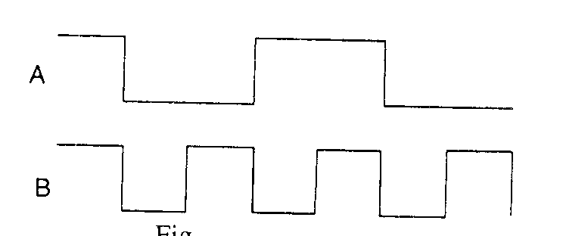
11. Two input waveforms A and B as shown in the figure are applied to an AND gate .Write the output waveform. 2

12. Establish the relation between drift velocity v_{d} of the electrons in a conductor of cross section A carrying a current I and concentration of free electrons per unit volume of the conductor being n. 2

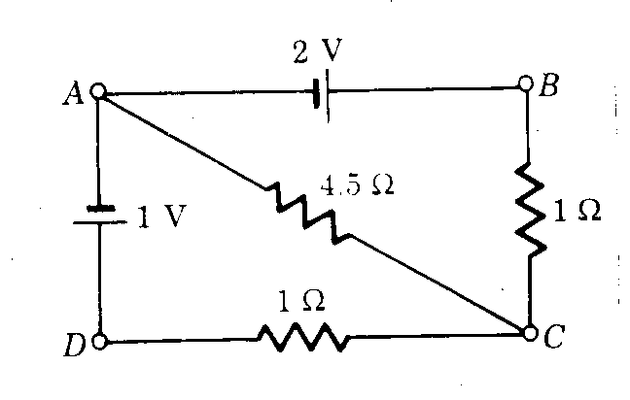
13. Calculate the current flowing in each of the resistances of the network shown in the figure. Internal resistance of the cell is negligible. 3

14. Explain the important differences between dia-, para- and ferro – magnetic substances. 3

15. State the Lenz’s law. Two identical loops, one of copper and the other of aluminum are rotated with same speed, in a uniform magnetic field acting normal to the plane of loops. State with reason, for which of the two coils (i) induced emf &(ii) induced current will be more. 3

16a. A ray of light goes from medium 1 to medium 2, velocities of light in the two media are c₁ and c₂ respectively. For an angle of incidence θ in medium 1 the corresponding angle in medium 2 is θ/2. Establish a relation between θ, c₁ and c_{2.}

b. Two polaroids are used to study polarization. One of them ( polariser ) is kept fixed and the other ( analyzer) is initially kept with its axis parallel to the polariser axis. The analyzer is then rotated through angles 45⁰ ; 90⁰ & 180⁰ in turn. How would the intensity of light coming out of the analyzer be affected for these angles of rotation as compared to the initial intensity and why? 3

17. A beam of light converges to a point on the screen. A plane parallel glass slab is introduced in the path of this beam. How will the point of convergence be affected? Draw the relevant ray diagram. 3

18. calculate the deBroglie wavelength associated with an electron of energy 200 eV. What will the change in its wavelength if the accelerating potential difference is increased to four times? 3

19. The disintegration rate of a certain radioactive sample at any instant is 4750 disintegrations per minute, 5 minute after, the rate becomes 2700 disintegrations per minute. Calculate (i) decay constant & (ii) half life of the sample. ( log₁₀ 1.760 = 0.2455 ) 3

20. Compare the energy of an electron of the deBroglie wavelength 10⁻¹⁰ m with an x ray photon of the same wavelength. 3

21. With the help of a block diagram, explain the principle f an optical communication system. Give its two advantages over the cable system.
3
22. Explain the formation of (i) potential Barrier and (ii) depletion region in a pn junction diode.
How does the width of the depletion region vary with increase in forward bias? 3
23. Explain the mechanism of the pulse code modulation with a suitable example. 3

24. Discuss the oscillator action of an LC circuit. Show that it obeys the energy conservation principle. 3

25. You are given two convex lenses of short aperture having focal lengths 4 cm and 8 cm respectively. Which one of these two will you use as an objective and which one as the eyepiece for constructing a compound microscope? Draw a ray diagram to show the formation of the image of a small object due to compound microscope. Derive an expression for its magnification.
OR
With the help of a ray diagram explain the phenomenon of total internal reflection. Obtain the relation between the critical angle and the refractive index of the medium. Draw ray diagrams to show how a right angled isosceles prism can be used to (i) deviate the ray through 180⁰ , (ii) through 90⁰ and (iii) invert the ray. 5

26. What is meant by the term ‘resonance’ in LCR series ac circuit? State the essential conditions for resonance.
A 50mH inductor, a capacitor 20μF and a 10Ω resistor are connected in series across 220 V ac source of variable frequency. Calculate (i) the resonant frequency of the circuit, (ii) current amplitude at resonance, and (iii) maximum power dissipated . 5

27. Derive an expression for the energy stored in a parallel plate capacitor, with air as the medium between the plates.
A parallel plate capacitor of capacitance 100μF is charged to 200 V. After disconnecting it from the battery, using an insulated handle, the distance between the plates is doubles. Find (i) potential difference between the plates, and
(ii) energy stored in the capacitor, after the separation between the plates has been increased. 5

