Sample Paper - 2008
Class- X
Subject - Mathematics
- In what ratio is the line segment joining the points (-2,-3) and (3,7) divided by the y-axis? Also, find the coordinates of the point of division.
- If the bisector of an angle of a triangle bisects the opposite side, prove that the triangle is isosceles triangle.
- In triangle ABC, DE is parallel to BC. Line segment CD and BE intersect each other at F. Find the ratio of the areas of triangles DFE and CFB.
- D is a point on the side BC of triangle ABC, such that Angle ADC= Angle BAC. Prove that CA/CD= CB/CA.
- ABCD is a quadrilateral in which P,Q,R and S are the points of trisection of the sides AB,BC,CD and DA respectively. Prove that PQRS is a parallelogram.
- In triangle ABC , D is the mid point of side AB and DE is parallel to BC. If BC = 5 cm, find ratio of the areas of triangle ABC and trapezium DBCE.
- Prove that the sum of the squares of the sides of a rhombus is equal to the sum of the square of its diagonals.
- State and prove area theorem. Using this theorem, prove that the area of triangle described on sides of a square is half of the area of triangle described on its diagonal.
- State and prove Pythagoras Theorem. Using this theorem Prove, AC² =AB² +BC²+2BC.BD
C
B

A

D

- ABC is a right angled triangle at B. A circle is inscribed in it. The lengths of the two sides containing the right angle are 6 cm and 8 cm. Find the radius of in-circle.
- A circle is inscribed in a triangle ABC having AB=10cm, BC=12 cm and CA= 8 cm and touching these sides at D,E and F respectively. Find AD,BE and CF.
- In the given figure O is the centre of circle, Chord PQ=16 cm, radius= 10cm. Find the length of tangents PT and QT.
T
Q
P
Q

- A cow is tied to a peg at vertex A of an equilateral triangular grass field of side 30 m by means of a 10m long rope. Find the area of field which the cow can graze.
- Three horses are tethered with 7 m long ropes at the three corners of a triangular field having sides 20m,34m and 42 m. Find the area of the field which can be grazed by the horses. Also , find the area of the field which remains ungrazed.
- An athletic track 14 m wide consists of two sections, 120m long Joining semi-
circular ends whose inner radius is 35m. find
- The distance around the track along its inner edge.
- The area of the track i.e. the shaded region.

A D

F G

49. A shuttle cock used for playing badminton has the shape of a frustum of
a cone mounted on a hemisphere. The external diameter of the frustum
are 5 cm and 2 cm, the height of the entire shuttle cock is 7 cm. find its
external surface area.
50. A building is in the form of a cylinder surmounted by a hemispherical vaulted
dome ,the building contains 17.7 m³ of air and its internal diameter is equal to the
height of the cylindrical part find the height of the building (use $π=\frac{\text{22}}{7}$)
51 AB is a line segment and M is its middle point. On one side of AB, semi-circles
have been drawn by taking AM, MB and AB as diameters. A circle has been drawn
which touches each of the three semi-circles. Prove that the radius of the circle = 1/6
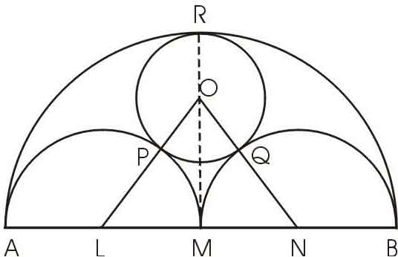
AB.

52. ABC is a right angled triangle, right angle at c . If p is the length of the
perpendicular side from c to AB and AB = c , BC = a , CA = b, Prove that :
i) pc = ab ii ) 1 = 1 + 1
p² a² b²
53. From the top of a lighthouse , the angles of depression of two ships on the
opposite sides of it are observed to be ά and β. If the height of the light house be h metres and the line joining the ships passes , through the foot of the lighthouse, show that the distance between the ships is h(tanα +tanβ)
tanα.tanβ

54. A round balloon of radius r subtends an anglesάat the eye of the obsever while the
angle of elevation of its centre is β. Prove that the height of the centre of the
balloon is rsinβcosecα/2
55. The diameter of the cross-section of water pipe is 5cm.Water flows through it
@10km/hr into a cistern which is in the form of cylinder. If the radius of the base of
cistern is 2.5m.Find the height to which the water will rise in cistern in 24 minutes.
- A cylindrical container of diameter 12 cm is filled with ice cream. The height of the
container is 15 cm. The whole ice cream is distributed among 10 customers in equal
cones having hemispherical tops. If the height of the conical portion is twice the
diameter of the base, find the diameter of the ice cream cone.
57. Prove the following identity:
58 Evaluate:
(ii) If A, B, C are the interior angles of triangle ABC, prove that

59. A bird is sitting on the top of a tree, which is 80m high. The angle of elevation
of the bird, from a point on the ground is 45⁰; the bird flies away from the point
of observation horizontally and remains at a constant height. After 2 seconds,
the angle of elevation of the bird from the point of observation becomes 30⁰.
Find the speed of the bird.
60 An aeroplane, when 3000 m high, passes vertically above another aeroplane
at an instant when the angles of elevation of the two aeroplanes from the
same point on the ground are 60⁰ and 45⁰ respectively. Find the vertical
distance between the two aeroplanes.
61. In the figure two small circles touch each other externally at the centre of the big

circle and these small circles are touched internally by a big circle with radius 4cm.
Find the area of shaded region.

62. Prove the following identities
(sin A + cosec A)² + (cos A + sec A)² = tan² A + cot² A + 7
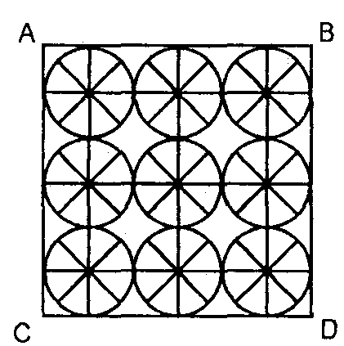
63.
64. On a square handkerchief, nine circular designs each
of radius 7 cm are made. Find the area of the remaining
portion of the handkerchief.

65. Find the median of the following distribution and deduce the 2 ogives from the given distribution: CL F 25-29 1 30-34 1 35-39 3 40-44 4 45-49 7 50-54 9 55-59 3 60-64 8 65-69 4 29.
65. From an aeroplane vertically above a straight horizontal plane the angles of
depression of two consecutive kilometer stones on the opposite sides of the
aeroplane are found to be α and β. Show that the height of the aeroplane is .
66. The angles of elevation of the top of a tower, as seen from two points A and B
situated in the same line and at distances p and q respectively from the foot of the
tower, are complementary. Prove that the height of the tower is .
67. A boat goes 35 km upstream and 55 Km downstream in 12 hrs . It can go 30 Km
upstream and 44 Km downstream in 10 hrs . Find the speed of the stream and that
of the boat in still water .

CHINMAYA INTERNATIONAL RESIDENTIAL SCHOOL
IMPORTANT QUESTIONS FOR BOARDS EXAM 2008

