Guess Paper - 2008
Class - XII
Subject – Biotechnology

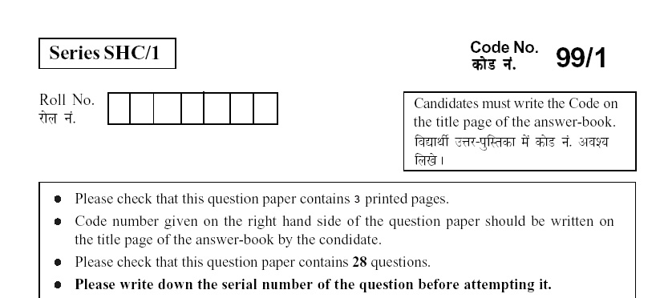

Time Allowed: 3 Hours Maximum Marks: 70

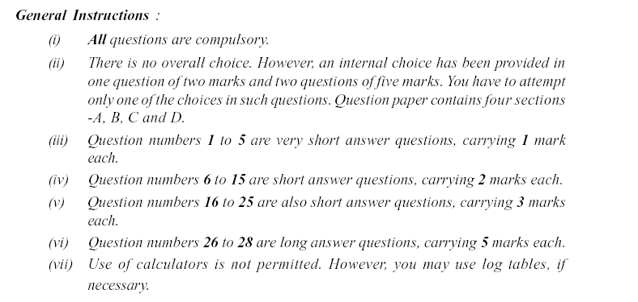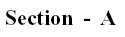
1. | What is meant by polylinker? | 1
2. | What is the role of ddNTPs in Sanger’s method? | 1
3. | What is the advantage of using baffle flask for microbial cultute? | 1
4. | Define contact inhibition. | 1
5. | You are trying to preserve cells at very low temperature using liquid Nitrogen. You are advised to add glycerol or dimethyle sulphoxide along with serum. What will happen if glycerol or DMSO is not added in this technique? | 1
 | 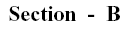
6. | Give reasons for the non-linear relationship between number of genes and number of proteins. | 2
7. | What are essential amino acids? Which one of the following is not an essential amino acid?  Ile, Leu, Val, Lys, Glu | 2
8. | Draw pBR 322 and label significant regions/genes.  OR  What is meant by:  - Shuttle vectors  - Expression vectors | 2
9. | What is achieved by the following techniques?  - Nick translation  - FISH | 2
10. | What does the BLAST acronym stand for? What are the principles involved in BLAST? | 2
11. | Why are lyophilized cultures viable for several years? | 2
12 | What is the main fear associated with the genetically engineered microorganism? | 2
13 | If the bacterial culture contains 10⁴ cells/ml at t₀ and 10⁹ cells/ml after 4 hours, calculate its specific growth rate and doubling time. | 2
14. | 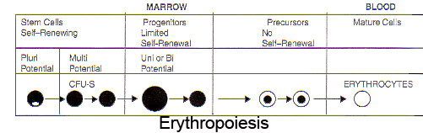  What is the main difference between pluripotential, multipotential and unipotential cells? | 2
15. | Give one difference between primary metabolites and secondary metabolites in plants. Name a secondary metabolite produced by Dioscorea deltoidea, which is used as antifertility drug. | 2
 | 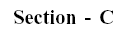
16. | Discuss the four categories of non-covalent interactions involved in organizing the structure of protein molecules. | 3
17. | Which features should vectors possess to serve as a vehicle to carry a foreign DNA sequence into a given host cell? | 3
18. | - What are the advantages of producing proteins in the milk?  - List down the factors on which the exact details of the purification scheme for any given protein will depend.  - In aqueous two-phase partition, which one is the dense phase? | 3
19. | How nested DNA fragments are synthesized using Sanger’s method? | 3
20. | - What are contigs?  - Discuss the method followed in random shotgun sequencing.  - What is the chromosome number of Saccharomyces cerevisiae? | 3
21. | - Expand NCBI.  - Classify the resources available from the NCBI.  - What kind of information does Locus Link carry? | 3
22. | Draw a neat and well labeled diagram of the basic design of a fermentor. | 3
23. | - How can virus-free plants be produced?  - Name a chemical that is used to encapsulate embryos to prevent desiccation.  - Name a chemical that acts as ‘fusogen’ in protoplast fusion. | 3
24. | Discuss about four equipments that are required for animal cell culture. | 3
25. | - Give another name for Anti – CD3 MoAb  - Monoclonal antibodies can be produced for therapeutic purposes. Explain, giving an example. | 3
26. | - Expand RFLP.  - What is the advantage of MCS?  - Name two phages that have been extensively modified for development of cloning vectors.  - What are cosmids?  - What do BAC vectors contain? | 5
27. | How will you establish the fact that a glutamic acid was replaced by Valin in scHb? Discuss the technique in detail. | 5
 | OR
 | Diagrammatically represent the two dimensional gel electrophoresis.
28. | - Which bacterium is considered as natural genetic engineer in plants? Why?  - Discuss a general strategy for transforming plants using this ‘natural genetic engineer’.  - What is meant by biolistics? | 5
 | OR
 | Discuss five potential and remarkable examples of plants that are used as bioreactors.

