Guess Paper - 2008
Class - XII
Subject – Biotechnology
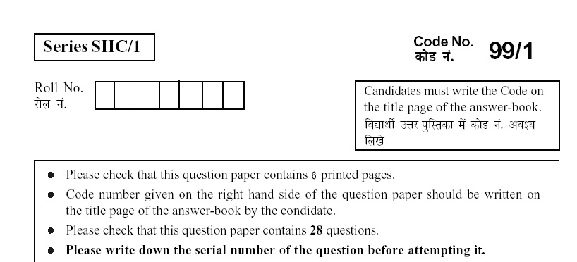

Time Allowed: 3 Hours Maximum Marks: 70
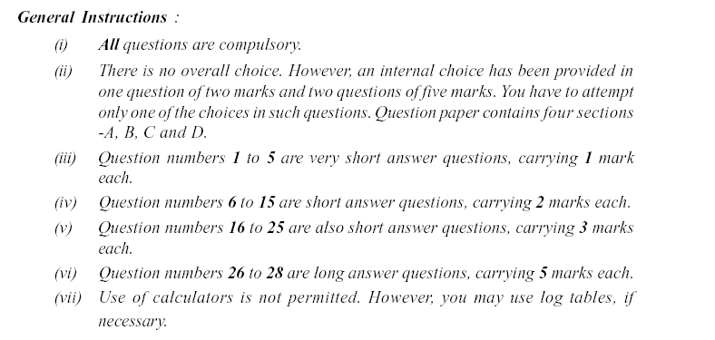
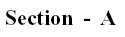
1. | Which two techniques are combined to achieve two-dimensional electrophoresis? | 1
2. | An E. coli produce intracellular enzyme A of molecular weight 1,00,000 Daltons at a level of 3000 molecules per cell under optimum conditions. To purify 1 gram of enzyme A, how many bacterial cells are required? | 1
3. | Write the complementary sequence of the given polynucleotide.  3’ A C H G S N V R W 5’ | 1
4. | Give one difference between ‘somaclones’ and gametoclones’. | 1
5. | Name the gene introduced in transgenic tomato for insect resistance. | 1
 | 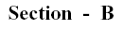
6. | Discuss insertional inactivation in pBR 322. | 2
7. | Study the following enzyme (Protein) purification table and answer the questions that follow.  - What is the yield of active protein from crude extract?  - Which step in this purification is most effective and why?  - Which step in this purification is least effective and why? | 2
  Procedure | Total Protein (mg) | Activity (units)
  Crude extract | 1000 | 2000
  Precipitation (Salt) | 200 | 1890
  Ion-exchange chromatography | 100 | 1500
  Gel Chromatography | 90 | 1400
  Affinity Chromatography | 2 | 1000
8. | How does the defense mechanism of a bacterium work against a bacteriophage? | 2
9. | Who devised the “whole genome shotgun strategy”? How does it work? | 2
10. | Even if we know where the genes are in the genome, it is not entirely clear how to count them. What reason do you attribute to this observation?  OR  What is meant by in silico gene prediction? Why do you think it is unreliable? | 2
11. | 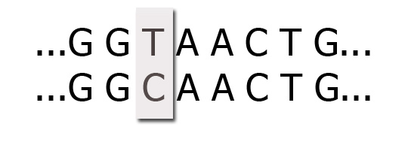  - Name the phenomenon represented by the highlighted difference between the two polynucleotide from two different DNA.  - Interpret the given SNP map and explain how this can be used to predict medicine response.  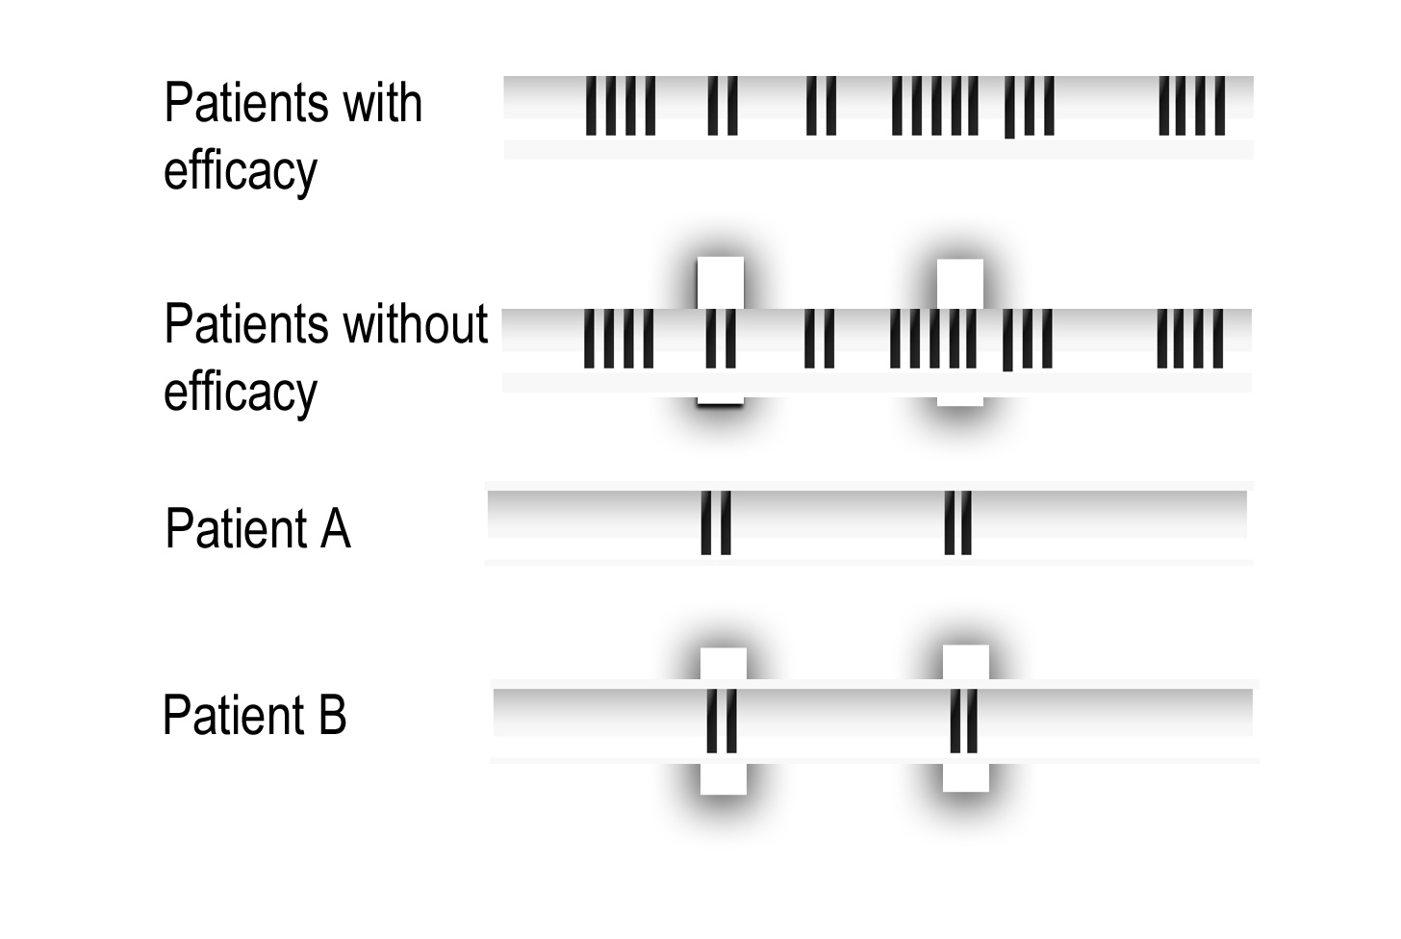 | 2
12 | How is aeration and mixing ensured in:  - laboratory microbial culture  - Microbial culture in large scale bioreactors | 2
13 | 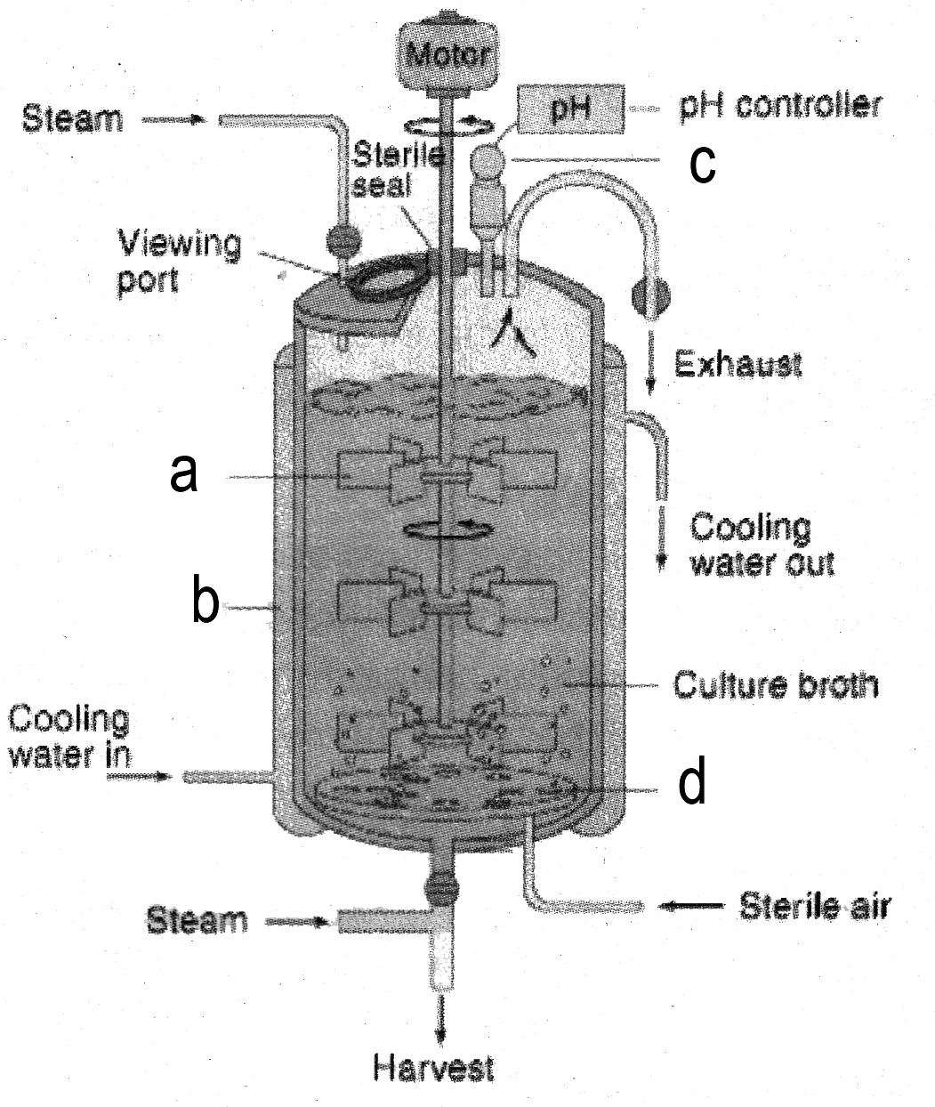  - Label parts a, b, c and d.  - What is the role of part d? | 2
14. | Sketch a somatic seed and label any three parts. | 2
15. | - Define ‘cell lines’  - Write one difference between finite cell line and continuous cell line.
 | 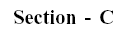
16. | Nature has found a useful folding pattern which can cause hydrolysis of substrates. Discuss what is attained by this folding pattern in chymotrypsin. How does it help in hydrolysis? | 3
17. | - Draw an outline of mass spectrometer.  - A protein with a molecular weight of 10,000 contains 5, 4, 3, 2, or 1 +^{ve} charges in its ions. At what m/z the mass spectrometer detects the protein ions?  - Name two ionization methods used in mass spectrometer. | 3
18. | - Name three enzymes used in rDNA technology and mention their specific roles.  - What are plasmids? | 3
19. | 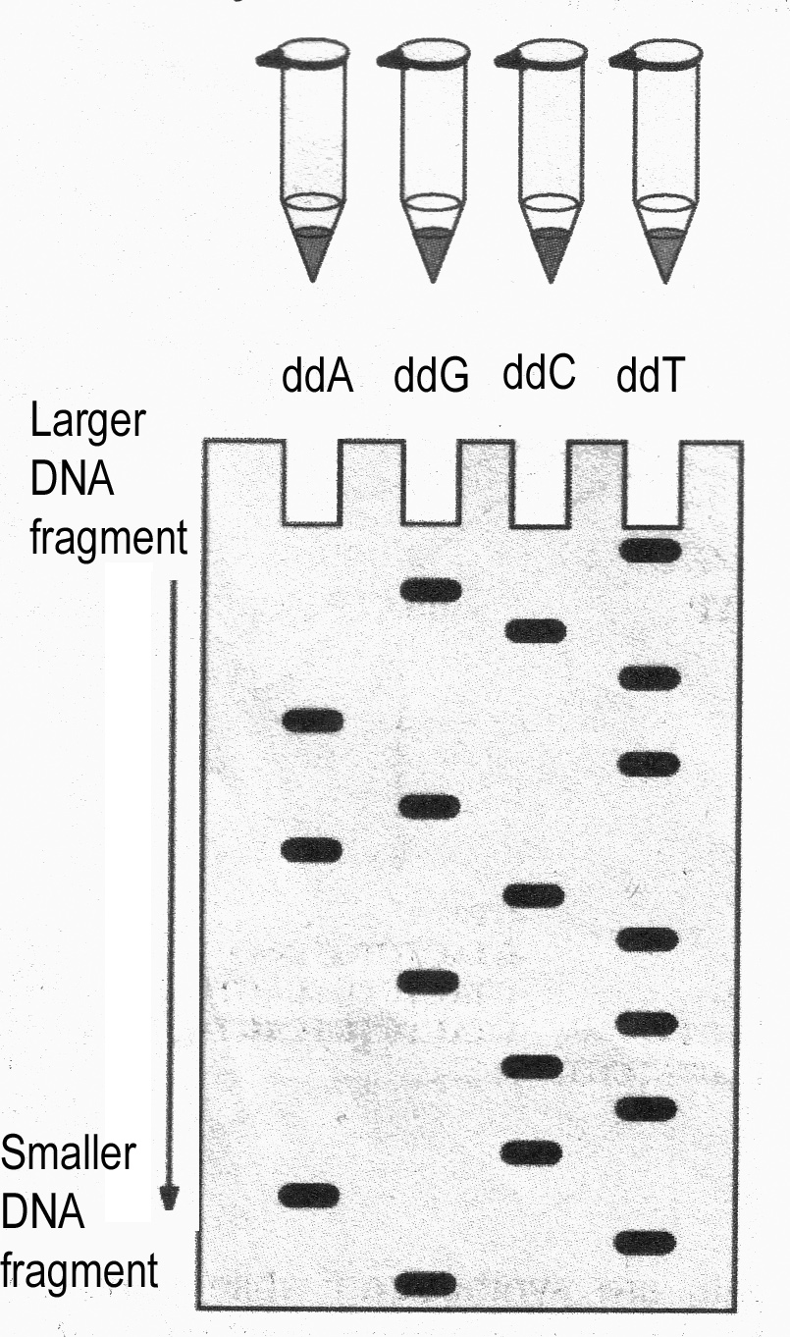  - What technique is depicted in the above diagram?  - Based on the information available from the autoradiograph write the sequence of bases of both coding and non-coding strands of DNA used.  - What is the role of ddNTPs in this technique? | 3
20.
  a. | Give the three letter and one letter codes of the following amino acids.  - Glutamic acid  - Asparagine / Aspartic acid  - Unspecified aminoacid
  b. | If you are given a sequence without any label, how will you find out  whether it is a DNA, RNA or Protein sequence?
21. | - List down the steps involved in isolation of the desired microbial product after completion of fermentation.  - Suggest two methods of preserving microbial strains. | 3
22. | You are planning to culture three types of microbes requiring different types of culture procedures. Explain three such methods giving the basis of selection of methods. | 3
23. | List down the steps involved in the basic technique of plant tissue culture. | 3
24. | - What is meant by i) Explant and ii) Callus  - Write three uses of callus culture.  - Write four uses of suspension culture. | 3
25. | - What are the medical application of the following:  - tPA  - Monoclonal Antibodies  - Erythropoietin  - FSH  - Factor VIII  - Factor IX  - Expand:  - ICM  - FGH  - PGDF | 3
26. | - Differentiate between subunit, domain, and epitop.  - List the four categories of non-covalent bonds involved in protein folding.  - Which technique did Linus Pauling and G. N. Ramachandran use for studying the 3-D shapes of proteins?  - Name the catalytic triad in subtilisin. | 5
27. | - List down the basic requirements of a PCR reaction.  - Discuss the basic steps involved in a PCR amplification cycle.  - Draw diagrams to illustrate PCR reactions. | 5
 | OR
- Discuss the procedure of Southern hybridization technique.
- Draw diagrams to illustrate Southern hybridization.
- What do you call variations of Southern hybridization developed for
- RNA and
- Proteins
28. | - List down the characteristics of ICM cells that can be exploited in embryonic stem cell culture.  - How the differentiation of ES cells into lineage-restricted cells can be accomplished?  - How could a chimeric mouse be created?
 | OR
- Explain hybridoma technology in the production of monoclonal antibodies.
- How do monoclonal antibodies differ from polyclonal antisera?
- Write another use of monoclonal antibodies than detection of infectious diseases like hepatitis and AIDS.

