Informatics Practices
CLASS-XII

Max. Marks : 70 Duration : 70

General Instructions
- The question paper is divided into three sections.
- Section – A consists 30 marks.
- Section – B and Section – C are of 20 marks each.
- Answer the questions after carefully reading the text.

---------------------------------------------------------------------------------------------------------------------

Section – A

- Answer the following questions :
- Write the differences between one-tier and two-tier computing model. 2

- Give any four application areas of Databases? 2

- What are the difference between software, Hardware & Firmware ? 2

- Explain what is meant by Generalization and Specialization ? 4

- Answer the following questions in the references of Oracle :
(a) How is the primary key Constraint different from the Unique Constraint? 2

(b) Differentiate between Decision Control and Looping Control Structure in context
with PL/SQL? 4

(c) What are Cursor attributes? What do these attributes evaluate to when associated with IMPLICIT and EXPLICIT cursors? Write a PL/SQL block to find the factors of a number entered by user. 4

- Answer the following questions in the references of Visual Basic:
(a) What do you understand by option explicit statement? How and where we can set it? 2

(b) Explain the use of Access Keys and Shortcut Keys for menus? How can you add a menu separator to you menu. 2

(c) Define Recordset and all its types. How we can apply the recordset in a project? 4

(d) What is Common Dialog Box control? How it is applied in your program? 2

Section – B

(VISUAL BASIC)

- Read the following case study and answer the questions that follow:
Home Decor Furnishing is a company that manufactures and sells various furnishing items in three qualities (Economy, Business and Elite) and three sizes (Kids, Adults and Giants). The cost of each furnishing item is calculated on basis of a Base Cost, which is the cost of the item in Business quality and Adults size. The cost is changed by – 10% and +20% in case of Economy and Elite quality respectively. Similarly the cost is changed by –5% and +15% in case of Kids and Giants sizes respectively. The interface for gathering users choice is as given below :

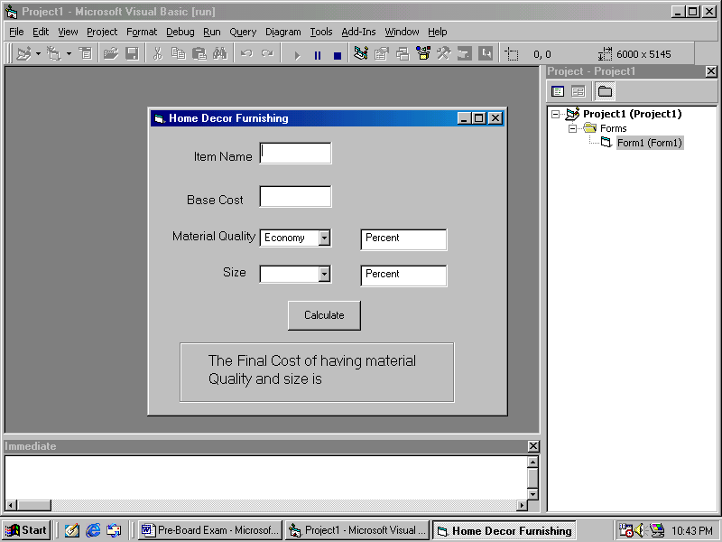
Add the following functionality to the interface:
- The combo box cmbquality must contain economic, Business and Luxury when the form loads in the memory. 2
- The combo boxes cmbquality and cmbsize should respectively be set to default values of Economy and Adults initially. 1
- What is the caption of cmdcalculate button and lblsize. 1
- When a user chooses a choice other than the default choices, the labels lblchangeforquality and lblchangeforsize should display the message.
‘Percent Increase / Decreases in cost ....% according to the logic explained above. 3
- When user clicks the Calculate button the final message should be displayed in the label lblyourchoice as indicated in the form image. 3

- Read the following text and answer the questions that follow:
- A student of ABCD School, Davis Mathews wanted an application to find Even or Odd out of a given number. He had written the following code snippet and he is unable to correct some of the errors in the code. You are requested to help him in correcting the code segment. Find the errors and erwrite the corrected code underlining the correction made.
Dim n as integer
N = val(txtnumber)
If n mod 2 = 0
Msgbox “It is an Even”
Else
Msgbox “it is an odd”
Endif 2

- What is the output of the following programs:
Dim i as integer, num as integer
For i = -10 to 5 step 3
If i mod 2 = 0 then
Num = num + i
End if
Print num
Next 2
- Discuss various types of errors that may encountered in VB? Specify with examples? 3
- What is ADO? How is it useful as a database access technology? Specify the steps to connect ADODC to the oracle and specify recordsource? 3

Section – C

(ORACLE SECTION)

- Read the questions given below and answer accordingly :
- Write the output produced by the following part of code in PL/SQL :
DECLARE
Y NUMBER;
X NUMBER;
BEGIN
Y:=2;
FOR X IN 1..5
LOOP
Y:=X+(Y*2);
DBMS_OUTPUT.PUT_LINE(Y);
END LOOP;
END; 2

- Find the error(s), if any, in the following code :
DECLARE
v_empno NUMBER[4];
v_empname VARCHAR2(20);
begin BOOLEAN :=’True’
START
SELECT empno,ename,salary
into v_empno,v_ename
FROM emp
FOR empno = 1234 and 2345 2
END

- What happens when you close and then re-open a cursor? Create a view VU_EMP2 which should include columns Empno, Ename and Deptno from the table Emp and change the column headings as Empnumber, Employee, Department. 3

- Write a PL/SQL Function ISODDEVEN to return value True if the number passed to it is odd else will return False. 3

- (a) Answer the following questions based on the following Employee Table :

Column Name | Data Type
ID | Number(4)
First_Name | Varchar2(30)
Last_Name | Varchar2(30)
Email_ID | Varcharr2(10)
Salary | Number(9,2)

- Write the difference between a Cursor and a Trigger. 2
- Write a PL/SQL procedure EDSAL to find out the salary of an Employee with ID=1234 is less than 5000 or not. If it is less then 5000, modify the salary of employee by increasing it by 15%. 4
- Write a PL/SQL block to create a trigger to display a Hello message before each insert operation on the table. 4

