Informatics Practices
CLASS-XII

Max. Marks : 70 Duration : 70

General Instructions
- The question paper is divided into three sections.
- Section – A consists 30 marks.
- Section – B and Section – C are of 20 marks each.
- Answer the questions after carefully reading the text.

---------------------------------------------------------------------------------------------------------------------

Section – A

- Answer the following questions :
- Write the differences between one-tier and two-tier computing model. 2
- Give any four application areas of Databases? 2
(c) What do you understand by the term SDLC ? Name its essential components. 2
(d) What are conditional or decision control statements ? Name the two conditional statements used in Visual Basic. 2
(e) Explain the terms ODBC and OLE-DB. 2

2. Answer the following questions:
(a) What is a syntax error in the context of a program? Give an example. 2
(b) Differentiate between Do While loop and Do Until loop of Visual Basic giving a suitable example of each. 2
(c) What do you understand by the term Record Source of an
ADO Data Control? 2
(d) Define the term Library Functions in Visual Basic. Name the different categories of library functions available in Visual Basic. Give the usage and syntax of any two library functions. 4

3. Answer the following questions :
(a) Differentiate between DML and DCL giving suitable example in each case. 2
(b) What is NULL value ? What is the result of an arithmetic operation containing NULL value? 2
(c) What is the use of a Sub-Query ? Which query gets executed first, the parent query or the sub-query? 2
(d) How is a Before trigger different from After trigger. 2
(e) What is the difference b/w Function and Procedures? What are actual and formal parameters? 2

Section – B

(VISUAL BASIC)

(4) Read the following case study and answer the questions that follow:
Home Decor Furnishing is a company that manufactures and sells various furnishing items in three qualities (Economy, Business and Elite) and three sizes (Kids, Adults and Giants). The cost of each furnishing item is calculated on basis of a Base Cost, which is the cost of the item in Business quality and Adults size. The cost is changed by – 10% and +20% in case of Economy and Elite quality respectively. Similarly the cost is changed by –5% and +15% in case of Kids and Giants sizes respectively. The interface for gathering users choice is as given below :

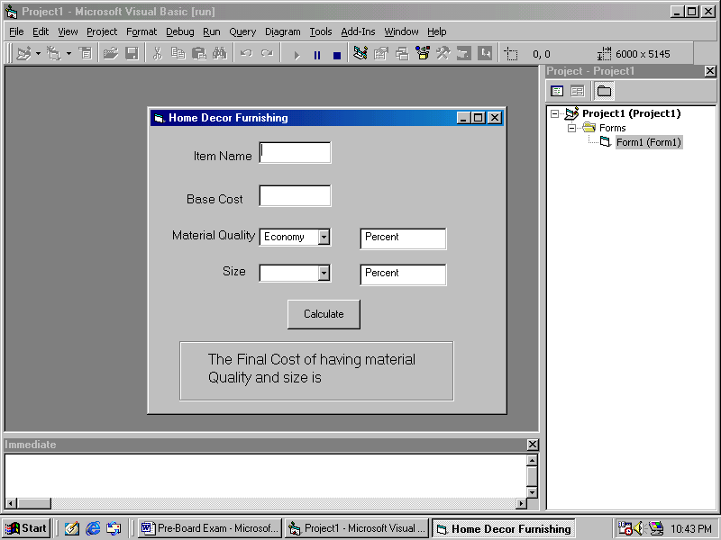

Add the following functionality to the interface:
- The combo box cmbquality must contain economic, Business and Luxury when the form loads in the memory. 2
- The combo boxes cmbquality and cmbsize should respectively be set to default values of Economy and Adults initially. 1
- What is the caption of cmdcalculate button and lblsize. 1
- When a user chooses a choice other than the default choices, the labels lblchangeforquality and lblchangeforsize should display the message.
‘Percent Increase / Decreases in cost ....% according to the logic explained above. 3
- When user clicks the Calculate button the final message should be displayed in the label lblyourchoice as indicated in the form image. 3

5. Answer the following questions:
(a) Find the errors from the following code segment and rewrite, the corrected code underlining the correction made: 2

Private Sub Command1_Click()
Dim p = 1 As Integer, i As Integer
For i = 1 UpTo 50
p = p + 1
If p = 5 Then
p = 1
Display "P is equal to 5"
Else
Display "P is not equal to 5"
Loop i

End Sub

(b) Find the Output of the following code segment: 2
Dim work As Integer, I As Integer
work = 10
I = 0
Do While work < 20
Print work * I
I = I + 2
If I = 8 then
work = 20
Else
work = work - 3
End If

Loop

(c) Rewrite the following code segment using For...Next instead of Do...While: 2 Private Sub cmdFactorial_Click ()
Dim factorial As Long
Dim counter As Integer
Dim strAnswer As String
counter = Val (txtFactorial.Text)
factorial = counter
Do While counter > 1
counter = counter - 1
factorial = factorial * counter
Loop
Print "Factorial of " & txtFactorial.Text & " is " & factorial

End Sub

(d) Write a Visual Basic function that takes an integer argument N and returns the sum of all even numbers less than the given number N. 4

Section – C

(ORACLE SECTION)

- Read the questions given below and answer accordingly :
- Write the output produced by the following part of code in PL/SQL :
DECLARE
Y NUMBER;
X NUMBER;
BEGIN
Y:=2;
FOR X IN 1..5
LOOP
Y:=X+(Y*2);
DBMS_OUTPUT.PUT_LINE(Y);
END LOOP;
END; 2

- Find the error(s), if any, in the following code :
DECLARE
v_empno NUMBER[4];
v_empname VARCHAR2(20);
begin BOOLEAN :=’True’
START
SELECT empno,ename,salary
into v_empno,v_ename
FROM emp
FOR empno = 1234 and 2345 2
END

- What happens when you close and then re-open a cursor? Create a view VU_EMP2 which should include columns Empno, Ename and Deptno from the table Emp and change the column headings as Empnumber, Employee, Department. 3

- Write a PL/SQL Function ISODDEVEN to return value True if the number passed to it is odd else will return False. 3

7. Answer the questions based on the table Employee given below :
Table : Sports
Column Name | Data Type | Size | Constraint
SPORTCODE | NUMBER | 5 | PRIMARY KEY
SPORTNAME | DATE |  | NOT NULL
INSTRUCTOR | VARCHAR2 | 50 | NOT NULL
FEE | NUMBER | 4 | Range 500-3200

(a) Write the SQL command to create the table SPORTS including the constraints. 2
(b) i)Write a SQL statement to display the sportcode and sportname of all sports whose fee is same as that of VolleyBall. 1
ii) Write a PL/SQL block that uses a cursor to display all the records from Sports table. 2
(c) Write a PL/SQL function that uses the Hero’s formula: [ Area=(s*(s-a)*(a-b)*(s-c))^{1/2} ]
to calculate the area of a triangle, given that the sides of the triangle are a,b and c respectively and S=(a+b+c) /2. The function should take the three sides as parameters and return the area. 3
(d) Write a trigger that displays following message every time a record is added in Relation SEMINAR. 2
A seminar on <Topic> is scheduled on <date>
Relation: Seminar (Code, Date, Topic, TargetDesignation)

