- Please check that this question paper contains 4 printed pages.
- Code number given on the right hand Top should be written on the title page of the answer-book by the candidate
- Please checkthat the question paper contain 21 questions
- Please write down the serial number of the question before attempting it
- Use only Royal Blue ink and HB pencils.

Informatics Practices
XII
Time allowed : 3 hours Maximum Marks : 70
General Instructions :
- This question paper contains three sections A, B and C.
- Section A, section B and section C are compulsory for all candidates.
- All parts of the question should be attempted at one place.

Section A
- Answer the following question :
(a) What is database ? What is RDBMS? 2
(b) What is data warehousing? What is its significance? 2
(c) What is interface? How are front end and back end related to each other in an information system? 4
(d) Discuss the importance of Cost- benefit analysis? 2

- Answer the following question :
(a) What are the different types of database connectivity in Visual Basic? 4
(b) What is data-report? What is its significance? 2
(c) What are the difference between references and components? 2
(d) What are library functions? Name 4 such function. 2

- Answer the following question :
(a) What is a cursor? What are the different types of cursors? 4
(b) Define the following : 2
- Joining
- Attribute
(c) Distinguish the following in terms of PL/SQL 4
- Procedure and Function
- Triggers and Procedure
Section B
- Sai Institute of technology, an institute for higher studies is thinking of launching an online forum, that can help the candidates to fill-up the admission forms digitally.
The requirement specification is as under.
- Candidate opting for MCA will be charged for library, Mess, Hostel Charges and Lab. Charges, whereas candidates opting for MBA will be charged for all charges accept Lab. charges.
- The charges will be entered into the following textboxes :
Txtlibcharges
TxtMess
TxtHostel
Txtlabcharge
And should be added and displayed with a Proper message on clicking the command button “calculate”.
- On clicking the “Clear” button all the controls of the form should be cleared
(txtname, optMba, optMca, chkLib, chkMess, chkhostel, chkLabCharges,
Txtlibcharges, TxtMess, TxtHostel and Txtlabcharge)

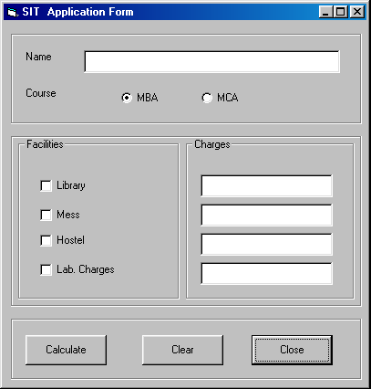
The form Follows:

Now answer the following questions :
(a) Provide the solution for the requirement 2. 2
(b) Provide the solution for the requirement 3. 2
(c) Write code for optMba and optMca so that the given requirement 1 can be met, by checking all the check boxes if optMca is selected and by checking all check boxes accept chkLabCharges and disabling the textbox txtLabCharges if optMba is selected. 4
(d) Suggest 2 alternative codes for “Close”. 2

- Write the output of the following code snippet.

(a) Private Sub cmdgetresult_Click() 2 ½
Dim a As Integer, b As Integer
b = 5
For a = 1 To 5 Step 1
If a < b Then
Print a
Else
Print b
End If
b = b - 1
Next
End Sub

(b) Private Sub cmdgetresult_Click() 2 ½
Dim a As Integer, b As Integer
b = 4
For a = 1 To 5 Step 1
Print b Mod a
b = b - 1
Next
End Sub

(c) Private Sub cmdgetresult_Click() 2 ½
Dim a As Integer, b As Integer, c As Integer
a = 5
b = 3
For c = 1 To 5 Step 1
a = a + b
b = b - 1
Next
Print a
End Sub

(d) Private Sub cmdgetresult_Click() 2 ½
Dim a As Integer
For a = 1 To 10 Step 2
Print "The no. is " & a
Next
End Sub

Section C
- Answer the following question
- Write the SQL Statement to create the following table : HotelRoom 2
Columns | Data Type | Size | Constraints
RoomNumber | Number | 5 | Primary Key
RoomType | Varchar2 | 20
RoomStatus | Varchar2 | 8
(b) Write a PL/SQL function that takes RoomType as Parameter and returns the number of vacant rooms. 4
(c) Write a PL/SQL block to insert data into the above table HotelRoom. 4

- Answer the following question:
(a) Write a trigger to show the “update begin” and “update completed” message when any field is updated in the table HotelRoom. 4
(b) Write a SQL Query to show all the persons who are in emp table and working as salesmen and having salary more than 2500. 2
(c) Write a PL/SQL procedure to generate the amount in rupees, when value of dollar is supplied along with the dollar amount as IN parameter. 4

