Guess Paper - 2008
Class – XI
Subject - INFORMATICS PRACTICES

Time allowed : 3 hours Max. marks : 70

Note :
- This question paper is divided into 3 section.
- Section A consists of 30 marks
- Section B and Section C are of 20 marks each.
- Answer the questions after carefully reading the text.

SECTION - A

- Answer the following questions :
  - What is the difference between Hardware, Software & Firmware? 2
  - What is MICR? Differentiate between OCR and OMR? 2
  - What are various types of Operating System ? 2
  - What is the difference between Interpreter & Compiler ? 2
  - What is an Operating System? What are its Function? 2

- Answer the following questions :
  - What do you mean by the term Word Wrapping ? 2
  - What is meant by Text Alignment ? 1
(c) Describe Page Set Up Dialog Box, its need, utility with Diagram. 3
OR
Describe Font Dialog Box with its need, utility with Diagram.
- What is CBIS ? What is its role in an organization ? 2
- What is Event Driven Programming ? How is it different from Traditional Programming approaches ? 2

- Answer the following questions :
  - What is the difference between SDI & MDI Interface ? 2
(b) What is the similarity between option buttons and check boxes ? 2
(c) What are the files that are saved when a project is saved in Visual Basic ? 1
- How is a variable different from a constant ? 1
- What are type-declaration characters ? 2
- What do you understand by Scope & Lifetime of a variable ? 2

SECTION - B

- Answer the following questions :
  - Both Picture Box & Image Box controls are used to display graphics ? How are these two different? 2
  - What are Access Key? What is their significance ? How can you assign an Access Key (Explain with suitable example)?. 2
  - Write the code for the following:- 6
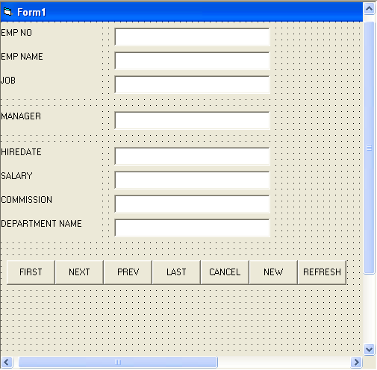

The form details are given in the following table :
Object or Control Type | Object Name | Description
Form Label | Frm1  lblEMPNO  lblEMPName  lblJOB  lblMANAGER  lblHIREDATE  lblSALARY  lblCOMMISSION  lblDEPTNAME | The Main Form Object
Text Box | txtEMPNO  txtEMPNAME  txtJOB  txtMANGER  txtHIREDATE  txtSALARY  txtCOMMISSION  txtDEPTNAME | To enter name of Employee No  To enter name of emp.  To enter Job of emp  To enter manager of employee  To enter Hiredate of employee  To enter salary of employee  To enter commission of emp  To enter dept name of emp
Command button | cmdFirst  cmdNext  cmdPrev  cmdLast  cmdCancel  cmdNew  cmdrefresh | To go to first record  To go to next record  To go to prev record  To go to last record  To cancel the entries  To add new record  To refresh the record

5. Answer the following questions :
(a) What do you mean by Guard Code ? 2
(b) Enlist the steps required for a program development ? 2
(c) How many types of users work on Database Systems ? 2
(d) What are the various data models available for Database Systems ? 2
(e) What is the need for Normalization ? Define First, Second and Third Normal Form ? 2

SECTION - C

6. Answer the following questions :
(a) Differentiate between DDL and DML Commands ? 2
(b) Write a Query to display employee number, name, salary and sal*12 as “Annual Salary” whose commission is Not Null from table emp? 2
(c) Write a Query to display the name of employee whose name contains ‘A’ as third alphabet ? 2
(d) Write a Query to display name, job, salary and hiredate of employees who are hired between May 20, 1981 and Dec. 31, 1991. Order the Query in ascending order of Hiredate? 2
(e) Write a Query to display the difference of highest & lowest salary of each department having maximum salary > 4000 ? 2

7. Answer the following questions :
(a) Display names and average order value for customers whose average order value is more than at least one average ordervalue grouped by customers ? 2
(b) Create a sequence that generates random numbers between range 50 – 100? 2
(c) Write the code to create the following table :- 6
ID | FIRSTNAME | LASTNAME | USERID | SALARY
1 | DIM | JOSEPH | JDIM | 5000
2 | JAGANNATH | MISHRA | JNMISHRA | 4000
3 | SIDDARTH | MISHRA | SMISHRA | 8000
4 | SHANKAR | GIRI | SGIRI | 7000
5 | GAUTAM | BUDDHA | BGAUTAM | 2000
Write the code to do the following tasks :-
  - Single value insertion
  - Multiple value insertion
  - Update userid JDIM to JJOHN
  - Update firstname of DIM to JOHN
  - Update lastname from GIRI to SHARMA
  - Update userid from SGIRI to SSHARMA
  - Alter table & add DOB column in table
  - Alter table add EMAILID with size 30 in table.

--x--

