Sample Paper – 2008
Class: - X
Subject - Mathematics

Maximum Marks: 80 Time: 3 hours
General Instructions:
- All questions are compulsory.
- This question paper consists of 30 questions divided into four Sections A, B, C and D. Section-A consist of 10 questions of 01 marks each, Section -B consists of 5 questions of 02 marks each, Section - C consist of 10 questions 03 marks each and Section – D consist of 5 questions 06 marks each.
- All questions in section – A are to be answered in one ward, one sentence or as per the exact requirement of the question.
Section – A
- For what value of k ,does the equation 3x² – 4 k x + 12 = 0 have equal roots?
- Sides of two similar triangles are in the ratio 4 : 9. What are the Areas of these triangles?
- If $\text{cos}θ=\frac{4}{5}$ and $θ+φ={\text{90}}^{0}$. Find the value of $\text{sin}φ$.
- Find the value of k, if the points (2, 3), (6, - 3) and (4, k) are collinear.
- In the figure given below, AQ and AR are a tangent to the circle drawn from an external point A. CB is third tangent touching the circle at P. If AQ=15 cm, and CP=4cm.What is the length of AC.
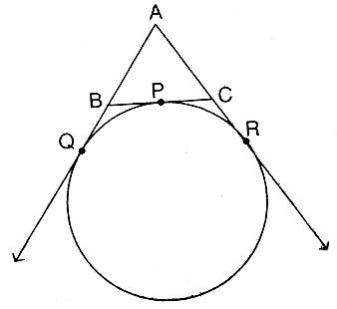
- A pair of dice is tossed once. What is the probability of getting a doublet (same number on both dice)?
- For the polynomial$3x^{2}−5x+1$, what is the sum of zeros?
- Find the condition that if the linear equations $\text{lx}+\text{my}=n$ and $\text{ax}+\text{by}=c$have unique solution.
- State the Euclid’s Division Lemma.
- The n^{th} term of an A.P is a_{n ,} whose first term is ‘a’. Express the sum of n^{th} term in terms of a_{n}, a and n.
Section – B
- Without using trigonometric table, evaluate: $\frac{\text{sin}{\text{50}}^{0}}{\text{cos}{\text{40}}^{0}}+\frac{\text{cos}\text{ec}{\text{40}}^{0}}{\text{sec}{\text{50}}^{0}}−4\text{cos}{\text{50}}^{0}\text{cos}\text{ec}{\text{40}}^{0}$
- In given figure A, B and C are points on OP, OQ and OR respectively such that $\text{AB}‖\text{PQ}$ and $\text{AC}‖\text{PR}\text{.}$ Show that $\text{BC}‖\text{QR}\text{.}$
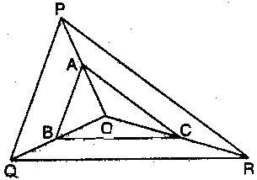
- What is the probability that a leap year contains (a) 53 Sundays (b) 53 Sundays and 53 Mondays?
Or
Two coins are tossed simultaneously. Find the probability of getting (a) two heads
(b) at least one head.
14. If the distances of (x, y) from (5 ,1) and ( - 1, 5) are equal , prove that 3x = 2y
15. Find the sum of all numbers between 700 and 950 which are multiple of 5.
Section – C
- Prove that $\sqrt{7}$ is an irrational numbers.
- Students of a class are made to stand in rows. If one student is extra in a row, there would be 2 rows less. If one student is less in a row, there would be 3 rows more. Find the number of students in the class.
Or
In a flight of 600 km; an aircraft was slowed done due to bed weather. Its average
speed for the trip was reduced by 200 km/hr. and the time of flight increased by 30
minutes. Find the duration of the flight.
- Divide $−x^{3}+3x^{2}−3x+5$ by $−x^{2}+x−1$, and verify the division algorithm.
- If cosθ + sinθ = √2 cosθ , show that cosθ – sin θ = √2 sinθ
Or
If sinθ + sin²θ = 1 , prove that cos²θ + cos⁴θ = 1
20. Solve x and y: 6( ax + by ) = 3a + 2b ; 6( bx – ay ) = 3b – 2a
Or
A man travels 370km partly by train and partly by car. If he covers 250km by train
and the rest by car, it takes him 4 hours. But if he covers 130km by train and the
rest by car, it takes him 18 minutes longer. Find the speed of the train and that of
the car.
21. Determine the ratio in which 2x + 3y – 30 = 0, divides the line segment joining
A(3,4), and B(7,8) and what point.
22. The difference between the 2nd and 3rd term of an increasing A.P. is 20 and the 2nd
term is 38. Find the sum of first 15 term of the A.P.
23. Use section formula to show that A (4, 6), B (7, 7), C (10, 10) and D (7, 9) are the
vertices of a parallelogram.
24. Solve by using Quadratic formula: 4x² + 2(b – 3a)x – 3ab = 0
25. Construct a triangle with sides 5 cm, 6 cm and 7 cm and then another triangle
whose sides are 7/5 of the corresponding sides of the first triangle.
Section – D
- From a point on the ground 40m away from the foot of a tower, the angle of elevation of the top of the tower is 30⁰. The angle of elevation of the top of a water tank (on the top of the tower) is 45⁰. Find the height of the tower and the depth of the tank.
Or
A 10m high flagstaff is fixed on the top of a tower .the angle of elevation of the top of
the flag-staff as observed from o point P on the ground is 60⁰,the angle of
depression of the point P from the top of the tower is 45⁰. Find the height of the
tower.
- Prove that the ratio of the areas of two similar triangles is equal to the ratio of the squares of the corresponding sides. Using the above theorem, prove that the area of the equilateral triangle described on the side of a square is half the area of the equilateral triangle described on its diagonal.
- Prove that the angle between the two tangents drawn from an external point to a circle is supplementary to the angle subtended by the line segment joining the points of contact at the centre.

- Draw the graph of 2x – y + 2 = 0 and 2x + y – 6 = 0, Calculate the area bounded by these lines and x- axis.

- In given figure XY and $X^{'}Y^{'}$are two parallel tangents to a circle with centre O and another tangent AB with point of contact C intersects XY at A and $X^{'}Y^{'}$ at B. Prove that $∠\text{AOB}={\text{90}}^{0}$

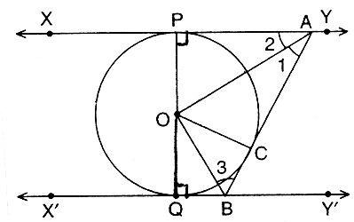
Or

In given figure PQR is a right angled triangle with PQ = 12 cm and QR = 5 cm. A
circle with centre O and radius x is inscribed in$Δ\text{PQR}$. Find the value of x.
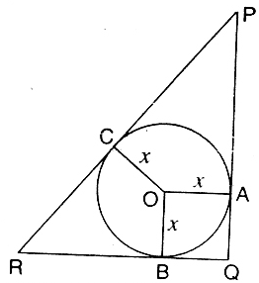
Devesh Yadav
Email Address : devesh_yadav_apex@yahoo.co.in

