GUESS PAPER - 2008
Class - X
SUBJECT - MATHEMATICS
TIME: 3 HOURS Max. Marks: 80

GENERAL INSTRUCTIONS:-
- All Questions are compulsory
- The question paper consists of thirty questions divided into 4 sections A, B, C and D. Section A comprises of ten questions of 01 marks each, section B comprises of five questions of 02 marks each, section C comprises of ten questions of 03 marks each and section D comprises of five questions of 06 marks each.
- All questions in section A are to be answered in one word, one sentence or as per the exact requirement of the question
- There is no overall choice. However, internal choice has been provided in one question of 02 marks each, three questions of 03 marks each and two questions of 06 marks each. You have to attempt only one of the alternatives in all such questions.
- In question on construction, drawings should be neat and exactly as per the given measurements.
- Use of calculators is not permitted. How ever you ask for mathematical tables.

Section A
- Write 102 as a product of its prime factors
- Form a quadratic polynomial with zeros and
- Find the value of such that the equation has equal roots
- If and then find the value of 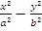
- Which term of the arithmetic progression 27, 24, 21, …………… is zero ?
- If the volume of a sphere is V and surface area is A then what is ?
- In triangle ABC, ∠B =90° , BC = 6 cm, CD = 9cm and AC = 10 cm Determine AD
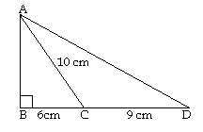
- A red die and a blue die are thrown at the same time. Find the probability of obtaining the same number on both dice.

- Find the sum of the deviations of 25, 38, 44, 29, 32, 52 and 25 from their mean.

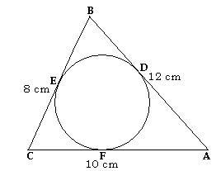
- A circle is inscribed in a ΔABC having sides 8 cm, 10 cm and 12 cm as shown in figure. Find AD, BE and CF

Section B
- Find the value of α and β for which the following system of equations has infinite number of solutions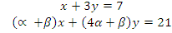

- If where and are acute angles, find the value of

- For what value of , if the point is equidistant from ) and

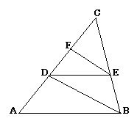
- In the given figure and , prove that
- A bag contains 24 balls out of which are white. If 12 more balls are added to the bag, the probability of drawing a white ball becomes twice. Find the original number of balls.

OR
A box contains 90 boxes numbered 1 to 90. One box is drawn at random find the probability that it bears perfect square.

Section C
- Use Fundamental theorem of Arithmetic to find the H.C.F and L. C. M of 225 , 336, and 360.

OR
Prove that is an irrational number

- One root of the quadratic equation is . Find the other root and the value of .
- Determine graphically the vertices of the triangle equations of whose sides are given below. $\begin{aligned}2y−x=8 \\ 5y−x=\text{14} \\ y−2x=1\end{aligned}$
- 90% and 97% pure acid solutions are mixed together to obtain 21 litres of 95% pure acid solution. Find the amount of each type of acid to be mixed to form the mixture.

- Prove that

OR
Prove that 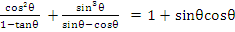

- Find ratio in which the join of and is divided by the line. Find the coordinates of the point of division.

- Find the area of the quadrilateral whose vertices taken in order are , , and .

- Construct an equilateral triangle with side 5.5 cm. Construct a triangle similar
to this triangle with sides of sides of given triangle.

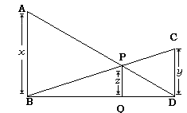
- In the figure given below ∠ABD = ∠CDB = ∠PQB = 900. If AB = units , CD = units and PQ = units, prove that 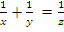
- A solid cylinder has a total surface area 462 sq.cm. Its curved surface area is one-third of the total surface area. Find the volume of the cylinder.

OR
A field is 200m long and 150m broad . There is a plot 50m long and 40m broad , near the field. The plot is dug 7m deep and the earth taken out is spread evenly on the field. By how many metres is the levels of the field raised? Give answer to the second place of decimal.

Section D

- From a circular cylinder of diameter 10 cm and height 12 cm, a conical cavity of the same base radius and of the same height is hollowed out. Find the volume and the whole surface of the remaining solid.
- Prove that in a right triangle, the square of the hypotenuse is equal to sum of squares of other two sides. Use this result to prove that the altitude of an equilateral triangle of side is

- Two pillars of equal height and on either side of a road, which is 100m wide. The angles of elevation of the top of the pillars are and at a point on the road between the pillars. Find the position of the point between the pillars and the height of each pillar.

OR
A man on the top of a vertical tower observes a car moving at a uniform speed coming directly towards him. If it takes 12 minute for the angle of depression to change form to , how soon after this, will the car reach the tower?.
- The length of the hypotenuse of a right triangle exceeds the length of its base by 2 cm and exceeds twice the length of the altitude by 1 cm. Find the length of each side of the triangle.

OR
A two digit number is such that the product of its digits is 18. When 63 is subtracted from the number the digits interchange their places. Find the number.

- Compute the arithmetic mean for the following frequency distribution:.
Marks | Below 10 | Below 20 | Below 30 | Below 40 | Below 50 | Below 60 | Below 70 | Below 80
No of Students | 5 | 9 | 17 | 29 | 45 | 55 | 67 | 75
=======================

