GUESS PAPER - 2008
Class - IX
SUBJECT - MATHEMATICS

Test Paper on HERON’S FORMULA & SURFACE AREAS AND VOLUMES

Q.1 A triangular park ABC has sides 120m, 80m and 50m (see Fig.). A gardener Dhania has to put a fence all around it and also plant grass inside. How much area does she need to plant? Find the cost of fencing it with barbed wire at the rate of Rs 20 per metre leaving a space 3m wide for a gate on one side.
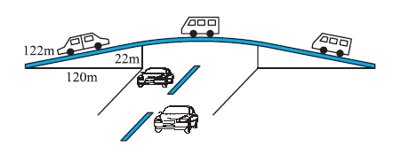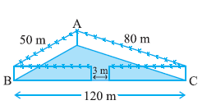
Q.2 The triangular side walls of a flyover have been used for advertisements. The sides of the walls are 122 m, 22 m and 120 m (see Fig.). The advertisements yield an
earning of Rs 5000 per m2 per year. A company hired one of its walls for 3 months. How much rent did it pay?
Q.3 Sanya has a piece of land which is in the shape of a rhombus .She wants her one daughter and one son to work on the land and produce different crops. She divided the land in two equal parts. If the perimeter of the land is 400 m and one of the diagonals is 160 m, how much area each of them will get for their crops?
Q.4: Mary wants to decorate her Christmas tree. She wants to place the tree on a wooden box covered with colored paper with picture of Santa Claus on it. She must know the exact quantity of paper to buy for this purpose. If the box has length, breadth and height as 80 cm, 40 cm and 20 cm respectively how many square sheets of paper of side 40 cm would she require?
Q.5 Savitri had to make a model of a cylindrical kaleidoscope for her science project. She wanted to use chart paper to make the curved surface of the kaleidoscope. What would be the area of chart paper required by her, if she wanted to make a kaleidoscope of length 25 cm with a 3.5 cm radius?
Q.6 A hemispherical dome of a building needs to be painted .If the circumference of the base of the dome is 17.6 m, find the cost of painting it, given the cost of painting is Rs 5 per 100 cm2.
Q.7 A wall of length 10 m was to be built across an open ground. The height of the wall is 4 m and thickness of the wall is 24 cm. If this wall is to be built up with bricks whose dimensions are 24 cm × 12 cm × 8 cm, how many bricks would be required?

By
Ramesh kumar Tiwari

