GUESS PAPER - 2008
Class – XII
SUBJECT – MATHEMATICS

MATRIX DETERMINANT & DEFERENTIATION CLASS - XII
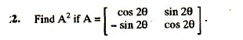
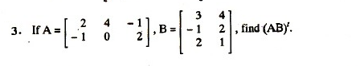
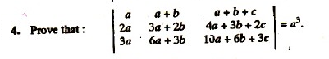
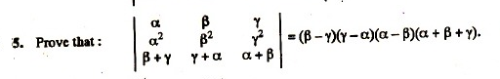
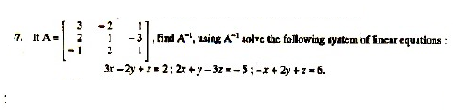
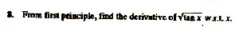
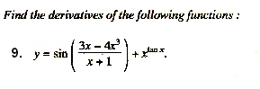
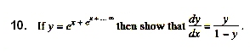
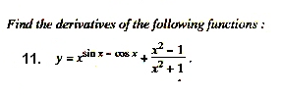
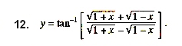
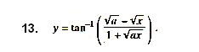-By
Ramesh Kumar Tiwari D.A.V. Kymore Katni (M.P.)

