GUESS PAPER - 2008
Class - XII
SUBJECT – MATHEMATICS

TEST PAPER ON DEFINIT INTEGRAL
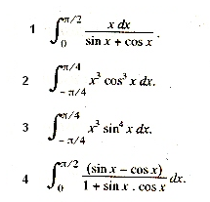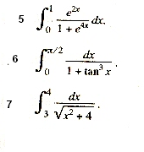
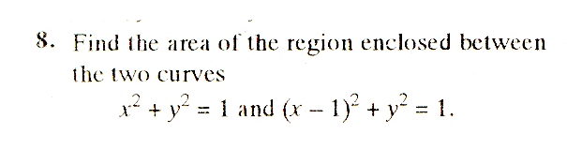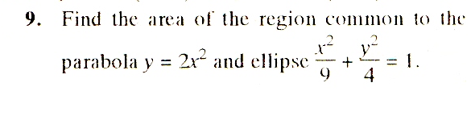

By
Ramesh Kumar Tiwari
D.A.V. Kymore Katni (M.P.)

