GUESS PAPER - 2008
Class - X
SUBJECT - MATHEMATICS

Chapter 1

1 Write the condition to be satisfied be q so that a rational number p/q has a terminating decimal expansion.

2 Using Euclid’s division algorithm, find the HCF of 56, 96 and 404. 4

3 State the Fundamental Theorem of Arithmetic.

4 Prove that 5 + √2 is irrational.

5 Write 98 as a product of its prime factors.

6 Show that 3 + 5√2 is an irrational number.

CHAPTER 2
1 The sum and product of the zeros of a quadratic polynomial are – ½ and – 3 respectively. What is the quadratic polynomial?

2 If two zeros of the polynomials x⁴ + 3x³ - 20x² - 6x + 36 are √2 and - √2, find the other zeroes of the polynomial.

3 The graph of y = f(x) is shown below. Find the number of zeroes of f(x)
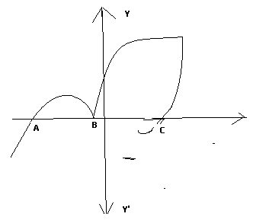
4 Find the zeroes of the quadratic polynomial x² + 5x + 6, and verify the relationship between the zeroes and the coefficient.

5 In fig, the graph of some polynomial p(x) is given. Find the zeroes of the polynomial.
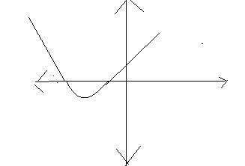
6 Write a quadratic polynomial, sum of whose zeros is 2√3 and product is 2.

CHAPTER 3

1 Without drawing the graph, state whether the following pair of linear equations will represent intersecting lines, coincident lines or parallel lines.
6x – 3y + 10 = 0; 2x – y + 9 = 0

2 Draw the graph of the following pair of linear equations:
X + 3y = 6; 2x – 3y = 12.
Hence, find the area of the region bounded by x = 0, y = 0 and 2x – 3y = 12.

3 For what of ‘k’ will the following pair of linear equations have infinitely many solutions:
Kx + 3y = k – 3; 12x + ky = k. k = 6

4 Solve for x and y: 5 + 1 = 2; 6 __ 3 = 1 x, y ≠ 0 (3, 3)
x y x y

5 Solve the following system of linear equations graphically:
3x + y – 12 = 0; x – 3y + 6 = 0
Shade the region bounded by these lines and the x – axis. Also, find the ratio of areas of the triangles formed by given lines with the x- axis and the y – axis.

6 For what of k, the following pair of linear equations has infinitely many solutions?
10x + 5y – (k – 5) = 0; 20x + 10y – k = 0. k = 10

7 Find the solution of the pair of equations: 3 + 8 = - 1; 1 __ 2 = 2 x, y ≠ 0 (1, - 2)
x y x y

8 Form a pair of linear equations in two variables using the following information and solve it graphically;
Five year ago, Sagar was twice as old as Tara. Ten years later Sagar’s age will be ten years more than Tara’s age. Find their present ages. What was the age of Sagar when Tara was born. (25, 15)

CHAPTER 4
1 For what values of k the quadratic equation x² - kx + 4 = 0 has equal roots?

2 Some students arranged a picnic. The budget for food was Rs. 240. Because four students of the group failed to go, the cost of food to each student got increased by Rs. 5. How many students went for the picnic.

3 What the nature of roods of the quadratic equation 4x² - 12x ² 9 = 0?

4 If a student had walked 1 km/h faster, he would have taken 15 minutes less to walk 3 km. Find the rate at which he was walking.

5 A plane left 30 minutes late than its scheduled time and in order to reach the destination 1,500 km away in time, it had to increase the speed by 250 km/h from the usual speed. Find its usual speed.

CHAPETER 5
1 Which term of the sequence 114, 109, 104,…………. Is the first negative term?

2 A contract on construction job specifies a penalty for delay of completion beyond a certain date as follows:
Rs. 200 for first day, Rs. 250 for second day, Rs. 300 for third day and so on. If the contractor pays, Rs. 27, 750 as penalty, find the number of days for which the construction work is delayed. 30

3 From your pocket money, you save Rs. 1 on day 1, Rs. 2 on day 2, Rs. 3 on day 3 an so on. How much money will you save in the month of March 2008. Rs. 496

4 Determine an AP whose 3rd term is 16 and when 5th is subtracted from 7th term, we get 12.

5 If the 10th term of an AP is 47 and its first term is 2, find the sum of its 15 term.

6 Find the sum of three digit number each of which leave the remainder 3 when divided by 5.

CHAPTER 7
1 Find a point on the y –axis which is equidistant from the point A (6, 5) and B ( - 4, 3). (0, 9)

2 Find the area of the quadrilateral whose vertices taken in order are A(- 5, - 3), B (- 4, - 6), C( 2, - 1) and D ( 1, 2).

3 Find the value of x for which the distance between the points P (2, - 3) and Q (x , 5) is 10 units.

4 Prove that the points A (- 3, 0), B(1, - 3) and C (4, 1) are the vertices of an isosceles right triangle.

5. For what value of ‘k’ the points A (1, 5), B(k, 1) and C (4, 11) are collinear.
6 in what ratio does the points P (2, -5) divide the line segment joining A (-3, 5) and B ( 4, - 9)?

7 The coordinates of the vertices of Δ ABC are a (4, 1), B ( - 3, 2) and C (0, k). Given that the area of Δ ABC is 12 units² , find the value of ‘k’.

8 Find the ratio in which the line segment joining the points A (3, - 6) and B (5, 3) is divided by x – axis. Also, find the coordinates of the point of intersection.

9 Find the relation between x and y such that the point P (x, y) is equidistant from the points A(2, 5) and B (-3, 7).

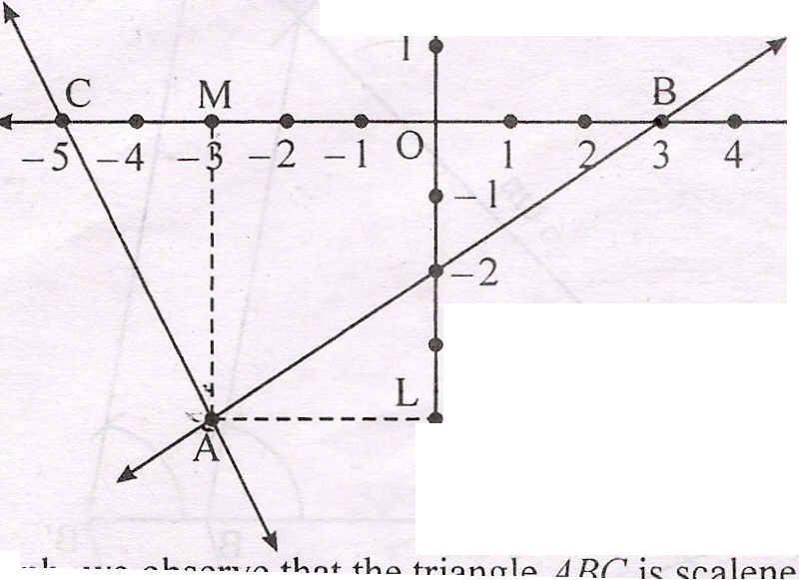
10 Observe the graph below and state whether triangle ABC is scalene, isosceles or equilateral. Justify your answer. Also, find the Area. Y

Chapter 8
1 Given that tan θ = 1/ √5, what is the value of cosec ² θ – sec ² θ
Cosec ² θ + sec ² θ

2 Without using trigonometric table, find the value of cos 70º + cos 57º cosec 33º -- 2 cos 60º
Sin 20º

3 Prove that : 1 + cos A + sin A = 2 cosec A
sin A 1 + cos A

4 Prove that: sin A + cos A + sin A – cos A = 2
sin A – cos A sin A + cos A sin ² A - cos² A

5 The height of a tower is 10 m. Calculate the height of its shadow when sun’s altitude is 45º.

6 Express sin 67º + cos 75º in terms of trigonometric ratios of angles between 0º and 45º.

7 If, A, B, C are interior angles of ∆ ABC, then show that cos ( B +_C) = sin A
2 2

8 Prove that: √sec A – 1 + √sec A + 1 = 2 cosec A
√sec A +1 √sec A – 1

9 What is the maximum value of 1/sec θ ?

10 If tan A = ¾ and A + B = 90º, then what is the value of cot B ?

11 Prove that : sin θ = 2 + sin θ
cot θ + cosec θ cot θ – cosec θ

12 Evaluate: sec 29º + 2 cot 8º cot 17º cot 45º cot 73º cot 82º - 3 (sin² 38º + sin ² 52º)
cosec 61º

CHAPTER 9
1 From the top of a building 100 m high, the angles of depression of the top and bottom of a tower are observed to be 45º and 60º respectively. Find the height of the tower. Also, find the distance between the foot of the building and the bottom of the tower.

2 The angle of elevation of the top of a tower at a point on the level ground is 30º. After walking a distance of 100 m towards the foot of the tower along the horizontal line through the foot of the tower on the same level ground, the angle of elevation of the top of the tower is 60º. Find the height of the tower.

3 There are two poles, one each on either bank of a river, just opposite to each other. One pole is 60 m high. From the top of this pole, the angles of depression of the top and the foot of the other pole are 30º and 60º respectively. Find the width of the river and the height of the other pole.

4 From the top and foot of a tower 40 m high, the angle of elevation of the top of a light house is found to be 30º and 60º respectively. Find the height of the light-house. Also, find the distance of the top of the light house from the foot of the tower.
CHAPTER 11

1 Construct a triangle ABC in which CA = 6 cm, AB = 5 cm and ∠ BAC = 45º, then construct a triangle similar to the given triangle whose sides are 6/5th of the corresponding sides of the Δ ABC.

2 Construct a circle whose radius is equal to 4 cm. Let P be a point whose distance from its centre is 6 cm. Construct two tangents to it from P.

3 Construct a triangle similar to given Δ ABC in which AB = 4 cm, BC = 6 cm, and ∠ ABC = 60º, such that each side of the new triangle is 3/4th of given Δ ABC.

4 Draw a pair of tangents to a circle of radius 5 cm which are inclined to each other at an angle of 60º.

5 Draw a right triangle in which the sides other than hypotenuse are of lengths 4 cm and 3 cm. Then construct another triangle whose sides are 5/3 times the corresponding sides of the given triangle.

CHAPTER 12
1 A square field and an equilateral triangular park have equal perimeters. If the cost of ploughing the field at the rate of Rs. 5/m² is Rs. 720, find the cost of maintaining the part at the rate of Rs. 10/m².

2 PQRS is a square land of side 28 cm. Two semicircular grass covered portions are be made on two of its opposite sides as shown in the figure. How much area will be left uncovered.

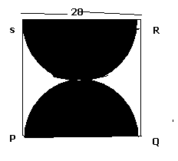

3 Find the area of the shaded region from figure, if the diameter of the circle with centre O os 28 cm and
AQ = ¼ AB.
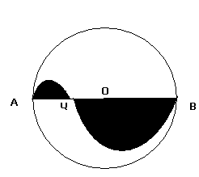

4 In fig, OAPB is sector of a circle of a radius 3.5cm with the centre at O and ∠ AOB = 120º, find the length of OAPBO., and also find the area of sector.
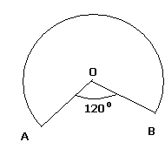

CAHPTER 13
1 A cylinder, a cone and a hemisphere are of equal base and have the same height. What is ratio of their volume?

2 The interior of a building is in the form of a right circular cylinder of radius 7 m and height 6 m surmounted by a right circular cone of a vertical angle is 60º. Find the cost of painting the building from inside at the rate of Rs. 30/m²?

3 An iron pillar has lower part in the form of a right circular cylinder and the upper part is the form of a right circular cone. The radius of the base of each of the cone and a cylinder is 8 cm. The cylindrical part is 240 m high and conical l part is 36 cm high. Find the weight of the pillar is 1 cm³ of iron weighs 7. 5 grams.

4 A container (open at the top) made up of a metal sheet is in the form of a frustum of cones of height 16 cm with radii of its lower and upper ends are 8 cm and 20 cm respectively. Find
(i) The cost of milk when it is completely filled with milk at the rate of Rs. 15 per litre.
(ii) The cost of metal sheet used, if it cost Rs. 5 per 100 cm².

5 A solid is composed of a cylinder with hemispherical ends. If the whole length of the solid is 100 cm and the diameter of of the hemispherical ends is 28 cm, find the cost of polishing the surface of the solid at the rate of 5 paisa per sq. cm.

6 An open contain made up of a metal sheet is in the form of a frustum of a cone of height 8 cm with radii of its lower and upper ends as 4 cm and 10 cm respectively. Find the cost of oil which can completely fill the container at the rate of Rs. 50 per liter. Also, find the cost of metal used, if it costs Rs. 5 per 100 cm².

7 A toy is in the form of a cone mounted on a hemisphere of common base radius 7 cm. The total height of the toy is 31cm. Find the total surface are of toy and the volume of the toy.

8 If h, c and V respectively are the height, the curved surface area and volume of a cone, prove that
3 ∏ V h³ -- c² h² + 9 V² = 0

9 A toy is in the shape of a right circular cylinder with a hemisphere on one end and a cone on the other. The radius and height of the cylindrical part is 5 cm and 13 cm respectively. The radii of the hemispherical and conical parts are the same as that of the cylindrical part. Find the surface area of the toy if the total height of the toy is 30 cm.

10. A solid cylinder of diameter 12 cm and height 15 cm melted and recast into 12 toys in the shape of right circular cone mounted on a hemisphere. Find the radius of the hemisphere and total height of the toy if height of the cone is 3 times the radius.
CHAPTER 14
1 The following table shows the marks obtained by 100 students of Class X in a school during a particular academic session. Find the mode and mean of this distribution.
Marks Number of students.
Less than 10 7
Less than 20 21
Less than 30 34
Less than 40 46
Less than 50 66
Less than 60 77
Less than 70 92
Less than 80 100

2 Which measure of central tendency is given by the x – coordinate of the point of intersection of the ‘more than ogive’ and ‘less than ogive’

3 If the median of the distribution is 28.5, find the value of x and y.
CI 0 – 10 10 – 20 20 – 30 30 – 40 40 – 50 50 – 60 Total
F 5 x 20 15 y 5 60

4 The median of the following data is 32.5. Find f1 and f2
CI 0 – 10 10 – 20 20 – 30 30 – 40 40 – 50 50 – 60 60 – 70 Total
F f1 5 9 12 f2 3 2 40

5 The median of the following data is 525. Find the value of ‘p’ and ‘q’, if the total frequency is 100.
CI 0 – 100 100 – 200 200 – 300 300 – 400 400 – 500 500 – 600 600 – 700 700 – 800 800 -900 900 - 1000
F 2 5 p 12 17 20 q 9 7 4

6 The median of the following data is 20.75. find the missing frequencies x and y, if the total frequency is 100.
CI 0 – 5 5 – 10 10 – 15 15 – 20 20 – 25 25 – 30 30 – 35 35 – 40.
F 7 10 x 13 y 10 14 9

7 The mean of the following frequency table is 53. But the frequencies fi and f2 in the classes 20 – 40 and 60 – 80 are missing. Find the missing frequencies.
CI 0 – 20 20 – 40 40 – 60 60 – 80 80 – 100 Total
F 15 f1 21 f2 17 100

6 The mean of the following distribution is 62.8 and the sum of all frequencies is 50. Compute the missing frequencies fi and f2:
Class 0 – 20 20 – 40 40 – 60 60 – 80 80 –100 100 - 120
Frequency 5 fi 10 f2 7 8

7 The mean of the following distribution is 57.6 and the sum of all frequencies is 50. Compute the missing frequencies fi and f2:
Class 0 – 20 20 – 40 40 – 60 60 – 80 80 –100 100 - 120
Frequency 7 fi 12 f2 8 5

8 The mean of the following distribution is 132 and the sum of all frequencies is 50. Compute the missing frequencies fi and f2:
Class 0 – 40 40 – 80 80 – 120 120 – 160 160 –200 200 - 240
Frequency 4 7 fi 12 f2 9

9 Find the Mean, Median and Mode of the following data;
CI 0 – 100 100 – 200 200 – 300 300 – 400 400 – 500 500 – 600 600 – 700 700 – 800 800 -900 900 - 1000
F 2 5 9 12 17 20 15 9 7 4

CHAPTER 15
1 Cards each marked with one of the numbers 4, 5, 6……….. 20 are placed in a box and mixed thoroughly. One card is drawn at random from the box. What is the probability of getting an even prime number?

2 A bag contains 5 red, 8 green and 7 white balls. One ball is drawn at random from the bag, find the probability of getting:
(i) a white ball or a green ball (ii) neither a green ball nor a red ball.

3 A bag contains 5 red and 4 black balls. A ball is drawn at random from the bag. What is the probability of getting a black ball?

4 All cards of ace, jack and queen are removed from a deck of playing cards. One card is drawn at random from the remaining cards, find the probability that the card drawn is :
(a) a face card (b) not a face card.

5 A dice is thrown once, what is the probability of getting a prime number?

6 Justify the statement: “Tossing a coin is fair way of deciding which team should get the batting first at the beginning of a cricket team”,.

7 Cards numbered 3, 4, 5,…….. 17 are put in a box and mixed thoroughly. A card is drawn at random from the box. Find the probability that the card drawn bears:
(a) an odd number (ii) a number divisible by 3 or 5.

8 From a well shuffled pack of 52 cards, black aces and black queen are removed. From the remaining cards, a card is drawn at random. Find the probability of drawing a king or a queen.

9 Two coins are tossed simultaneously. Find the probability of getting at most one head.

10 A bag contains 7 red balls, 8 white balls and 5 green balls. A ball is drawn from the bag at random. Find the probability that the drawn ball is not of a green ball.

CHAPTER 6
1 Prove that in a right triangle, the square of the hypotenuse is equal to the sum of squares of the other two sides.

2 prove that the ratio of area of two similar triangles is equal to the square of their corresponding sides.

3 prove that in a triangle, if square of one side is equal to the sum of the squares of the other two sides, then the angle opposite to the first side is a right angle.

4 State and Prove the Basic Proportionate Theorem.

“The roots of education are bitter, but the fruit is sweet”.

Prepared by: Trilochan Wadhwa
M.Com, B.Ed.
PHONE NO: - 20286098 and 25176448
(Deepak Tuition Centre))
A – 98, New Moti Nagar, New Delhi – 1100 15.

ALL THE BEST

