GUESS PAPER - 2008
Class - XI
SUBJECT - MATHEMATICS
STRAIGHT LINE
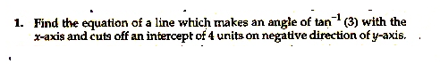
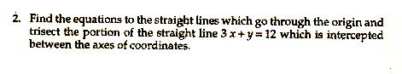
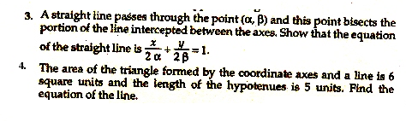
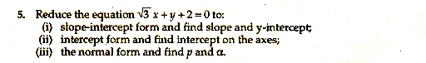
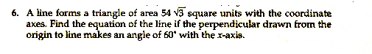

By Ramesh Kumar Tiwari
DAV ACC KYMORE (M.P.)
Mo 09893648169

