GUESS PAPER - 2008
Class - XI
SUBJECT - MATHEMATICS

TEST EXAMINATION CLASS –XI MATHEMATICS
Q.1 The vertices of the triangle are A(5,4,6), B(1,-1,3)and C(4,3,2) .The internal bisector of angle A meets BC at D. Find the coordinates of D and the length AD.
Q.2 The mid- points of the sides of a triangle ABC are given by (-2, 3,5),(4,-1,7) and (6,5,3).Find the coordinates of A,B and C.
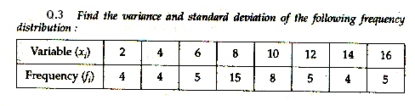
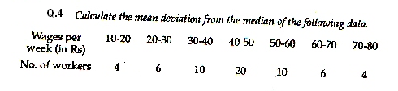
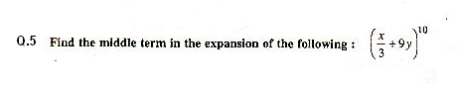
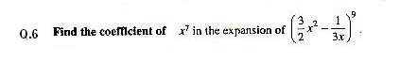

By Ramesh Kumar Tiwari
DAV ACC KYMORE (M.P.)

