Guess Paper - 2008
Class - XI
Subject - Mathematics

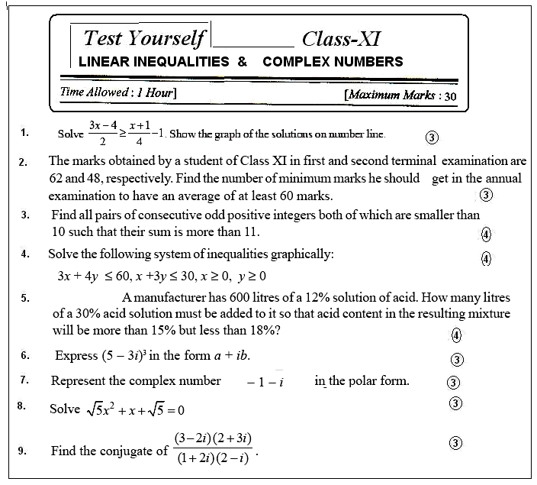

By Ramesh Kumar Tiwari
DAV ACC KYMORE (M.P.)
Mo 09893648169

