GUESS PAPER – 2008
CLASS - X
SUBJECT - MATHEMATICS
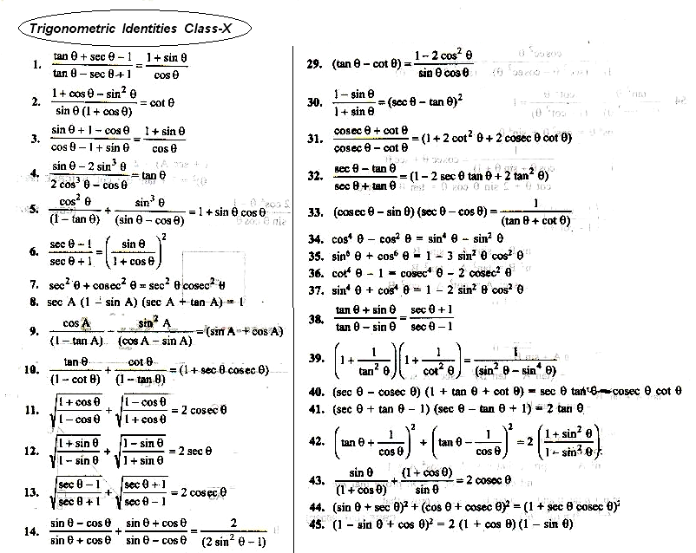
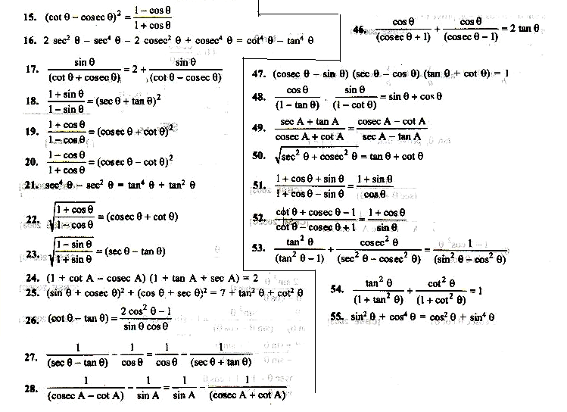
By Ramesh Kumar Tiwari
DAV ACC KYMORE (M.P.)

