Guess Paper – 2009
Class – X
Subject – Science (Theory)

Time: 2.5 Hrs Max. Marks: 60

General Instructions:-

- The question paper comprises of two sections A and B. You are to attempt both the sections.
- All questions are compulsory.
- There is no overall choice. However, internal choices have been provided in all the three questions of five marks category. Only one option in such questions is to be attempted.
- All questions of section A and all questions of section B are to attempt separately.
- Questions 1 to 6 in section A and 17 to 19 in section B are short answer type questions. These carry one mark each.
- Questions 7 to 10 in section A and 20 to 24 in sections B are short answer type questions and carry two marks each.
- Questions 11 to 14 in section A and 25 to 26 in sections B are also short answer type questions and carry three marks each.
- Questions 15 and 16 in section A and question 27 in section B are long answer type questions and carry five marks each.

SECTION A

- State any one use of Concave lens?
- A metal M has a valency 3 and it belong to 3rd period in the modern periodic table. Identify the metal M and writ it’s atomic number and electronic configuration?
- Explain the twinkling effect of stars?
- Write any two application of pH in daily life?
- 6 electric bulbs each of rating 18W works for 6 hours daily. Calculate the electricity bill of the household for the month of June if cost per unit- of electricity energy is Rs.3.00?
- Write any four Physical properties of Covalent Bonded Compounds?

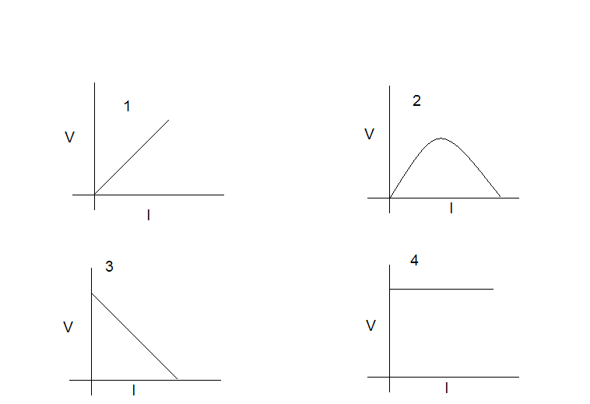
  - Which of the above graphs shows Ohm’s Law?
  - State Ohm’s Law?
- Observe the below circuit:

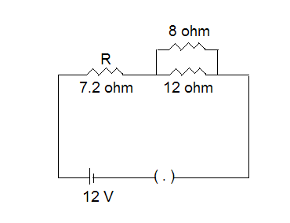
  - Find the total resistance in the circuit.
  - Total current flowing in the circuit.

- You must have seen tarnished copper vessels being cleaned with lemon or tarnished
juice. Explain why these sour substances are effective in cleaning the vessel.
- Explain the two process of extracting the Ore?
- A chemical compound ‘X’ is used in soda and fire extinguishers and also in
antacids.
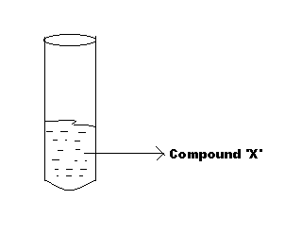
  - Identify the compound ‘X’ and give its chemical formula.
  - Write a chemical equation for its preparation from Nacl.
  - What happens when this compound is heated strongly?
- Explain the eye defect Myopia? Draw its three diagrams?

  - What is Activity Series?
  - Write the Activity Series.
  - Write the name and symbol of metal which exist in liquid at room temperature?
- A Concave Mirror produces three times enlarged image of an object placed at 10 cm in front of it. Calculate the radius of Curvature?

  - Give two Limitation of Modern Periodic Table?
  - Describe the Periods and Groups present in Modern Periodic Table?

OR

- Explain the Principle and the working of an A.C. Generator? Explain the rule used
to determine the direction of the Force produced?

OR

Explain the various components of o household electric circuit. (Figure Necessary)

SECTION B

- Give two examples of recyclable materials?
- Name four Plant Hormones?
- Which organ secretes the Hormone Insulin? State it’s Location and Function in the Human Body?
- Why are thermal Power Plants set up near Coal or Oil Fields?
- Explain the function and location of Male Reproductive System in Human Beings?
- Explain Aerobic and Anaerobic Respiration?
- Explain the three R’s in conserving Natural Resources?
- Draw a neat diagram of the Longitudinal Section of a Flower?
- What is a Tropic Level? Name the various Tropic Level’s in a Food Chain? Who occupy the highest position in a Food Chain?
- How Mendel does’s discovered that traits may be dominant or recessive?
  - Draw a neat and labeled diagram of Human Brain?
  - Write the Various functions of Hind- Brain?

OR

- Explain Double Circulation with the help of a neat and labeled diagram?

********************
BEST OF LUCK!
********************

***************************************************
For Solutions Contact: amalhisham@gmail.com
***********************************************

