SAMPLE QUESTION - 2008
Class - X
Subject - Mathematics
Time:3hrs Max.Marks:80
General Instructions
- All questions compulsory
- The question paper consist of thirty questions divided in to 4 sections A,B,C and D. Section A comprises of ten questions of 1 marks each ,Section B comprises of five questions of 2 marks each, Section C comprises of ten questions of 3 marks each and section D comprises of five questions of 6 marks each
- All questions in section A are to be answered in one word , one sentence or as per the exact requirement of the question
- there is no overall choice .However internal choice has been provided in one question of 2 marks each ,three question of three marks each and two questions of 6 marks each .You have to attempt only one of the alternatives in all such questions.
- In question on construction ,drawings should be neat and exactly as per the given measurements
- Use of calculators is not permitted .However you may ask for mathematical tables
To download more Sample Papers log on http://mathshelpline.co.cc http://pushpender86.co.cc www.mathshelpline.blogspot.com
Mail me at pushpender86@gmail.com

SECTION A
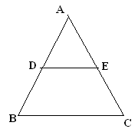
- $5×7×\text{13}×\text{17}+\text{17}$ is a composite number because ………………………
- If H.C.F.(26,91)=13, find the L.C.M.(26,91).
- Find the value of k if ${\text{kx}}^{2}−2\sqrt{2}x+1=0$ has equal roots
- Express $\text{sin}{\text{72}}^{0}+\text{cos}{\text{81}}^{0}$ in terms of trigonometric ratios of angles between 0⁰ and 45⁰
- How many terms of the AP $−6,−\frac{\text{11}}{2},−5\text{.}\text{.}\text{.}\text{.}\text{.}\text{.}\text{.}$ will give the sum zero.
- If each side of an equilateral triangle is ‘2a’ units, what is the length of its altitude?

7. Prove that the tangents at the end of a diameter are parallel..

- In the given figure DE is parallel to BC and $\text{AD}:\text{DB}=2:3$determine $\text{ar}(Δ\text{ADE}):\text{ar}(Δ\text{ABC})$
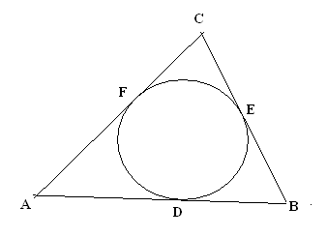
- A circle is inscribed in $Δ\text{ABC}$ having sides AB = 8 Cm ,BC = 10 Cm , and AC= 12 Cm
as shown in the figure find AD , BE and CF
- One letter is selected at random from the word ‘UNNECESSARY’. Find the probability of selecting an E
To download more Sample Papers log on http://mathshelpline.co.cc http://pushpender86.co.cc www.mathshelpline.blogspot.com

SECTION- B

11. Solve the equation 2x² –7x + 3 = 0 by the method of completing the square.

- If 7 cosec θ - 3 cot θ = 7, then prove that 7 cot θ – 3 cosec θ = 3.
OR
Prove that (1+ cot A + tan A )(sin A – cos A) = secA.

13. ABCD is the rectangle whose vertices are A(0,0), B(a,0), C(a,b), D(0,b). Show that the diagonals of it bisect each other and are equal.

14. Find the value of P if the mean of the following distribution is 20.

x | 15 | 17 | 19 | 20+P | 23
f | 2 | 3 | 4 | 5P | 6

15. Construct two tangents to a circle of radius 3cm from a point on the concentric circle of radius 6cm.
OR
Construct a triangle similar to a given triangle with sides 5 cm, 12 cm, 13 cm and whose sides are 3/5 of the corresponding sides of the given triangle.
To download more Sample Papers log on http://mathshelpline.co.cc http://pushpender86.co.cc www.mathshelpline.blogspot.com

SECTION-C

16. Show that any positive odd integer is of the form 6q+1 or 6q+3 or 6q+5 where q is some integer.
OR
If the sum of the zeros of the polynomial (a+1) x² + (2a+3) x + (3a+4) be –1, find the product of its zeros.

17. Sum of the areas of two squares is 468 m². If the difference of their perimeters is 24 m, find the sides of the two squares.

18. Find the vertices of the triangle, the mid-points of whose sides are (3,1), (5,6) and (-3,2).

19. Mizna is walking along the path joining (-2,3) and (2,-2) while Fathima is walking along the path joining (0,5) and (4,0). Represent and discuss this situation graphically.
OR
A 90% acid solution is mixed with a 97% acid solution to obtain 21 litres of a 95 % solution. Find the quantity of each of the solution to get the resultant mixture.

20. If 7 Sin²θ + 3 Cos²θ=4, find the value of Secθ + Cosecθ.

21. Find the lengths of the medians of the triangle whose vertices are (1,-1), (0,4) and (-5,3).

22. The vertices of a ∆ABC are (3,0), B(0,6) and C (6,9) and DE divides AB and AC in the same ratio 1:2. Prove that area of ∆ABC = 9(area of ∆ADE).

23. In fig. ABC, points P and Q lies on AB and AC respectively. If PQ || BC, Prove that the median AD bisect PQ.
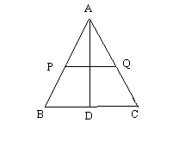

24. Two circles with radii a and b (a > b) touch each other externally. Find the length of the common tangent AB.
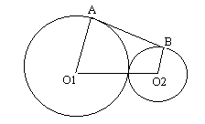

- The area of an equilateral triangle is 17300 cm². With each vertex of the triangle as centre, a circle is drawn with a radius equal to half the length of the side of the triangle. Find the area of the triangle not included in the circles.
( π = 3.14 and √3 =1.73 )
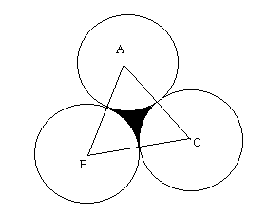
OR
A solid composed of a cylinder with hemi spherical ends . The whole height of the solid is 19cm and the radius of the cylinder is 3.5cm. Find the weight of the solid if 1cm³ of the metal weighs 4.5g.
To download more Sample Papers log on http://mathshelpline.co.cc http://pushpender86.co.cc www.mathshelpline.blogspot.com

SECTION- D

26. In Birla auditorium the number of rows was equal to the number of seats in each row. When the number of rows was doubled and the number of seats in each row was reduced by 10, the total no. of seats increased by 300. How many rows were there?

27 Two pillars of equal height stand on either side of a roadway which is180 m wide From a point on the roadway between the pillars, the angles of elevations of the top of the pillars are 60˚ and 30˚. Find the height of the pillars and the position of the point.

28. BL and CM are the medians of ∆ ABC, right angled at A.
Prove that 4(BL² + CM²) = 5 BC²

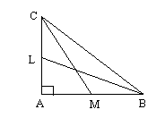

OR
To download more Sample Papers log on http://mathshelpline.co.cc http://pushpender86.co.cc www.mathshelpline.blogspot.com

State and prove the converse of Pythagoras theorem. Using it prove that triangle PQR is right angled if QS² =PS×SR and QS⊥PR.

29. Water is flowing at the rate of 15 km per hour through a pipe of diameter 14 cm into a rectangular tank which is 50 m long and 44 m wide. Find the time in which the level will rise by 21cm.
OR

A right circular cone is divided into two portions by a plane parallel to the base and passing through a point, which is 1/3 of the height from the top. Find the ratio of the smaller cone to that of the remaining frustum of the cone.
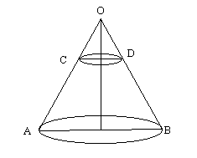
30. For the following frequency distribution draw the less than give and using it find the median.

Marks obtained | 50-60 | 60-70 | 70-80 | 80-90 | 90-100
No. of students | 4 | 8 | 12 | 6 | 6

