Guess Paper – 2009
Class – IX
Subject – Mathematics

Time – 2 hrs MM - 50

Instructions :-

- Question paper consists of 22 questions at all.
- Question paper is divided into four sections i.e. Section A, Section B , Section C and Section D.
3. Section A contains 5 questions carries 1 marks each , Section B contains 10
questions carries 2 marks each , while section C contains 5 questions carries 3
marks each.
4. Section D contains 2 questions and carries 5 marks each.
5. All questions are compulsory however internal choice is given in 3 marks question
and in 5 marks question.

Section – A

1. Find the values of X and Y from the figure given below.
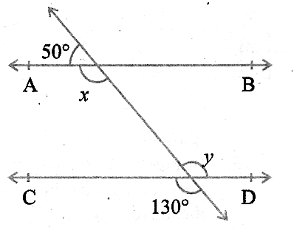
2. Find one irrational number between .

3. Give one example each of binomial of degree 35 and a monomial of degree 100.

4. The cost of the notebook is twice then the cost of a pen. Write a linear equation in
two variable to represent this statement.

5. In which quadrant, does each of the following point (-2,4), (3,-1), (-1,0),(1,2) and
(-3,-5) lies ?

Section - B

6. Line XY and MN intersect at O. If POY = 90 º and a : b = 2 : 3. Find C.

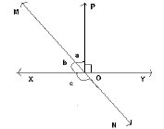

7. Write the coefficient of X² in each of the following :
(a) 2 – X² + X³ (b) X² + X

8. Find the value of K, if X = 2 and Y = 1 is a solution of the equation 2X + 3Y = K.

9. If AB||DE , BAE = 35 º, CDE = 53 º. Find DCE.
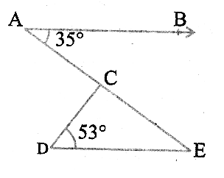
10. Show that angles of an equilateral triangles are 60 º each.

11. Study the graph carefully and answer the following questions :
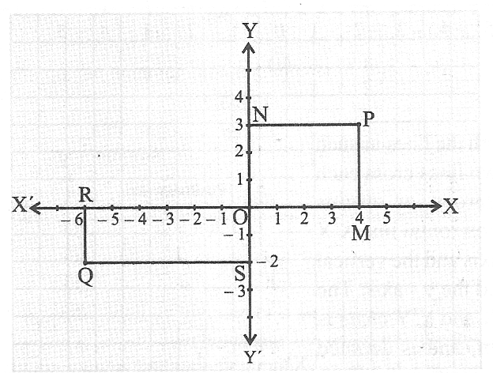
- What is the perpendicular distance of a point P from y axis ?
- Write the abscissa of point Q ?

12. Divide polynomial p(x) by g(x), Where p(x) = X + 3X² – 1 and g(x) = 1 + X.

13. Find four different solutions of the equation X + 2Y = 6.

14. Factorise Y² – 5Y + 6 , by using the factorization theorem.
15. Rationalise the following denominator :-

Section - C
16. Locate √3 on the number line.
Or
If x + y + z = 0, then show that x³ + y³ + z³ = 3 xyz.

17. Evaluate the following using suitable identities :

(a) (104)³ (b) (3a + 4b + 5c)²

Or
Factorise :
(a) (b) 4x² + 9y² + 16z² + 12xy – 24yz – 16xz

18. Plot the following ordered pair (X,Y) of numbers as points in the Cartesian plane :-

X | -3 | 0 | -1 | 4 | 2
Y | 7 | -3.5 | -3 | 4 | -3

19. Lines AB and CD intersects at point O. If AOC+BOE = 70º & BOD = 40º. Find
BOE and reflex COE.
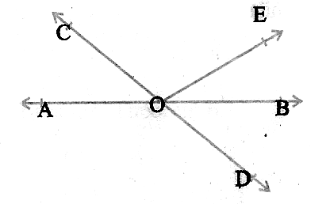
Or
Show that in a right angled triangle, the hypotenuse is the longest side.

20. AB is a line segment and P is its midpoint. D and E are the points on the same side
of AB such that BAD = ABE and EPA = DPB. Show that
(i) ∆ DAP ∆ EBP.
(ii) AD = BE.
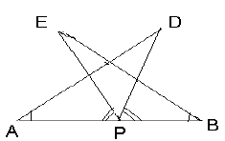

Section – D

21. Verify that x³ + y³ + z³ – 3xyz = (x+y+z)[(x-y)² + (y-z)² + (z-x)²]
Or
The sides AB and AC of ∆ ABC are produced to point E & D
respectively. If the bisectors BO & VO of CBE & BCD respectively
meet at point O, then prove that BOC = .
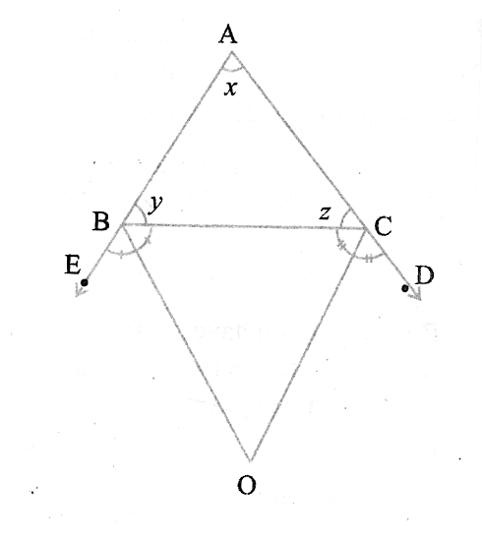

22. State and prove R.H.S congruence rule.

Or
(a) AB & CD are respectively the smallest & the longest side of quadrilateral ABCD.
Show that A > C and B > D.

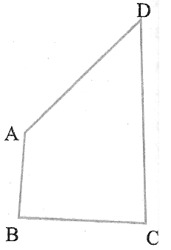

(b) The linear equation that converts the Fahrenheit to Celsius is as follows :-
(i) Draw the graph of the linear equation .
(ii) If the temperature is 95⁰ F,what is the temperature in Celsius .

