Guess Paper – 2009
Class – X
Subject – Mathematics

Time – 2 hrs MM - 50
Instructions :-

- Question paper consists of 18 questions at all.
- Question paper is divided into four sections i.e. Section A, Section B , Section C and Section D.
3. Section A contains 8 questions carries 2 marks each , Section B contains 8
questions carries 3 marks each , while section C contains 2 questions carries 5
marks each.
4. All questions are compulsory however internal choice is given in 3 marks question
and in 5 marks question.

Section – A

1. Find the first negative term of the A.P : 121, 117, 113, …..

2. Half the perimeter of a rectangular garden, whose length is 4m more than its
Width, is 36 m.Find the dimensions of the garden.

3. Prove that $3+2\sqrt{3}$ is an irrational number.

4. Find a relation between x and y if the points (x,y) , (1,2) and (7,0) are collinear.
5. On comparing the ratios ‘ and without drawing them, find out whether the lines
representing the following pair of linear equations intersect at a point, are parallel
or coincide. 5x - 4y + 8 = 0 ; 7x + 6y – 9 = 0

6. Find the quadratic polynomial which represents the graph from the fig. given below.

Y

4
3
2
1 _
X X’
-4 -3 -2 -1 0 1 2 3 4

-1
-2
-3

7. Find the roots of 4x² + 3x + 5 = 0 by the method of completing the square.
8. Roohi can row downstream 20 Km in 2 hours and upstream 4 Km in 2 hours.Find her speed
of rowing in still water and the speed of current.
Section – B
9.Show that the points A (2, -2), B (14, 10), C (11, 13) and D (-1, 1) are the vertices of a
rectangle.
Or
Determine the ratio in which the points (6, a) divides the join of A (-3, -1) & B (-8, 9).
Also find the value of a.

10.Solve graphically: 2y – x = 8, 5y – x = 14, y – 2x = 1. Obtain the vertices of the triangle so
obtained by the graphs of the equations.
11. Show that the square of any positive integer is of the form 3m or 3m + 1 for some
integer m.
Or
Using Euclid’s division algorithm, show that the cube of any positive integer is of the
form 9n or 9n + 1 or 9n + 8.

12. Solve the following system of linear equations for x and y.
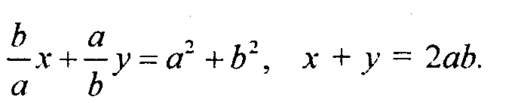
Or
Solve for x 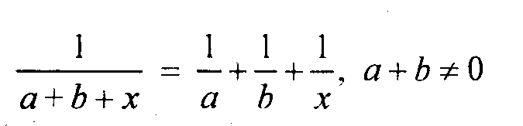

- A sum of Rs 700 is used to give seven cash prizes to students of a school for their overall performance. If each prize is Rs 20 less than its preceding prize, find the value of each of its prize.

14. Find the coordinates of the points of the trisection of the line segment joining the
points A(2, -2) and B(-7,4) ?

15. Divide 3x² – x³ – 3x + 5 by x – 1 – x² and hence verify the division algorithm.
16.The taxi charges in a city consists of a fixed charge together with the charge for the
distance covered. For a distance of 10 km , the charge paid is Rs 105 and for a
journey of 15 km , the charge paid is Rs 155.What are the fixed charges and the
charges per km ? How much does Vivek pays if he travels a distance of 20 Km ?

Or
The sum of the areas of two squares is 468 m² . If the difference of their
perimeters is 24 m. Find the sides of the squares.

Section – C

17.Find the area of the triangle formed by joining the midpoint of the sides of
the triangle whose vertices are (0, -1), (2,1) and (0,3).Find the ratio of this area to
the area of the given triangle.
Or
In a class test, the sum of gagan’s marks in mathematics and English is 30 .
Had he got 2 marks more in mathematics and 3 marks less in English , the product
of their marks would have been 210.Find his marks in in two subjects.

18.One says, “ give me a hundred, I shall then become twice as rich as you.” The
other replies “If you give me ten, I shall be six times as rich as you”.Find out how
much money does each one have ?

Or
Upasna travels 300 km to her home partly by train and partly by bus.She takes
4 hours if she travels 60 km by train and the remaining by bus.If she travels 100
km by train and the remaining by bus , she takes 10 minutes longer. Find the
speed of the train and the bus separately.

