Sample Paper – 2009
Class – X
Subject – Mathematics
- solve the following system of linear equations:
3x - 5y = -1, x - y = -1
OR
If u want to get more sample papers plz log on www.pushpender86.co.cc
www.mathshelpline.co.cc www.sciencehelpline.co.cc
Mail me at cbsehelp4u@gmail.com
Find the value of a and b for which the following system of linear equations has
Infinite numbers of solutions:
2x - 3y = 7
(a + b)x - (a + b - 3)y = 4a + b.)
- The polynomial x⁴ +bx³ +59 x² +cx +60 is exactly divisible by x² +4 x +3. Find the values of b and c.
OR
For what value of k, the g.c.d. of x² + x - (2k + 2) and 2x² + kx - 12 is x + 4?
- What is the additive inverse of a² + 1/a² - 1?
- Find 11th term of 1/2, 3/4, 1, 5/4, ------
- . A table is available for Rs. 1800 cash or for Rs. 600 cash down payment followed by two monthly installments of Rs. 610 each. Compute the rate of interest charged under the installments plan.
- Tickets numbered from 1 to 20 are mixed up together and then a ticket is drawn at random. What is the probability that the ticket has a number which is a number of 3 or 7?
- In the adjoining figure. PQTS is a cyclic quadrilateral and O is the centre of the circle. Find .
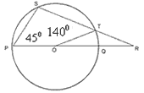
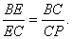
- . In the given figure, DE || AC and DC || AP, prove that

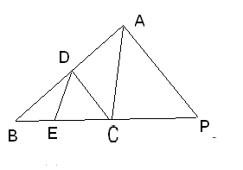

OR

In is aculte, BD and CF are perenducular on AC and AB respectively.

Prove that AB X AE = AC X AD

- Construct a triangle ABC similar to a give triangle PQR with QR = 6cm, PQ = PR = 5cm. Such that each of its side is 6/7th of the corresponding sides of the triangle PQR. Also draw the circumcircle of triangle ABC.

- Evaluate: 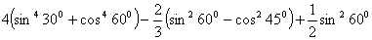
OR
Prove 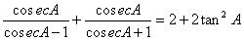
If u want to get more sample papers plz log on www.pushpender86.co.cc
www.mathshelpline.co.cc www.sciencehelpline.co.cc
Mail me at cbsehelp4u@gmail.com

- The volume of two spheres are in the ratio 64 : 27. Find their radii if the sum of their radii is 21cm.

- Find point (or points) which are at a distance of 10 from the point (4 3) given that the ordinate of the point (or points) is twice the abscissa

- Show that the points (0, 1), (2, 3), (6, 7) and (8, 3) are the vertices of a rectangle.
- If the equation (1 + m²) x² + 2 mcx + (c² - a²) = 0 has equal roots, prove that c² = a²(1 + m²)
- Find the value of p if mean of the following distribution is 7.5.
x | 3 | 5 | 7 | 9 | 11 | 13
y | 6 | 8 | 15 | p | 8 | 4

- A girl 1·6 m tall is 20 m away from a tower and observes that the angle of elevation of the top of the tower is 60°. Find the height of the tower.
A spherical cannon ball, 28cm in diameter is melted and cast into a right circular conical mould, the base of which is 35cm in diameter. Find the height of the cone.
- . Bisectors of angles A, B and C of a triangle ABC intersect its circum circle at D, E and F, respectively. Prove that the angles of the are 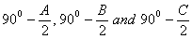, respectively.
- . If two sides of a cyclic quadrilateral are parallel, prove that
A) The remaining two sides are equal and
B) Both the diagonal are equal
If u want to get more sample papers plz log on www.pushpender86.co.cc
www.mathshelpline.co.cc www.sciencehelpline.co.cc
Mail me at cbsehelp4u@gmail.com
- A polygon has 10 sides .The lengths of the sides starting with the smallest form an AP .If the perimeter of the polygon is 420 Cm and the length of the longest side is twice that of the shortest side .Find the first term and the common difference of the AP
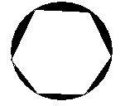
- Prove that $(\text{sin}A+\text{cos}\text{ecA})^{2}+(\text{cos}A+\text{sec}A)^{2}=7+{\text{tan}}^{2}A+{\text{cot}}^{2}A$OR
Prove that $\frac{\text{cos}A−\text{sin}A+1}{\text{cos}A+\text{sin}A−1}=\text{cos}\text{ecA}+\text{cot}A$ , Using the identity $\text{cos}{\text{ec}}^{2}A=1+{\text{cot}}^{2}A$
- Observe the graph and state whether the quadrilateral ABCD is a parallelogram .Justify your answer .
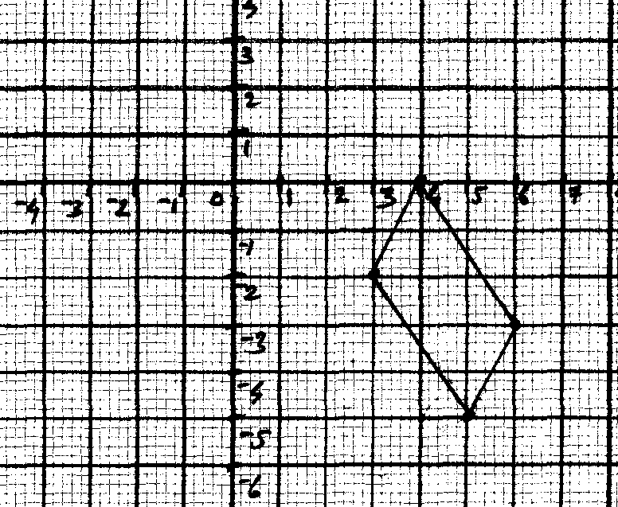
- Find the area of the triangle formed by joining the mid points of the sides of the sides of triangle whose vertices are $(4,−7),(−8,7),(\text{10},\text{13})$
- Draw a triangle ABC with side $\text{BC}=6\text{cm}$ , $∠B={\text{30}}^{0},∠A={\text{120}}^{0}$ then construct a triangle whose sides are $\frac{4}{3}$ times the corresponding sides of $Δ\text{ABC}$
- Prove that the opposite sides of a quadrilateral circumscribing a circle subtend supplementary angles at the centre of the circle
- A regular hexagon is circumscribed by a circle of radius 14 Cm .Find the area of the shaded region .OR

A square ABCD is inscribed in a circle of radius 10 units .Find the area of the circle , not included in the
square (use $π=3\text{.}\text{14}$)
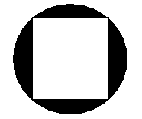
SECTION D

- A train covers a distance of 90 Km at uniform speed .Had the speed been 15 Km /hr more . it would have taken 30 minutes less for the journey find the original speed of the train
OR
A party of tourists booked a room in a hotel for Rs 1200 , three of the members failed to pay as a result others had to pay Rs 20 more (each) . How many tourists were there in the party
- The angle of elevation of a jet plane from a point A on the ground is ${\text{60}}^{0}$ .After a flight of 15 seconds , the angle of elevation changes to ${\text{30}}^{0}$ .If the jet plane is flying at a constant height of $\text{1500}\sqrt{3}m$ , find the speed of the jet plane OR
From a building 60m heigh the angle of depression of the top and bottom of lamp post are ${\text{30}}^{0}$ and ${\text{60}}^{0}$ respectively .Find the distance between lamp post and building ,also find the difference of height between building and lamp post
- Prove that in a right triangle , the square of the hypotenuse is equal to the sum of the squares of the other two sides
Using the above solve the following
L and M are the mid points of AB and BC respectively of $Δ\text{ABC}$, right angled at B prove
that $4{\text{LC}}^{2}={\text{AB}}^{2}+4{\text{BC}}^{2}$
- A building is in the form of a cylinder surmounted by a hemispherical vaulted dome ,the building contains 17.7 m³ of air and its internal diameter is equal to the height of the cylindrical part find the height of the building (use $π=\frac{\text{22}}{7}$)
- Find the median of the following data
Class interval | 110-119 | 120-129 | 130-139 | 140-149 | 150-159 | 160-169 | 170-179
Frequency | 5 | 25 | 40 | 60 | 40 | 25 | 5

