Guess Paper – 2009
Class – X
Subject – Mathematics

Set - A
__________________________________________________________________________

Section A

1. Express 0.6 as a rational number in simplest form.

2. Can we have two medians of a data ?

3. Can a quadratic polynomial have no zero?

4. On comparing the ratios ‘ and without drawing them, find out whether the lines
representing the following pair of linear equations intersect at a point, are parallel
or coincide
5x - 4y + 8 = 0 ; 7x + 6y – 9 = 0

sin 18°
5. Evaluate : cos 72°

6. A tangent PQ at a point P of a circle of radius 5 cm meets a line through the centre
0 at a point Q so that OQ = 12 cm. Find the length of PQ.

7. Find the length of the tangent drawn to a circle with radius 7 cm from a point 25
cm away from the centre of the circle.

8. Without using trigonometric tables, evaluate
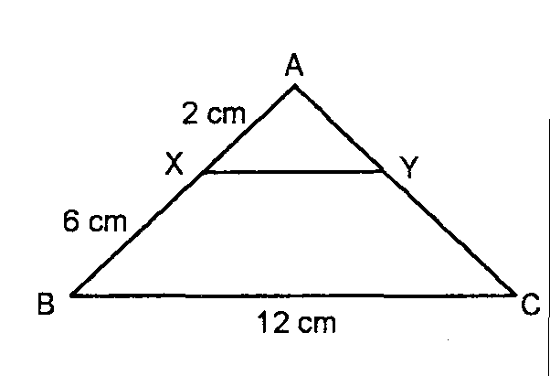
cosec 89° — sec 1°.

9. In the given figure, XY BC. Find the length of XY.

10. Prove that: tanA (1 – sin A) = sinA . cosA .

Section B

11. The 10th term of an AP is 52 and 16th term is 82. Find the 32nd term and the general
term.

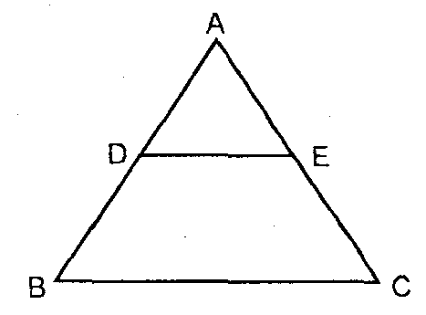
12. Two unbiased coins are tossed simultaneously. Find the probability of getting at
most one head.

13. In the adjoining figure, find AE.


14. Show that the points (1, —1), (5. 2) and (9, 5) are collinear.

15. A quadrilateral ABCD is drawn to circumscribe a circle. Prove that
AB + CD = BC + DA.
Section C

16. Determine graphically the vertices of the triangle whose sides are
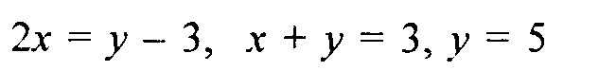
Or
Solve the following system of linear equations for x and y.
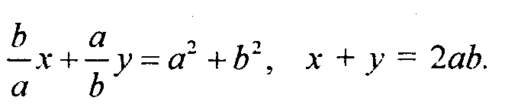

17. If the roots of the equation (b - c) x² + (c - a) x + a - b = 0 are equal, prove that
2b = a + c.

18. Divide 32 into four parts which are in AP such that the ratio of the product of
extremes to the product of means is 7 : 15.
Or
If the sum of m terms of an AP is the same as that of n terms,show that the sum of
(m + n) terms of the AP is 0.
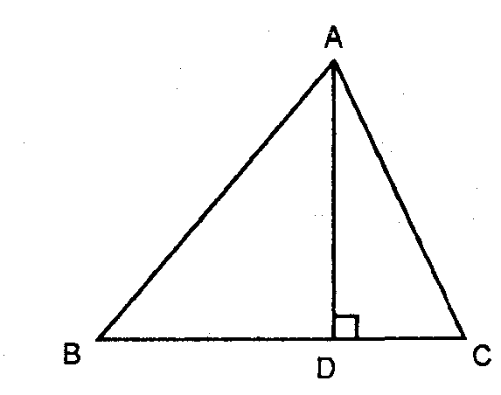
19. In an acute angled triangle ABC, . Prove that
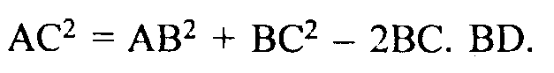

20. Draw a pair of tangents to a circle of radius 5 cm, which are inclined to each
other at an angle of 60.

21. Prove that the sum of the squares of the diagonals of a rhombus is equal to the
sum of the squares of its sides.

22. The wheels of a car are of diameter 80 cm each. How many complete revolutions
does each wheel make in 10 minutes, when the car is traveling at a speed of 66
km/h ?
23. Find the values of k for which the quadratic equation 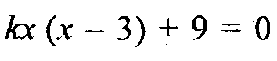 has real
and equal roots.
Or
Solve for x 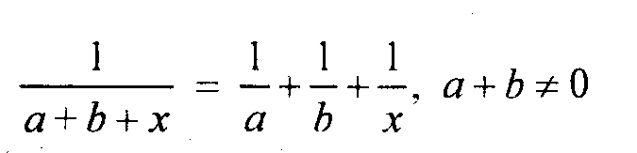

24. D is a point on the side BC of ^ABC such that <ADC = <BAC. Prove that CA² = CB x
CD.

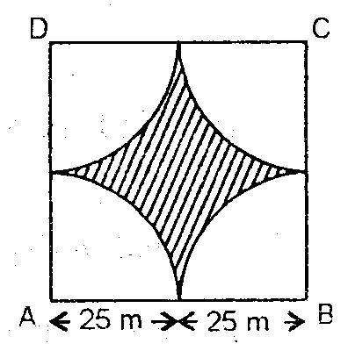
25. Four cows are tethered at four corners of a square plot of side
50 inches, so that they just can not reach one another. What area
will he left ungrazed ?

26. Solve the following system of linear equations graphically
4x - 5y - 20 = 0; 3x + 5y - 15 = 0
Determine the vertices of the triangle formed by the lines representing the
above equation and the y - axis.

27. A man standing on the deck of a ship, which is 10 metre in above water level.
He observes the angle of elevation of the top of a hill as 60° and the angle of
depression of the base of the hill as 30°. Calculate the distance of the hill from the
ship and the height of the hill.
Or
Two poles of equal heights are standing opposite each other on either side of the
road, which are 80 in wide. From a point between them on the road, the angles of
elevation of the top of the poles arc 60° and 30° respectively. Find the height of
the poles and the distance of the point from the poles.

28. Calculate the mode of the following frequency distribution.
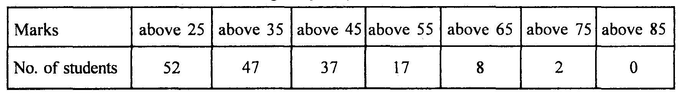

29. Two trains leave a railways station at the same time. The first train travels due
south and the second train due north. The first train travels 5 km/h faster than
the second train. If after 2 hours, they are 50 km apart, find the average speed of
each train.
Or
The hypotenuse of a right angled triangle is 20 cm. If the difference between the
lengths of the other two sides is 4 cm , find the other sides.

30. If a line is drawn parallel to one side of a triangle to intersect the other two sides
in distinct points, the other two sides are divided in the same ratio. Prove.

For any queries,please feel free to contact
Vivek Sir T.G.T (Maths)
# 66,saket nagar, infront of the church, ranjhi, jabalpur, m.p – 482005
Mobile :- 09424677661, Tel :- 0761 - 2337892

Email :- vivekjab@hotmail.com
vivekonjob@yahoo.co.in
vivek_soni@indiatimes.com

