Sample Paper -2009
Class – XII
Subject- Informatics Practices

Time allowed: 3hr. M.M:-70
Note
- Please check that this question paper contains 7 questions.
- Please write down the serial number of the question before attempting it.
- This question paper is divided into sections
- Section – A consists of 30 marks.
- Section – B and Section – C are of 20 marks each
- Answer the questions after carefully reading the text.
- Take control object name as required.

Section – A
Q1.
- What are different advantages and disadvantages of visual basic? 2
- Differentiate enabled and visible properties. 2
- How do we specify comments in Visual Basic? How do we break a long line of
code to a new line? 2
- Differentiate between public and private variable and discuss their scope of visibility. 2
- How do input box and msgbox differ from each other? 2

Q2.
- What is the purpose of ALTER TABLE command? 1
- What is the purpose of COMMIT and ROLLBACK statement? 2
- How do we restrict duplicate rows in SELECT Query? Give example. 1
- What is Distributed database? What are its significance? 2
- Sate difference between SQL and PL/SQL. 2
- What is the purpose of %TYPE and %ROWTYPE? 2

Q3.
- Identify the errors in the following statement: 2
- Name := VEER;
- DOJ := ’DEC-26-1982’;
- Roll = 232;
- X+Y := Z;
- What is difference between EXIT and EXIT-WHEN statement in PL/SQL? 2
- Explain the usage of bind variable in PL/SQL with help of an example. 2
- What is cursor in PL/SQL? List any two commands used for cursor control. 2
- What is looping statement? Differentiate between an entry control and an exit control 2 loop.

Section B
Q4. Read the following case study and answer the question follow:
The FOR U SHOP has computerized its billing. A new bill is generated for each customer.
The shop allows three different payment modes. The discount rate is based on the payment mode. The following is the data entry screen used to generate the bill:
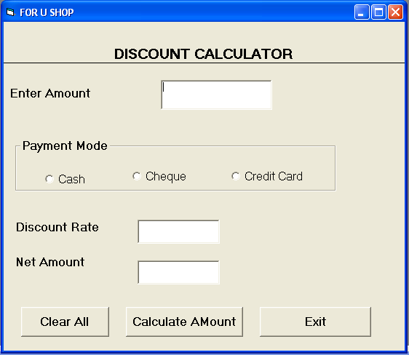

Object Type | Object Name | Description
Form | frmDiscount | The main form
Text Box | TxtAmt | To input total Shopping Amount
Text Box | TxtDisc | To display Discount Rate
Text Box | TxtNet | To display Net Price
Option Buttons | Optcash | To select mode of payment as cash
Option Buttons | Optcheque | To select mode of payment as cheque
Option Buttons | OptCredit | To select mode of payment as credit card
Command Buttons | Cmdcalc | To calculate discount and Net amount
Command Buttons | Cmdclear | To clear all textboxes
Command Buttons | Cmdexit | To exit from the application

(a) Write the code for the CmdClear command button to clear all the textboxes. 1
(b) Write the code for the form load event of FrmDiscount so as to
(i) Disable the TxtDisc and the Txtnet textboxes and set default choice in the option button as cash. 1
(ii) Set the focus to the textbox. 1
(c) Write the code for the change event of the TxtAmt textbox to ensure that the user does not enter a negative or zero value. If a negative or zero value is entered then the textbox should be made blank and warning message should be displayed. 2
(d) Write the code for code for Cmdexit to display the message “APPLICATION IS SHUTING DOWN” and exit from the application. 1
(e) Write the code for the CmdCalc command button to display the discount rate and net price in the TxtDisc and TxtNet textboxes respectively. Note that net price is calculated as shopping amount- discount amount. The discount amount is calculated according to the discount rate which is based on the payment mode and total shopping amount to the following table. 4

Payment Mode | Shopping Amount | Discount Rate
Cash | <10000 | 20%
Cash | >=10000 | 25%
Cheque | <15000 | 10%
Cheque | >=15000 | %15
Credit Card | <10000 | 10%
Credit Card | >=10000 | 12%
Q5.
(a) A student of ABCD School, Davis Mathews wanted to make an application to find Even or Odd out of a given number. He had written the following code snippet and he is unable to correct some of the errors in the code. You are required to help him in correcting the code segment. Find the Errors and rewrite the corrected code underlining the correction made. 2
‘Program code to check Even or Odd out of a number in a text box txt
Private Sub cmdFind_Click()
if Val(txtNumber) Mod 2 =0
MsgBox "It is an Even Number"
Else
MsgBox "It is an Odd Number"
End Sub
(b) Find the output of the following code segment : 2
Private Sub cmdClickMe_Click()
Dim N1, N2, Counter
Counter = 1
N1 = 0
N2 = 0
Do While Counter <= 4
Print N1
Print N2
N1 = N1 + N2
N2 = N2 + N1
Counter = Counter + 2
Loop
End Sub
(c) What is the output of the following program: 2
Dim i as integer, num as integer
For i = -10 to 5 step 3
If i mod 2 = 0 then
Num = num + i
End if
Print num
Next i
(d) Rewrite the following code segment using If ... ElseIf ... EndIf instead or Select ... Case.
Select Case marks 2
Case Is >= 85
comment.Caption = "Excellent"
Case Is >= 60
comment.Caption = "Above Average"
Case Is >= 50
comment.Caption = "Average"
Case Else
comment.Caption = "Need to work harder"
End Select

(e) A student wants to write a procedure to find if a given year is a leap year or not. He had written the following code segment and he is unable to correct some of the errors in the code. Find the Errors and rewrite the corrected code underlining the correction made. 2
Note : A leap year is a year which is divisible by 4 or divisible by 400.

‘Program code to check if a year is a leap year or not
Private Sub cmdLeapyear_ONClicking()
Y = Val(txtYear)
IF Y Mod 100 = 0 AND Y Mod 400 = 0 Then
MsgBox "It is a Leap Year"
ELSEIF Y Mod 4 = 0
MsgBox "It is a Leap Year"
ELSE
MsgBox "It is not a Leap Year"
Sub End

Section – C

Q6. Read the questions given below and answer accordingly:
(a) Write the output produced by the following part of code in PL/SQL: 2
DECLARE
P NUMBER;
Q NUMBER;
BEGIN
P := 5;
FOR Q IN 1..4
LOOP
P := P + Q;
DBMS_OUTPUT.PUT_LINE(P);
END LOOP;
END;

(b) Write the output of the following PL/SQL code segment: 2
BEGIN
FOR I IN REVERSE 1..10
LOOP
IF MOD(I, 2) = 0 THEN
DBMS_OUTPUT.PUT_LINE(TO_CHAR(I*10));
END IF;
END LOOP;
END;
(e) Write a SQL (DDL) query to create the following table Emp: 2

Column Name Data Type Size Constraint
EmpID NUMBER 6 PRIMARY KEY
EmpName VARCHAR2 20 NOT NULL
EmpAddress VARCHAR2 30
EmpPhone VARCHAR2 10
EmpSal NUMBER 9, 2
(d) Write PL/SQL code to create two Statement level triggers TrigBeforeUpdateEMP
and TrigAfterUpdateEMP before and after UPDATE statement respectively on
the table EMP which signals ‘Starting Update’ to signify that modification of
records has started and ‘End of Update’ message to signify that modification is over. 4

Q7.
(a) Write a PL/SQL function CHCK_YEAR that accepts a date from the user and return
1 if the year is a leap year and returns 0 otherwise. 4
(b) Write program code to declare and use an Explicit Cursor to display the Salary
increased by 10% of above table Emp. 3
(c) What is difference between Procedure and Function? 3

