Sample Paper – 2009
Class – X
Subject – Mathematics

Similar Triangles

- Prove basic proportionality theorem. Prove that the line draws through the mid point of one side of a triangle parallel to another side bisects the third side.
- State and prove Pythagoras theorem. If ABC is an equilateral triangle of side 2a. Prove that altitude AD is a√3.
- In given figure ABC and DBC are two triangles on the same base BC. If AD bisects BC at O, Show that $\frac{\text{ar}(Δ\text{ABC})}{\text{ar}(\text{DBC})}=\frac{\text{AO}}{\text{DO}}$
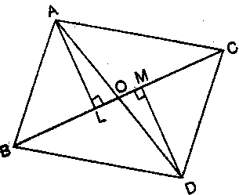
- In given figure DEFG is a square and $∠\text{BAC}$ is a right angle. Show that ${\text{DE}}^{2}=\text{BD}×\text{EC}$
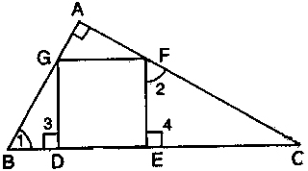
- If the triangle ABC. DE ll BC and DE : BC = 4 : 5 find the ratio of area of triangle ADE to area of trapezium BCED.
- ABCD is a trapezium in which $\text{AB}\text{ll}\text{EF}\text{ll}\text{DC}$Prove that AE : ED = BF : FC
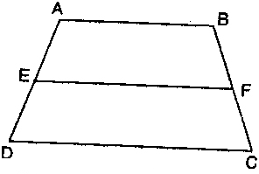
- Prove that the ratio of the areas of two similar triangles is equal to the ratio of the squares of the corresponding sides. Using the above theorem, prove that the area of the equilateral triangle described on the side of a square is half the area of the equilateral triangle described on its diagonal.
- In given figure AD is a median of $Δ\text{ABC}$ and $\text{AE}⊥\text{BC}$. Prove that i) ${\text{AC}}^{2}={\text{AD}}^{2}+\text{BC}\text{.}\text{DE}+{\left(\frac{\text{BC}}{2}\right)}^{2}$ ii) ${\text{AB}}^{2}={\text{AD}}^{2}−\text{BC}\text{.}\text{DE}+{\left(\frac{\text{BC}}{2}\right)}^{2}$ iii) ${\text{AC}}^{2}+{\text{AB}}^{2}=2{\text{AD}}^{2}+\frac{1}{2}{\text{BC}}^{2}$
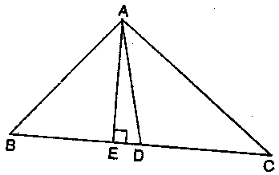
- The perpendicular AD on the base BC of a triangle ABC interests BC internally at D such that BD = 3CD Prove that 2AB² = 2AC² + BC².
- Prove that if the areas of two similar triangles are equal, then the triangles are congruent.
- Two triangles ABC and PQR are similar. If area ($Δ\text{ABC}$) = 4 area ($Δ\text{PQR}$) and BC = 12 cm. Find QR
- In $Δ\text{ABC}$, $\text{AD}⊥\text{BC}$and BD = 3CD . Prove that $2{\text{AB}}^{2}=2{\text{AC}}^{2}+{\text{BC}}^{2}$
- In $Δ\text{ABC}$, <A = 90⁰,$\text{AD}⊥\text{BC}$. Prove that ${\text{AB}}^{2}+{\text{CD}}^{2}={\text{BD}}^{2}+{\text{AC}}^{2}$
- In given figure PA, QB and RC are each perpendicular to AC and AP = x, QB = z, RC = y, AB = a, and BC = b. Prove that $\frac{1}{x}+\frac{1}{y}=\frac{1}{z}$
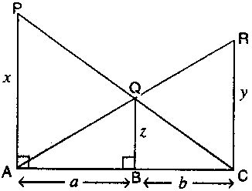
- ABC is a right angle triangle at C ,If p be the length of the perpendicular from C to AB and AB = c, BC = a , CA = b, then prove that (a) pc = ab (b) $\frac{1}{p^{2}}=\frac{1}{a^{2}}+\frac{1}{b^{2}}$
- In given figure E is the point on side CB produced of an isosceles $Δ\text{ABC}$ with AB = AC. If $\text{AD}⊥\text{BC}$and $\text{EF}⊥\text{AC}$, prove that $Δ\text{ABD}≈Δ\text{ECF}$
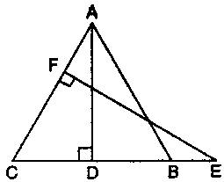
- In given figure the line segment DE is parallel to side BC of triangle ABC and it divides the triangle into two parts of equal areas. Find the ratio of $\frac{\text{BD}}{\text{AB}}$
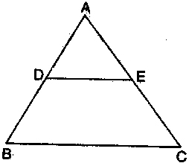
- In given figure A, B and C are points on OP, OQ and OR respectively such that $\text{AB}‖\text{PQ}$ and $\text{AC}‖\text{PR}\text{.}$ Show that $\text{BC}‖\text{QR}\text{.}$
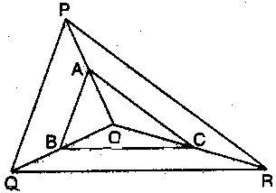
- The areas of two similar triangles are 121 cm² and 64 cm² respectively. If the median of the first triangle is 12.1 cm. Find the corresponding median of the other.
- In given figure $\text{DE}‖\text{AC}$ and $\text{DF}‖\text{AE}$. Prove that $\frac{\text{BF}}{\text{FE}}=\frac{\text{BE}}{\text{EC}}$
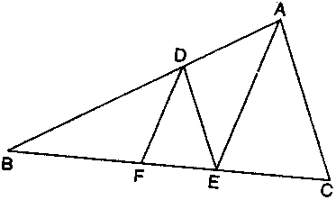
- ABC is a right angled at A,$\text{AD}⊥\text{BC}$. If BC = 13cm, AC = 5cm. Find the ratio of the areas of $Δ\text{ABC}$ and $Δ\text{DAC}$.
- In given figure $Δ\text{ABC}$ and $Δ\text{DBC}$are on the same base BC. Prove that $\frac{\text{ar}(Δ\text{ABC})}{\text{ar}(\text{DBC})}=\frac{\text{AX}}{\text{DX}}$
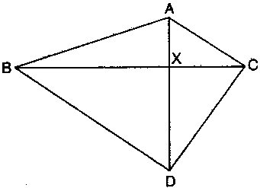
- Prove that three times the square of any side of an equilateral triangle is equal to four times the square on the altitude.
- In given figure AD and CE are medians of a triangle ABC right angled at A. Prove that $4({\text{AD}}^{2}+{\text{CE}}^{2})=5{\text{AC}}^{2}$
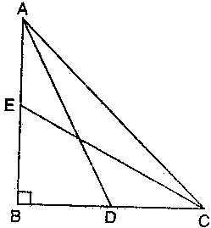
- In a rhombus ABCD, prove that ${\text{AB}}^{2}+{\text{BC}}^{2}+{\text{CD}}^{2}+{\text{DA}}^{2}={\text{BD}}^{2}+{\text{AC}}^{2}$
- In a isosceles$Δ\text{ABC}$, AC = BC and${\text{AB}}^{2}=2{\text{AC}}^{2}$, Prove that C is a right angle.
- In given figure $\text{LM}‖\text{CB}$ and $\text{LN}‖\text{CD}$. Prove that $\frac{\text{AM}}{\text{AB}}=\frac{\text{AN}}{\text{AD}}$
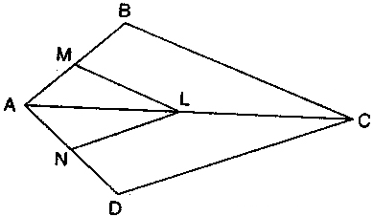
- Find the length of the diagonal of a square whose side measures 50 cm.
- The perimeter of two similar triangles are 24cm and 18cm. If one side of the first triangle is 8 cm, what is the corresponding side of the other triangle?

