Sample Question Paper-I
GEOGRAPHY (Theory)
CLASS XII
Time : 3 hrs. Max. Marks : 70

General Instructions:
1. There are 26 questions in all.
2. All questions are compulsory.
3. Marks for each question are indicated against it.
4. Question numbers 1 to 10 are very short answer questions carrying 1 mark each.
Answer to each of these questions should not exceed 20 words.
5. Question numbers 11 to 20 are short answer questions carrying 3 marks each. Answer
to each of these questions should not exceed 80 words.
6. Question numbers 21 to 25 are long answer questions of 5 marks each.
Answer to each of these questions should not exceed 150 words.
7. Question no. 26 is related to identification or locating and labelling of geographical
features on maps.
8. Outline maps of the World and India provided to you must be attached within your
answer book.
9. Use of templates or stencils for drawing outline maps is allowed.

Q 1. What is the population size of Class I cities in India? 1

Q 2. Name the two categories of air transport in India. 1

Q 3. Name the headquarters of Northern Railway Zone of India. 1

Q 4. Name the stretch of National Waterway No. 1 of India. 1

Q 5. Which type of pollution causes various diseases related to the respiratory system?
Q 6. Give one example each of ferrous and non-ferrous industries. 1

Q 7. Explain the term Quinary Activities. 1
Q 8. Which means of transport is highly suitable for transporting heavy and bulky goods at very low cost over long distances between continents. 1
Q 9. Explain the most important feature of the pipeline constructed from Naharkatia oil field to Barauni. 1
Q 10. Which one of the following waterways has drastically reduced the oceanic distance between India & Europe:- (i) The Rhine waterway; (ii) The Cape of Good Hope Searoute; (iii) Suez Canal and (iv) Panama canal. 1

Q 11. Make the correct pairs of each item of List I by selecting the appropriate word from
List I : Fields of Human Geography
1.1 Social Geography, 1.2 Political Geography and 1.3 Economic Geopraphy
List II : Disciplines of Social Science
A. Urban Studies and Planning, B. Agricultural Sciences, C. Demography, D. History and
E. Military Science. 3x1=3
Q 12. State any three characteristics of clustered rural settlements in India. 3x1=3
Q 13. Describe three major problems associated with urban waste disposal in India. 3x1=3

Q 14. Distinguish between the Dryland farming and Wetland farming in India by explaining three distinguishing features of each. 3x1=3

Q 15. Explain the meaning of water quality. Why is the quality of water in India deteriorating? Give any two reasons. 1+2=3

Q 16. Explain any three important measures initiated under the new Industrial Policy of India announced in 1991. 3x1=3

Q 17.
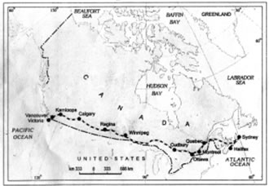
(17.1) Name the transcontinental railway line shown in the above map.

(17.2) How has this railway line helped in the economic development of the region? Explain two points. 1+2=3

For Blind Candidates only in lieu of Question 17

(17.1) Name the Trans Continental railway of Canada.

(17.2) Explain any two points regarding the economic importance of this railway line for the country. 1+2=3

Q 18. Study the given table and answer the following questions.
Percentage of net irrigated area to total by wells and tube-wells
State Percentage
Gujarat 86.6
Rajasthan 77.2
Madhya Pradesh 66.5
Maharashtra 65
Uttar Pradesh 58.21
West Bengal 57.16
Tamil Nadu 54.7

(18.1) Name the state which has the highest percentage of irrigated area by wells & tube-wells.Also give the reason for the same.

(18.2) Which state has the lowest percentage of area irrigated by wells and tube-wells? Also give the main reasons for the same. 1½+1½=3

Q 19. Study the given map showing areas of extensive commercial grain farming in the world. Write in your answer book the correct names of grasslands associated with commercial Grain Farming in areas A, B and C marked in the map. 1+1+1=3
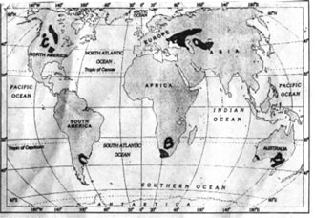

For Blind Candidates only in lieu of question No. 19

Name the grasslands assoicated with commerical grain farming in North America, Africa and Australia 3x1=3
Q 20. Study the diagram given below and answer the questions that follow.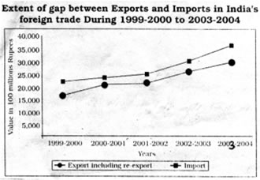

(20.1) In which year is the gap between exports and imports least? How much is the deficit in our foreign trade in this year?

(20.2) Which year shows the highest deficit in our foreign trade? Give its value.

(20.3) What is the main reason behind an increase in our trade deficit? 1+1+1=3

For Blind Candidates only in lieu of question No. 20
Answer the following questions

(20.1) What is International Trade?
(20.2) Give the meaning of Trade deficit.
(20.3) What is the main reason behind an increase in India’s trade deficit? 3x1=3

Q. 21 What is the Human Development? Describe in brief the four approaches of Human Development. 1+4=5
Q. 22 Define the term ‘trade’. State four characteristics of Rural Marketing Centres. 1+4=5

Q. 23 Explain any five advantages of water transport in the world. 5x1=5

Q. 24 “Rural settlements in the world are affected by several factors”. Support this statement with five suitable examples. 5x1=5

Q.25 Explain any five economic consequences associated with migration in India. 5x1=5

Q. 26 (26.1) In the given outline political map of the World, four features are shown by A, B, C, D. Identify the features with the help of the information given below and write their correct names on the lines marked in the map.
A. Mega City
B. Largest region of dairy farming.
C. Western terminal city of Australian Trans Continental Railway.
D. An important industrial centre.
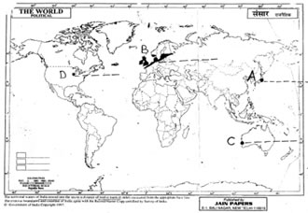

(26.2) Locate and label the following on the given outline politicial map of India.
(i) The state having the highest percentage of population below the
poverty line.
(ii) The state leading in coffee production.
(iii) The software technology park in Uttaranchal. 3x1 = 3
4x½=2
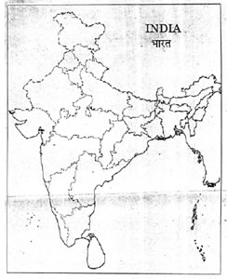
For Blind Candiates only in lieu of question 26
Answer the following questions :
(1) Name the western terminal station of Australian Trans Continental Railway.
(2) Name any one Mega city of Japan
(3) A state in India having the highest percentage of population below the poverty line.
(4) A state in India leading in coffee production.
(5) The software technology park in Uttaranchal.
5x1=5

