TIME:3HR M.MARKS: 100
CLASS: X
MATHEMATICS

General Instructions
(i) All questions are compulsary.
(ii) This question paper consists of 25 questions divided into three sections. Section A
(Q.1to 10), Section B (Q. 11 to 20) and Section C (Q 21 to 25).
(iii) As far as possible answer questions in serial order. When you are not sure of
answering the question, you may leave it for the tine being and proceed further
without wasting your time.
(iv) When you wish to re-answer any question, please cancel the first one.
(v) Use of a calculator is not permitted.
(vi) Keep some time for revision.
(vii) Please, write down the serial number of the question before attempting it.
(viii) Use of calculator is not allowed. However, you can use Mathematical Tables.

SECTION A
(Question numbers 1 to 10 carry three marks each).

1. Find the value of k for which the system of equations have a unique solution:
x −ky = 2, 3x+ 2y = −5

2. Find the GCD (HCF) of the polynomial 2x⁴ − 2y⁴, 3x³ + 6x²y − 3xy² − 6y³

3. Simplify :

4. Solve using quadratic formula, for x : a(x² + 1) = x(a² + 1)

- Which term of A.P. 3, 15, 27, 39 ------- is 132 more than 54th term.

- Find the sum of the following A.P. 1 + 3+ 5+ 7 -------------199

7. A cooler is sold for Rs.4000 cash or for Rs.1600 cash down payment and two installments
of Rs.1300 paid monthly. Find the rate of interest.

8. A loan of Rs.12,000 is obtained by Shiela to repair her house. The amount is to be paid
back in equal 2 annual instalments. How much is each instalment, if the interest is
compounded annually on balance at 5% p. a.

- Show that the diagonals of a trapezium divide each other proportionally.

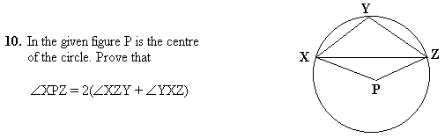

SECTION B
Question numbers 11 to 20 carry four marks each.

- Solve graphically the equation x − y =10, 2x −3y = − 10.

12. Simplify:

13. What point on the X- axis is equidistant from the points (7,6) and (− 3,4)

14. Prove that

15. An agricultural field is in the form of a rectangle of length 20m and width 14m. A 10m
deep well of diameter 7m is dug in a corner of the field and the earth taken out of the
well is spread evenly over the remaining part of the field. Find the rise in its level.

- Draw a pie chart representing the following data showing the number of
Students who like different subjects:
Subject No. of Students
Physics 45
Chemistry 20
English 60
Maths 30
Biology 10
Punjabi 15

17. A die is thrown once. Find the probability of getting: (i) an even no.
(ii) a prime no. (iii) a no. greater than 4 (iv) a no. greater than 3.

- Find the ratio in which the point (- 3, p) divides the line segment joining
the points (- 5, - 4) and (- 2, 3). Find also the value of p.

- The weekly observations of cost of living
Cost of Living Index | No. of Weeks
140 - 150 | 5
150 - 160 | 10
160 - 170 | 20
170 - 180 | 9
180 - 190 | 6
190 - 200 | 2
Total | 52

index in a certain city for the year 2000-01
are given alongside. Compute the mean
weekly cost of living index by using
Step Deviation Method.

- Draw a ΔABC with base BC = 4.1 cm ∠B = 60° and side AB = 5 cm. Draw its
incircle.
SECTION C
Question numbers 21 to 25 carry 6 marks each.

- Ram Lal has a total annual income of Rs. 1,60,000. He contributes Rs.4,000 per
month in his G.P.F. and pays an annual LIC premium of Rs. 15,000. If he pays
Rs.250 per month for the first 1 1 months as income tax, find his income tax
liability for the last month. Use the following slab for calculating the income tax.

Standard Deduction: (i) (1/3)rd of total income if the income is up to Rs. 1,50,000
( Maximum Rs. 30,000 )
(ii) Rs. 25,000 if the income is from Rs150000 to Rs300000
(iii) Rs. 20,000 if the income is from Rs300000 to Rs500000
(iv) Nil, if the income is above Rs.500000
.
Rate of Income Tax : (i) Up to Rs.50000: Nil
(ii) Rs.50001- 60000: 10% of income exceeding Rs.50000
(iii) Rs.60001 –150000 Rs.1000+20% of income exceeding
Rs.60000
(iv) Above Rs.150000 Rs.19000+30%of income exceeding
Rs.150000

Rebate: (i) 20% of total savings if taxable income is up to
Rs.150000 (Maximum Rs.14000)
(ii) 15% of total saving if taxable income is above
Rs.150000 (Maximum Rs. 10500)
- Special income tax rebate to women employees at the
rate of 100% (Maximum Rs.5,000)

Surcharge: 5% of net tax.

- Prove that the ratio of the areas of two similar triangles is equal to the ratio
of the squares of their corresponding sides. Using the above : prove that area
of an equilateral triangle described on the side of a square is half the area of
an equilateral triangle described on its diagonal.
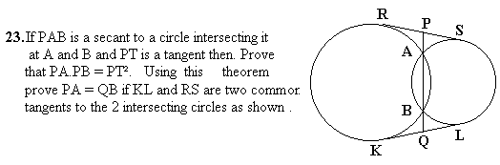
24. From the top of a house the angles of depression of two ships on the opposite sides
of it are observed to be α and β. If the height of the house be h meters and the line
joining the ships passes through the foot of the houae, show that the distance between

ships is h [tan α + tan β] tan α tan β metres.

25. A container made up of a metal sheet is in the form of a frustum of cone of
height 16 cm with radii of its lower and upper ends as 8 cm and 20 cm respectively.
Find the cost of milk which can completely fill the container at the rate of Rs.15
per litre.

