Guess Paper – 2009
Class – X
Subject – Biology
Nomenclature and Classification

MM: 70 TIME : 3hrs
General Instructions:
1)question 1-8 are of 1 mark each
2)question 8-21 are of 2 mark each
2)question 21-27 are of 3 mark each
3)question 27-30 are of 5 mark each

SECTION A
- Name the cell which form lining of kidney tubules and salivary glands?
- Where are bone cells located? what is it composed of?
- How are cardiac muscles different from striated muscles?
- Name any 4 triploblastic organisms?
- In which kingdom would you place the organisms that are photosynthetic as well as single celled eukaryotic organisms?
- Name the tissues storing fats in our body?
- Name the type of tissue present on the tip of the stem node?
- What is the function of fibres in xylem?

SECTION B
- Draw the labeled diagram of areolar tissue.Mention uses of
- What are properties of vertebrates?
- How do poriferans differ from coelenterates ?
- What are the differences between gymnosperms and angiosperms?
- Fill the table
Kingdom | Organization Level | Examples | Cell wall
a) | Organ level | Periplanata | b)
Fungi | Cell and tissue based | c) | d)

- Name the kingdom in which blue-green algae is present? Describe its structure.
- Where are areolar tissues found?
- Why is the shell of the coconut so hard?
- What is the function of
  - Guard cells
  - Cork cells
- How are glandular epithelium formed? In which subcategory is placed? What is its function?
- What is the type of tissue located at the tip of our nose? how is different from bone tissue.
- How does the bone retains its strength even after several years of life? How does it grow?
- What is function of blood?

SECTION C
- Draw a neat and labeled diagram of
  - Euglena
  - Paramecium
- Which group is called amphibian of plant kingdom? Why? label the diagram of pteridophyte (Marsilea ).
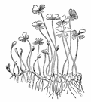
a)
b)
c)
d)

- What are cryptogames? Draw a labeled diagram of Hydra.
- Identify the groups which they belong to and give 2 examples of its members :
  - Sucker in parasites and segmented body
  - Blood does not flow in blood vessels but also in body cavity. It also has ‘joined legs’.
  - It is cold-blooded and it also has two chambered heart.
  - It has lungs in larval stage and can breath through its skin.
  - It has hard exoskeleton and has pores called ostia in its body
  - It shows sexual dimorphism(males differ from female) and some of its members cause disease like elephantiasis.
- Write the differences in the follow :
  - Poriferans and coelenterates
  - Annelids and arthropods
  - Amphibians and reptiles
- Write scientific names of :
  - Frog
  - Mango
  - Cockroach
What are the difference between Mammals and Aves?
- Fill the Flow-Chart

Animals
Cellular level organization
a)
b)
No cavityo
Pseudocoelem
Coelemate
c)
d)
e)
Coelomate
Mesodermal cells from single cell
during embriyonic growth
Formed from endotherm(pouches)
No notochord
Notochord
f)
g)
h)
i)
J)
Notchord in larval states
Replaced by vertebral column in adult
k)
l)
n)
o)
p)

- Fill the following table based on your observation
Epithelial Tissues
Sr no | Name | Shape | Location | Function
1 | a) | b) | c) | d)
2 | e) | f) | g) | h)
3 | i) | j) | k) | l)
4 | Stratified squamous | m) | n) | o)

  - 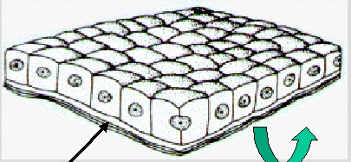

  - 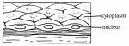

  - 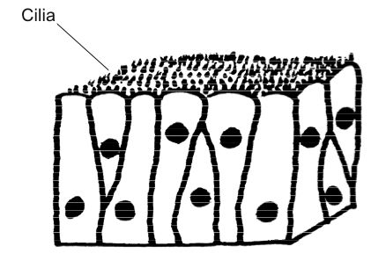

  - 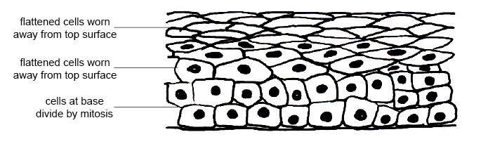

- Label the diagram and write a short note on each

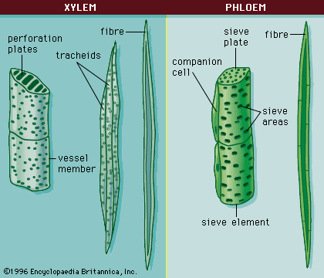
a)
b)

e)

d)

c)

Jaley
Email : Jaley.dholakia@gmail.com
Phone No. 9714089625

