Guess Paper – 2009
Class – X
Subject – Maths
TIME: 03 HOURS MAX.MARKS: 80
GENERAL INSTRUCTIONS:-
- All questions are compulsory.
- The question paper consists of thirty questions divided into 4 sections A, B,C and D. Section A comprises of 10 questions of 01 mark each. Section B comprises of 05 questions of 02 marks each, Section C comprises of 10 questions of 03 marks each and Section D comprises of 05 questions of 06 marks each.
- There is no overall choice. However, internal choice has been provided in one question of Sec: B, three questions of Sec: C and two questions of Sec: D. You have to attempt only one of the alternatives in all such questions.
- In question on construction, drawing should be neat and exactly as per the given measurements.
- Use of calculators is not permitted.

SECTION: A

- The lengths of the diagonals of a rhombus are 30cm and 40cm .
Find the side of a rhombus.
- In ABC.and DEF, if then find ar (ABC): ar (DEF).
- Prove that any two equilateral triangles are similar triangles.
- The length of the tangent from a point P to a circle of radius 3cm is
4cm. Find the distance of the point P from the centre of the centre.
- If Find the value of.
- If find the value Cos A/ Sin A
- Simplify.
- The area enclosed between two concentric circles is 770 cm². If the
radius of the outer circle is 21cm, find the radius of the inner circle .
- Determine the ratio of the volume of a cube to that of a sphere
which will exactly fit a inside the the cube.
10.How many balls, each of radius 1cm, can be made from a solid
sphere of radius 8cm?

SECTION: B

11.E is a point on side AD produced of a parallelogram ABCD and BE
intersects CD at F prove that triangle ABE is similar to triangle CFB.
(OR)
ABC is a right angled, right angled at A. A circle is
inscribed in it, the length of two sides containing the right angle
are 6,8cm. Find the radius of the circle.
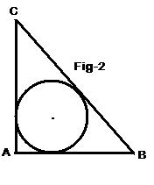

12. Prove that (SecA + TanA-1 ) (SecA-TanA+1) = 2 tanA
13. If cosecA+CotA = m. and CosecA - cotA = n, Find mn.
14. The perimeter of a sector of a circle of radius 5.2cm is 16.4cm.
Find the area of the sector.
15. In the adjoining figure, a circle touches the side BC of a ABC at P
and touches AB and AC produced at Q and R respectively. IF
AQ=5cm find the perimeter of ABC.
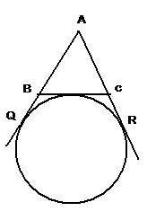

SECTION:C
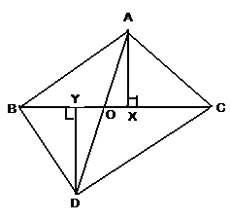

16. In fig. Prove that

(OR)

In an equilateral triangle prove that three times the square on one side is equal to four times the square of its altitudes.
17. In fig l and m are two parallel tangents to a circle of centre o at A
and B. The tangent at C makes an intercept DE between l and m.
Prove that the
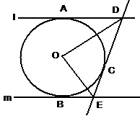

18. The length of the tangents drawn from an external point to a circle are equal. Prove it.
- If
- Prove that
(OR)
21.If A,B,C are interior angles of a ABC, prove that
tan=CotC

22. A 14m wide athletic track consists of two straight sections of
120m length joining semicircular ends whose inner radius is
35m. Calculate the area of the track.
23. A rectangular piece of paper 55cm long and 22cm wide is
rotated completely along its width. Find the volume of cylinder
thus generated.

24. A solid consisting of a cylinder 7cm diameter of height 6.5cm
surmounted by a cone at one end and a hemisphere at the other
end. If the total height of the solid is 12.8cm, find its volume.
(OR)
ABCD is quadrant of a circle of radius 14cm. With AC as diameter a semicircle is drawn. Find the area of the shaded region.
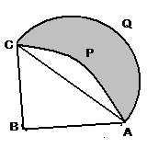

25. Draw a ABC with sides BC=6cm, AB=5cm and ABC =60.
Construct a A B’C’ similar to ABC such that sides of
A B’C’are 3/4 of the corresponding sides of ABC.

SECTION- D

26. An open metal bucket is in the shape of a frustum of a cone,
mounted on a hollow cyclindrical base made of the same metallic
sheet. The diameters of the two circular ends of a bucket sre 45cm
and 25cm , the total vertical height of the bucket is 30cm whereas
the height of the cylindrical base is 6cm. Find the area of the
metallic sheet used to make the bucket where we don’t take into
account the handle of the bucket. Also find the volume of water the
bucket can hold.
27. Two ships are sailing in the sea on either side of the light house,
the angles of depression of two ships are observed from the top of
the light house are 60º and 45º respectively. If the distance
between the ships is 200 (+1) / m. Find the height of the
lighthouse
28. A straight highway leads to the foot of the tower . A man standing
at the top of the tower observes a car at an angle of depression of
which is approaching the foot of the tower, .with uniform speed.
Six minutes later, the angles of depression of the car is found to be
60^{o.} Find the time taken by the car to reach the foot of the tower
from this point.
(OR)
Abird is sitting on the top of a tree, which is 80m high. The angle
of elevation of the bird from a point on the ground is 45º. The bird
flies away from the point of observation horizontally and remains at
a constant height. After 2 seconds, angle of elevation of the bird
from the point of observation becomes 30º. Find the speed of the
bird .
29. Prove that the ratio of the areas of two similar triangles is equal to
the ratio of the squares of their corresponding sides. Using the
above Solve the following:
If ABC is similar to DEF such that BC = 3cm, EF=4cm and area of ABC is 54cm². Find the area of DEF

(OR)

If in a triangle square one side is equal to the sum of the squares on the remaining two sides. Prove that the angle opposite to the first side is a right angle. Using the above solve the following: In a ABC, BD perpendicular to AC such that BD²=DC.AD. Prove that ABC is a right angled triangle.

30. P and Q are the mid points of the sides CA and CB respectively of a triangle ABC right angled at C. Prove that
(i) 4AQ²= 4AC²+BC²
(ii) 4BP²=4BC²+AC²
(iii) 4(AQ²+BP²)=5AB².

PREPARED BY MRS. V. KALAVATHI, TGT(MATHS),
GURU HARKRISHAN PUBLIC SCHOOL, SRI GANGANAGAR, RAJASTHAN.
E-MAIL: kalavathieswaran@yahoo.in
Phone: 0154-2482466

