Sample Paper – 2009
Class – XII
Subject – PHYSICS

Answer all the questions

Note: question no 1 -8 carries 1 mark each , 9-18 carries 2 marks each , 19-27 carries 3 marks each and 28-30 carries 5 marks each.

- What is Meissner effect of magnetism?

- If the current and voltage applied across an ideal inductor is 1A and 5 Volts what will be the power consumed by this inductor?

- What is the role of eddy current with electric power meters of our homes?

- Does E.M waves be polarized? If so give a suitable exmple to identify it.

- How should be the focal length of objective and eye piece lens to have large magnification in compound microscope?

- What is impact parameter?

- What is the overall charge of P-type semiconductor? Why?

- What are the important criterions required for selecting a material for solar cell fabrication?
- a)Draw electric field lines for an electric dipole. b) write the formula which relates polarization(electric) and electric susceptibility of dielectric medium.

- Determine the electrostatic Potential energy of the system consisting of two charges 7µc and -2 µc placed at (-9cm,0,0)and (9cm,0,0) and find the work required to separate the two charges infinitely away from each.

- a)Give an expression for mobility of charge carriers? Write its unit b)what are the two types of commercially produced resistors?

- A resistance of RΩ draw current from a potentiometer. The potentiometer has a total resistance R₀Ω . A voltage V is supplied to potentiometer. Derive that voltage across R – 2VR/ R₀ +4R when sliding contact is in the middle of potentiometer.

- What is velocity selector? Give an expression for it and for what purpose this principle has been used?
- a) why IR waves are often called as heat Waves? B) trace the path of light from the object when it passes through porro prism of critical angle 41 degrees.

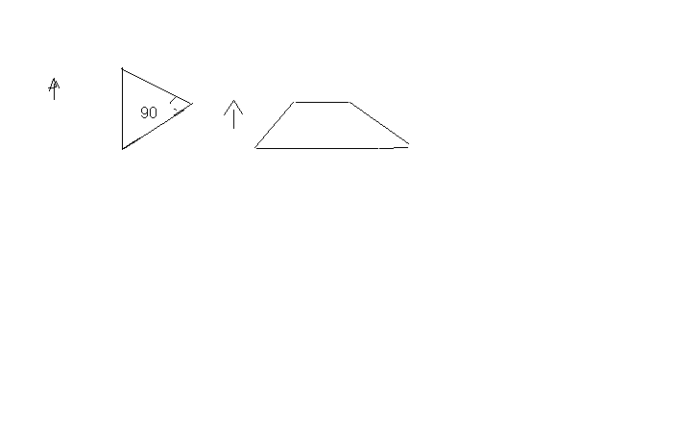
- Draw a graph to show a) the variation of retarding potential with the increase of frequency where ƒ greater than ƒ₀ b) effect of kinetic energy of photo electron with the increase of frequency ƒ
Y
- Monochromatic light of frequency 6x10¹⁴ _{Hz} is produced by a laser. The power emitted is 2x10⁻³ W. How many photons per second on an average are emitted by the source.?

- a) name the series of hydrogen spectrum lying in IR region. b) The half lifte of radon is 3.8 days. Calculate how much of 15mg radon will remain after 38 days.
- a) Name the best transmission media required for transmitting signal of frequency in excess of 100Ghz. b) why is modulation necessary for transmission of signals to distance places?
I

- Derive an expression for electric potential at any point due to an electric dipole.
- a) a metal sphere A of radius ‘a’ is charged to potential V. What will be its potential if it is enclosed by a spherical conducting shell B of radius ‘b’ and the two are connected by a wire where radius b greater than a. b) find the magnitude and direction of torque acting on a dipole placed in uniform electric field.
- a) Two heated wires of same dimension are first connected in series and then in parallel to a source of supply. What will be the ratio of heat produced in two cases. b) In the given network find the value of current across BD and BC.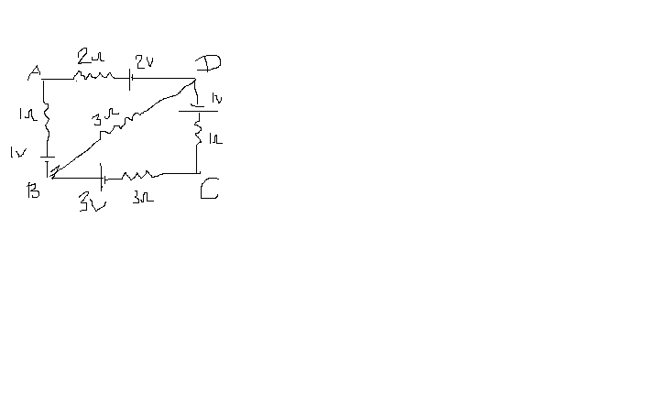
- Derive an expression for energy of LC oscillation.

- Find the e.m.f produced by a rod of length ‘l’ when rotated in an uniform perpendicular magnetic field B with respect to the centre O.

- a) Express why clouds appear white. B) why do thick lenses show chromatic aberration s? c) what are the causes of occurring two types of rainbow?

- Using Huygens’s principle, prove the law of reflection.

- Using Bohr’s postulates, derive an expression for energy of nth orbit of hydrogen atom.

- Draw a block diagram of production of amplitude modulation and hence derive an equation for production of amplitude modulated wave.

IV

- a) prove that magnitude of magnetic field at axial point of finite solenoid is equivalent to the field produced due to bar magnet at the same point. B) find the time period of magnetic dipole.

- Derive a condition for maxima and minima of angular diffraction obtained due diffraction of light through single slit by drawing a suitable diagram . b) Explain the term Red shift and blue shift involved in Doppler effect of light.

- a) explain with circuit diagram how does the transistor acts a switch. b) Draw transfer characteristics of base biased transistor. C) why npn transistor is more preferred than pnp?

ALL THE BEST

By

SIVESHWARI BHASKER
PGT PHYSICS
CHETTINAD VIDYASHRAM
CHENNAI-28 (TAMILNADU)

For any doubts/queries
Mail me at meghabhasker@gmail.com

