Guess Paper – 2009
Class – XII
Subject – Geography

Time 3 hours Max. Marks 70
General Instructions:
- There are 26 questions in all.
- All questions are compulsory.
- Marks for each question are indicated against it.
- Question numbers 1 to 10 are very short answer questions carrying 1 mark each. Answer to each of these questions should not exceed 20 words.
- Question numbers 11 to 20 are short answer questions carrying 3 marks each. Answer to each of these questions should not exceed 80 words.
- Question numbers 21 to 25 are long answer questions of 5 marks each. Answer to each of these questions should not exceed 150 words.
- Question no. 26 is related to identification or locating and labelling of geographical features on maps.
- Outline maps of the World and India provided to you must be attached within your answer book.
- Use of templates or stencils for drawing outline maps is allowed.
-------------------------------------------------------------------------------------------------------------

Q.1 Give one reason to why the compact settlements are found in parts of Rajasthan?

Q.2 On which railway route does the Asia's longest tunnel lye?

Q.3 Name one port developed after independence in India.

Q.4 Where in India is the largest wind power plant located?

Q.5 Give one reason for the degradation of land in India.

Q.6 Why Dairy farming is practiced mainly near urban and industrial centres?

Q.7 What do you mean by the term factory farming?

Q.8 Which is the busiest sea route in the world? Why the traffic is largest on this route? Give one reason.

Q.9 Name the type of settlement developed around tanks and lakes.

Q.10 Name the term coined by Patrick Geddes in 1915 applied to a large area of urban development that resulted from the merging of originally separate towns or cities.

Q.11 Name two each sub-fields of the social, political and economic fields of human geography.

Q.12 State any three measures proposed to promote sustainable development in the command area of Indira Gandhi Canal.

Q.13 Study the figure carefully and answer the questions that follow:

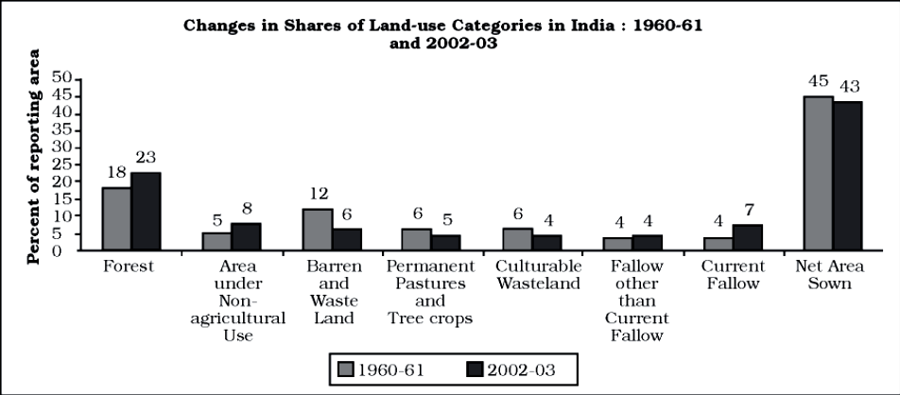

13.1 Name the land use category which have registered highest rate of increase from 1960-1961 to 2002-03.
13.2 Give two reasons for why this category has registered highest increase during this period.

Q.14 Explain with examples any three major problems associated with urban waste disposal in India?

Q.15 Study the table carefully and answer the questions that follow:
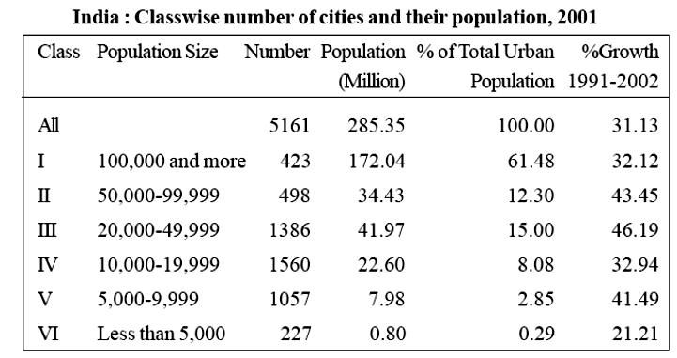
15.1 Which population size of the cities has the highest percentage of urban population?

15.2 What is the total population of this class of cities?

15.3 Give two reasons for such high percentage of total urban population residing in these cities.

Q.16 Mention any three problems which arise due to over use of ground water resources in the states of Rajasthan, Maharashtra and West Bengal.

Q.17 Compare and contrast any three features of traditional large-scale industrial regions and modern high-tech industrial parks.

Q.18 Study the map given below and write the answers of the following questions in your answer book.
18.1 Name the railway line shown in this map.
18.2 Name its terminal stations marked in the map as A and B.
18.3 State it’s importance in this region of the world?
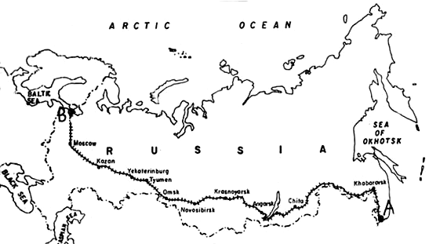

Q.19 Which three factors has improved the efficiency of ocean transport in the world?

Q.20 Explain three types of problems of urban settlements of the developing countries of the world.
Q.21 Explain any five economic consequences of migration in India.

Q.22 Explain any five factors which influenced the location of cotton textile industries away from the cotton producing areas in India.

Q.23 Describe any five features of changing patterns of the composition of India’s import.

Q.24 Explain five factors which affects the literacy rate in the world.

Q.25 What are quaternary activities? State any four important features of quaternary activities.
Q.26
(26.1) In the given outline political map of the World four features are shown by A, B, C, D. Identify the features with the help of the information given below and write their correct names on the lines marked in the map: 4x½=2

(26.2) Locate and label the following on the given outline political map of India.
(i) Software technology park of Andhra Pradesh.
(ii) The state having highest density of population.
(iii) An international airport in North-east India. 3x1=3

