Guess Paper – 2009
Class – X
Subject – Mathematics

TIME: 03 HOURS MAX.MARKS: 80
GENERAL INSTRUCTIONS:-

- All questions are compulsory.
- The question paper consists of thirty questions divided into 4 sections A, B,C and D. Section A comprises of 10 questions of 01 mark each. Section B comprises of 05 questions of 02 marks each, Section C comprises of 10 questions of 03 marks each and Section D comprises of 05 questions of 06 marks each.
- There is no overall choice. However, internal choice has been provided in one question of Sec: B, three questions of Sec: C and two questions of Sec: D. You have to attempt only one of the alternatives in all such questions.
- In question on construction, drawing should be neat and exactly as per the given measurements.
- Use of calculators is not permitted.

SECTION: A
- Two parallel tangents, drawn to a circle are at a distance of 10cm, then find the radius of the circle.
- If Sec θ=Cosec(30⁰+θ) Find the value of θ
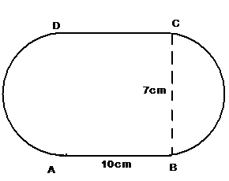
- Find the perimeter of the fig.
Arcs AD and BC are
Semicircular, given that
ABCD is a rectangle.

- A bag contains 4 red, 6 black and 9 white balls. A ball is taken out of the bag at random. Find the probability of getting a non white ball.
- If less than and more than cumulative frequency curves of certain data are intersected at a point (25, 33.5), then find the median of the distribution.
- Find the missing numbers in the factorization.

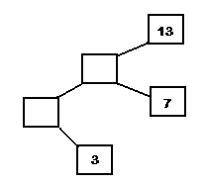

PAGE::2

- Find the HCF of 210 and 55 by Euclid’s Divisional algorithm.
- Find the sum and product of zeroes of the polynomial 3x²-4x-4.
- Check whether $\sqrt{7,}\sqrt{\text{28},}\sqrt{\text{63},}\sqrt{\text{112},}\text{.}\text{.}\text{.}\text{.}\text{.}\text{.}$form an A.P. If so find the common difference.
- In fig, DEBC and if $\frac{\text{AE}}{\text{AC}}=\frac{2}{5} ∧ \text{AB}= \text{15}\text{cm},$ find AD.
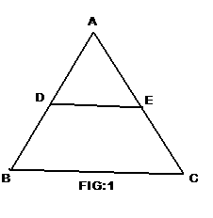

SECTION: B
- Cards. Marked with numbers 15 to 60, are placed in a box and mixed thoroughly. A card is drawn from the box at random. Find the probability that the number on the taken out card is
  - A multiple of 3 more than 45
  - A prime number more than 50.
- If (3,2), (-3,5) and (x, y) are collinear, Find the relation between x and y and hence find the value of x if y=0. (OR)
If the points (1,2),(4,y),(x,6) and(3,5) are the vertices of a parallelogram taken in order, find x and y.
13. Prove that in two concentric circles, the chord of the bigger circle, which touches the smaller circle, is bisected at the point of contact.
14 . Find the zeroes of the polynomial x²-2√2x-6.
15. Evaluate the following:
(Sin²35⁰+sin²55⁰)+ Cosec(50+θ)-Sec(40-θ)
SECTION: C
16.

17. Solve for x and y :
(OR)
Solve for x and y :
- Find a and b if (x+1) and (x-3) are factors of the polynomial
P(x) = x³+ax²+9x+b.
- The sum of the third and seventh terms of an A.P is 6 and their
product is 8. Find the sum of first sixteen terms of the A.P.
- Prove that √7 is an Irrational. Is 3+√7 an irrational number? Justify your answer.
21. In the fig No: 2, P is a point on AB such that AP:PB = 4:3. PQ is
Parallel to AC.
(i) Find PQ: AC
(ii) In ∆ARC, $∠\text{ARC}={\text{90}}^{0}$and in ∆PQS, $∠\text{PSQ}={\text{90}}^{0}$, QS=6cm.
Find the length of AR.
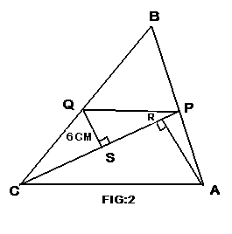

(OR)
If ‘A’ is the area of the right triangle and ‘a’ is one of the sides containing right-angle. Prove that the length of the altitude on the hypotenuse is $\frac{2\text{aA}}{\sqrt{a^{4}+4A^{2}}}$
- Draw a circle of radius 3.4cm. Construct two tangents to the circle with an angle of 80⁰ between them.
- Find the area of the design region in the adjoining figure, which is common between two quadrants of two circles of radius 8cm each.
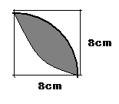

- Prove that the point (-1, 0) trisects the line segment joining the points A (2,-2) and B(-7,4). Find other points of trisection also.
25. Find the area of the triangle formed by the mid points of the sides of the triangle A (4,-6), B (3,-2) and C(5,2).
.
SECTION: D
26. Water flows out through a circular pipe whose internal radius is 1cm, at the rate of 80cm/sec into an empty cylindrical tank, the radius of whose base is 40cm. By how much will the level of water rise in the tank in half an hour?
27. The angle of elevation and depression of the top and bottom of a light-house from the top of a building 60m high, are 30⁰ and 60⁰ respectively. Find
(i) the difference between the heights of the light house and the building.
(ii) Distance between the lighthouse and the building.
28.Find the missing frequencies p & q in the following table if the median of the distribution is 55kg.
Weight(kg) | 30-40 | 40-50 | 50-60 | 60-70 | 70-80 | 80-90 | Total
No. of persons | 3 | 9 | p | 6 | q | 3 | 36

29. Prove that the lengths of the tangents drawn from an external point to a circle are equal.
Using the above, do the following.
If all sides of a parallelogram touch a circle, show that the parallelogram is a rhombus.
(OR)
In a right triangle, the square on the hypotenuse is equal to the sum of the squares on the other two sides. Prove it.
Using the above, do the following.
Show that the altitude of an equilateral triangle of side 10 cm is 5√3cm.
30. Sum of the areas of two squares is 468m². If the difference of their perimeter is 24m, find the sides of the two squares.
(OR)
An express train makes a run of 240km at a certain speed. Another train whose speed is 12km/hr less takes an hour longer to cover the same distance. Find the speed of the express train in km/hr.

