Guess Paper – 2009
Social Science
Class X
Time: 3hrs. Max Marks :80
General Instructions:-
(i) There are 29 questions in all. All questions are compulsory.
(ii) Questions from 1-10 are 1 mark questions.
(iii) Questions from 11-18 are 3 marks questions.
(iv) Questions from 19-28 are 4 marks questions.
(v) Question no. 29 is map question. Attach Maps inside your Answer sheet.

1. Mention a novel in which Dickens wrote about ill-effects of industrialization Or Who printed the first Bible? 1
2. With which dam Narmada Bachao Aandolan is associated? 1
3. What is an ore? 1
4. Give a difference between metallic and non-metallic roads. 1
5. What is feminist movement? 1
6. Name two leaders who fought against untouchability? 1
7. Give an example of the challenge faced by a democratic govt. 1
8. Define National income. 1
9. What do you mean by Human Development Index? 1
10. Which neighboring country of India has a better HDI rank than India? 1
11. What were the agreements reached in the Gandhi-Irwin pact? 3
12. Read the following passage and answer the given questions:-
‘It is said of ‘passive resistance that it is the weapon of the weak, but the power which is the subject of this article can be used only by the strong. This power is not passive resistance; indeed it calls for intense activity. The movement in South Africa was not passive but active…….. .
‘Satyagraha is not physical force. A Satyagrahi does not inflict pain on the adversary; he does not seek his destruction………. In the use of Satyagraha, there is no ill will whatever.
‘Satyagraha is pure soul-force. Truth is the very substance of the soul. That is why this force is called Satyagraha. The soul is informed with knowledge. In it burns the flame of love……. Non-violence is the supreme dharma……….
‘It is certain that India cannot rival Britain or Europe in force of arms. The British worship the war god and they can all of them become, as they are becoming, bearers of arms. The hundreds of millions in India can never carry arms. They have made the religion of non-violence their own………. .’
- What is the meaning of term ‘Satyagraha’? 1
- Why does Gandhiji call it a weapon for the strong? 1
- How British and European are different from the Indians? 1
Note: Below are given three groups A, B and C for questions no. 13 and 14. Select any one group for answering these two questions.

Group-A
13. Describe the impact of ‘Rinderpest’ on African lives. 3
14. Why did some industrialist in nineteenth century Europe prefer hand labour over machines? 3
Group-B
13. Who was a ‘jobber’? What was his role in availing work? 1+2
14. Write a short note on the Chawl culture of Bombay. 3
Group-c
13. Why G-77 was considered the reaction to the activities of the Bretton Woods twins? 3
14. Why Bombay (now Mumbai) has been considered a city of dreams for some and a city of hardships for others? 3
15. Examine the role of missionaries in the growth of press in India. 3
Or
Why were novels very popular among women?
16. What are the main challenges before Indian Railways? 3
17. Why is democracy considered a much superior system compared to other form of governments? 3
18. Explain the significance of ‘Right to Information’ in relation to consumers. 3
19. Describe the method with which the Vietnamese fought the US forces using the limited resources in their advantage. 4
OR
‘The Balkan issue was one of the major factors responsible for the First World War’. Explain by giving examples.
20. What are the problems associated with indiscriminate use of resources? 4
21. State the efforts made by the govt. of India to modernize the agriculture in India. 4
22. Why sugar industry is shifting to Southern India? 4
23. How did Belgium solve her ethnic problem? 4
24 Who was the leader of civil right movement? Describe its importance. 1+3
25. Describe the functions of Political Parties. 4
26. Why is working in Unorganised sector not consider secured? 4
27. How do Banks earn? Explain? 4
28. What is the role of MNCs in the process of globalization? Explain. 4
29. Six features with serial no 1-6 are marked on the political outline map of India. Identify these features with the help of the map key and write their names on the line marked on the map.
1. The place, where Gandhiji broke the salt law.
2. Large scale industrial region in India (1931).
3. A coal mine
4. An atomic reactor centre
5. A woolen textile centre
6. a software park 1+1+1+1+1+1
OR
On the given map of India show
- (1) where the Jallianwala massacre took place(2) show the place where the session of congress held in 1927
- On the same map of India four geographical features a, b, c, d are marked identify these features with the help of key and write their names on the lines marked against each in the map
- a dam on river Mahanadi
- an oil field
- iron steel plant in Andhra Pradesh
- cotton textile centre in Gujarat
or
- a region of black soil
- a leading jute producing state
- software park in Madhya Pradesh
- an international port in punjab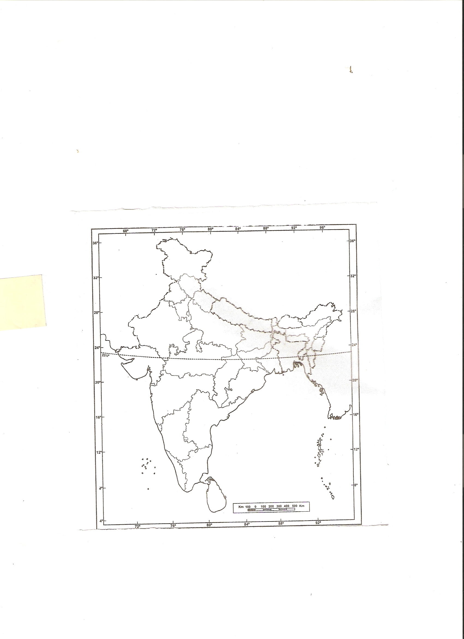
Guess Paper by:-
Harish Kamal
e-mail:- harish_kml@yahoo.com

