Guess PAPERS – 2009
Class – X
Subject - Mathematics (Code FP 1)
General Instructions:-
- All Questions are compulsory.

- The question paper consist thirty questions divided into 4 sections A, B, C and D. Section A comprises of ten questions of 1 mark each, Section B comprises of five questions of 2 marks each, Sections C comprises ten question of 3 marks each and Section D comprises of five questions of 6 marks each.

- All questions of Section A are to be answered in one word, one sentence or as per the exact requirement of the question.

- There is no overall choice. However, internal choice has been provided in one question of 2 marks each, three questions of 3 marks each and two questions of 6 marks each. You have to attempt only one of the alternatives in all such questions.

- In question on construction, drawing should be neat and exactly as per given measurements.
- Use of calculators is not permitted.

SECTION – A

1 If sec A = cosec B, find A + B.

2 State the fundamental theorem of Arithmetic.

3 Find a quadratic polynomial whose zeros are ± 3.

4 If the roots of the quadratic equation ax² + bx + c = 0 are equal then show that b² = 4 ac.

5 Which term of the AP: 84, 80, 76,………… is zero?

6 If the mean is 26 and median is 27 then what is mode?

7 A card is drawn from a pack of cards. Find the probability that it is not a black jack.

8 Find the area of circle whose circumference is 22 cm. (use ∏ = 22/7)

9 Find the length of the tangent drawn from a point whose distance from the centre of a circle with radius 7 cm is 25 cm.

10 D and E are points on sides AB and AC of ∆ ABC respectively. In the following say whether DE II BC or not:-
AB =12 cm, AD = 8 cm, EC = 6 cm and AC = 18 cm.

SECTION – B

11 ABC is an isosceles triangle right angled at B. Two equilateral triangles are constructed with side BC and AC as shown in Fig. 1.
Prove that area of ∆ BCD = ½ area of ∆ ACE.
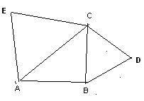

12 If A, B and C are the interior angles of a ∆ ABC, prove that:-
sin (B + C) = cos (A)
( 2 ) 2
OR
If A and B are angles of a right angled triangle ABC, right angled at C, Prove that
sin² A + sin² B = 1

13 Solve for x and y: 47x + 31y = 63; and 31x + 47y = 15.

14 Find the probability that a number selected at random from the numbers 1, 2, 3,……..35 is a (i) prime number (ii) multiple of 4

15 Prove that the points (0, 0), (5, 5) and (- 5, 5) are vertices of a right isosceles triangle.

SECTION – C

16 Prove: tan² A – tan² B = cos² B - cos² A
cos² A cos² B

OR
Prove:- (sin θ + cosec θ)² + (cos + sec θ)² = 7 + tan² θ + cot² θ

17 In fig, a circle touches the side BC of ∆ ABC at P and touches AB and AC produced at Q and R respectively. Prove that AQ = ½ the perimeter of ∆ ABC

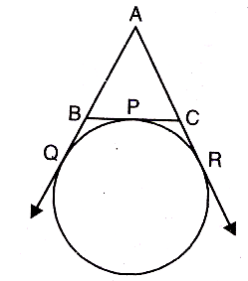
18 Draw the graph of the following equations:
3x – 4y + 6 = 0; 3x + y – 9 = 0
Also determine the co-ordinate of the vertices of the triangle formed by these lines and the x – axis.

19 In Fig. ABC is a right angle triangle, right angle at A. Semicircles are drawn on AB and AC and BC as diameters. Find the area of the shaded portion.
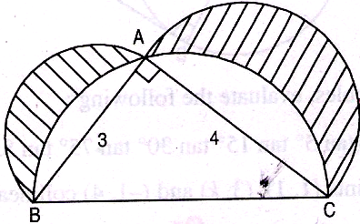

20 Show that any positive odd integer is of the form 4q + 1 or 4q + 3 where q is positive integer.
OR
Prove that √3 is an irrational number.

21 If the points (10, 5), (8,4) and (6, 6) are the mid-points of the sides of a triangle, find its vertices.
OR
The line joining of the points (2, 1) and (5, - 8) is trisected at the points P and Q. If point P lies on the line 2x – y + k = 0, find the value of k.

22 If A (-5, 7), B (-4, -5), C (- 1, 6) and D (4, 5) are the vertices of a quadrilateral ABCD. Find the area of quadrilateral ABCD.

23 Draw a line segment AB of length 8 cm. Taking A as centre, draw a circle of radius 4 cm and taking B as centre draw another circle of radius 3 cm. Construct tangents to each circle from the centre of the other circle.

24 Which term of the AP 5, 9, 13,……………… is 81?
Also find the sum 5 + 9 + 13+……..+ 81.

25 Find the zeros of √3x² + 10 x + 7√3. Also, verify the relationship between zeros and the coefficients.

SECTION – D

26 If twice of area of a smaller square is subtracted from the area of a larger square, the results is 14 cm². However, if twice the area of the larger square is added to three times the area of the smaller square, the result is 203 cm². Determine the sides of the squares.
OR
In the flight of 3000 km, an aircraft was slowed due to bad whether. Its average speed for the trip was reduced by 100 km/hr and consequently time of flight increased by one hour. Find the original duration of flight.

27 An aeroplane flying horizontally at a height of 2,100 m above the ground is observed at an elevation of 60◦ and after 10 seconds, the elevation is observed to be 30◦. Find the speed of the aeroplane in km/hr.

28 A tent is in the form of a cylinder of diameter 4.2m and height 4m, surmounted by a cone equal base and height 2. 8m. Find the capacity of the tent and the cost of canvas for making the tent at Rs. 100 per m².

29 Prove if a line is drawn parallel to one side of a triangle to intersect the other two sides in distinct points, the other two sides are divided in same ratio.
Use the above prove that the line drawn from the mid-point of one side of a triangle, parallel to another bisect the third side.
OR
Prove in a triangle, if the square on one side is equal to sum of the squares on other two sides, the angle opposite to the first side is a right angle.
Use the above show is the triangle with sides 7cm, 24cm and 25cm right-angled.

30 The median for the following distribution is 35. Find the value of x and y.
CI 0 -10 10 – 20 20 – 30 30 – 40 40 – 50 50 – 60 60 – 70
F 10 20 x 40 y 25 15 = 170

“Success is never permanent, and failure is never final”

Prepared By: Trilochan Wadhwa
M.Com, B.Ed. (011-20206098)

