Guess Paper – 2009
Class – XII
Subject – Chemistry

Time: 3 hrs. .
General instructions:
- All questions are compulsory.
- Marks for each question are indicated against it.
- Questions number 1to 8 are very short –answer questions, carrying 1 mark each. Answer these in one word or about one sentence each.
- Questions number 9 to18 are short –answer questions, carrying 2 marks each. Answer these in about 30 words each.
- Questions number19 to27 are short –answer questions, carrying 3 marks each. Answer these in about 40 words each.
- Questions number28 to30 are long-answer questions of 5 marks each. Answer these in about 70 words each.
7 Use log tables, if necessary. Use of calculators is not permitted

QUESTIONS:

Q1 Bleeding caused by a nick from a razor during shaving can be stopped by rubbing alum. Explain. (1)

Q2 Why is it essential to wash the precipitate with water before estimating it quantitatively? (1)

Q3 The conversion of molecules X to Y follows second order kinetics. If the concentration of X is increased to three times how will it affect the rate of formation of Y? (1)

Q4 What do you understand by pseudo first order reaction? (1)

Q5 What is the coordination entity formed when excess of KCN is added to an aqueous solution of copper sulphate? (1)

Q6 Why is sulphuric acid not used during the reaction of alcohols with KI? (1)

Q7 Di-tertiary butyl ether cannot be prepared by Williamson’s synthesis. Why? (1)

Q8 What are oligosaccharides? (1)

Q9 In the following pairs of halogen compounds, which would undergo S_{N}² reaction faster and why? (2)
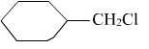
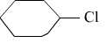
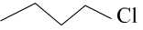
and ; and

Q10 Explain why?
- The dipole moment of chlorobenzene is lower than cyclohexylchloride.
- Alkyl halides though polar, are immiscible with water. (2)

Q11 State the type of no-ideality exhibited by a solution of cyclohexane and ethanol or a solution of acetone and chloroform(only one case). Give reason for your answer. (2)

Q12 Depict the galvanic cell in which the reaction
Zn(s) +2 Ag⁺ (aq) → Zn⁺²(aq) +2Ag(s) takes place. Further indicate what are the carriers of the current inside and outside the cell. State the reaction at each electrode. (2)

Q13 Answer the following:
(i) Which neutral molecule would be isoelectronic with ClO⁻?
(ii) Of Bi(V) and Sb(V) which may be a stronger oxidising agent and why? (2)

Q14 Account for the following:
- When Hi reacts with methyl phenyl ether, phenol and methyl iodide are formed and not methyl alcohol and iodobenzene.
- For the synthesis of unsymmetrical ethers by Williamson’s synthesis a proper choice of reactant is required. (2)

Q15 How would you convert?
- Phenol to 4-bromophenol
- Phenol to Aspirin (2)

Q16 Write the following reactions:
- Stephen reduction
- Etard reaction (2)

Q17 Explain briefly, how would you distinguish between primary, secondary and tertiary amines? ( 2)

Q18 Give reasons for the following statements:
(i) Amino acids are amphoteric in nature.
(ii) Amino acids have comparatively high melting points than the corresponding halo acids.(2)

Q19 An aqueous solution containing 1.248 g of barium chloride( molar mass 208.34 g mol⁻¹) in 100 gm of water boils at 100.0832⁰C.Calculate the degree of dissociation of barium chloride.(K_{b} for water=0.52 Kkg mol⁻¹). (3)

Q20 A certain reaction is 50% complete in 20 minutes at 300 K and the same reaction is again 50% complete in 5 minutes at 350 K. Calculate the activation energy if it is a first order reaction.[ R=8.314 JK⁻¹mol⁻¹; log 4= 0.602] (3)
OR
What is the name of the given curve?
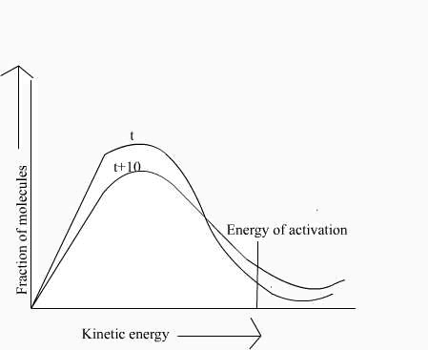
- Mark the area of fraction of molecules undergoing effective collisions.
- Why the rate of reaction doubles on increasing the temperature by 10⁰C?

Q21(i) A student was asked by his teacher to carry out the coagulation of hydrophilic and hydrophobic sols. He added electrolyte solution to both the sols. He found that one of the sols coagulated but other did not. Which sol must have coagulated and why? What should he do to coagulate other sol? Suggest few methods of coagulating sols. (3)

Q22 (A) is a gas of vapour density 8.5; on catalytic oxidation in the presence of Pt gauge at 850⁰C, it gives a colourless gas (B) which rapidly turns brown in air, forming gas(C). (B) is formed during thunder-storm in air. (B) is an odd electron species and gives a brown colour with freshly prepared solution of FeSO₄. Gas (C) is paramagnetic and is a mixed anhydride. Gas (C) on cooling dimerise to a colourless diamagnetic product (D) . Identify A, B, C and D and write the reactions involved. (3)

Q23 Explain how [Pt(NH₃)₂Cl₂] and [Pt(NH₃)₆]Cl₄ will differ in their electrolytic conductance? Give the hybridisation states of Pt in these complexes, also write their IUPAC names. (3)

Q24 Give chemical tests to distinguish between the following pairs of the compounds:
- Propanoyl chloride and Propanoic acid
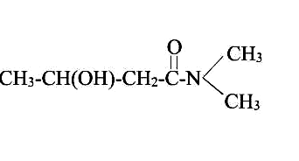
- Write IUPAC names of the following compounds: (3)
(a)
(b)
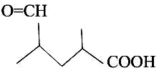

Q25 An aromatic compound (A) on treatment with aqueous ammonia and heating forms compound (B) which on heating with Br₂ and KOH forms compound (C) of molecular formula C₆H₇N. Write the structures and IUPAC names of compounds A, B, C. Also write the reactions involved. (3)

Q26 Explain chain growth and step growth polymerization with one example each. What is the difference between the two? (3)

Q27 What are antihistamines? Give two examples. Explain how they act on the human body? (3)

Q28 (a) The resistance of a conductivity cell containing 0.001 M KCl solution at 298K is 1500 Ω. What is the cell constant if the conductivity of 0.001 M KCl solution at 298 K is 0.146 X10⁻³ S cm⁻¹?
(b) Give reasons for the following:
(i) Rusting of iron is quicker in saline water than in ordinary water.
(ii) Aluminium metal cannot be produced by the electrolysis of aqueous solution of aluminium salt.(3+2)
OR
  - Calculate the equilibrium constant for the following reaction.
Cd²⁺(aq) + Zn(s)→Zn²⁺(aq) + Cd(s) If E⁰Cd²⁺/Cd= --- 0.403V, E⁰Zn²⁺/Zn=---0.763V
  - When a current of 0.75 A is passed through CuSO₄ solution for 25 min, 0.369 g of copper is deposited at the cathode. Calculate the atomic mass of copper.
  - Tarnished silver contains Ag₂S. Can this tarnish be removed by placing tarnished silverware in an aluminium pan containing an inert electrolyte solution such as NaCl. The standard electrode potential for half reaction:
Ag₂S(s) + 2e⁻→2Ag(s) +S²⁻ is ---0.71V
And Al³⁺ + 3e⁻→Al(s) is ---1.66 V

Q29 Account for the following:
(i) Tendency to show -2 oxidation state diminishes from sulphur to polonium in group 16.
(ii) Only higher members of group 18 of the periodic table are expected to form compounds.
(iii) NO₂ readily forms a dimmer, whereas ClO₂ does not.
(iv) Neon is not known to form compounds.
(v) SbF₅ is much more stable than BiF₅.
OR
Assign reasons for the following:
(i) Sulphur vapour is paramagnetic.
(ii) Ammonia has greater affinity for protons than phosphine.
(iii) The negative value of electron gain enthalpy of fluorine is less than that of chlorine.
(iv) SF₆ is much less reactive than SF₄.
(v) Of the noble gases only xenon is known to form well established chemical compounds

Q30 Answer the following questions briefly:
(i) What are any two good sources of vitamin A?
(ii) What are nucleotides?
(iii) What are enzymes?.
(b) How are carbohydrates classified? (3+2)
OR
(a)State differences between the following:
(i) α- helix and β pleated sheet structure.
(ii) Primary and secondary structure of a protein.
(iii) Enzymes and co-enzymes.
(b) What are essential and non-essential amino acids? Give two examples of each.

MOHINI BELANI
Email mohinibelani@yahoo.co.in
Phone No. 07544-273314

