Guess Paper – 2009
Class – XII
Subject – Informatics Practices (065)

1. This question paper is divided into sections
2. Section – A consists 30 marks.
3. Section – B and Section – C are of 20 marks each
4. Answer the questions after carefully reading the text.

Section – A

Q 1. Answer the following questions

(a) What do you mean by Three Tier System. ? ( 2 )

(b) Explain system development life cycle (SDLC) ?. (2 )

( c ) What is Feasibility studies ? ( 2)

(d) Explain the term Data Modeling. What does UML mean? Give the name of two commercially available packages supporting Object Modeling technique. (4 )

Q2 Answer the following questions

- “Oracle Database is an example of an RDBMS” Justify this statement (2 )

- What is the use of %type and %rowtype in PL SQL [2]

- What is a cursor and its type and how it is declared ? (2)
- What is procedure . Explain through an example (2)

( e ) What is Function. Explain through an example (2)

Q3 Answer the following questions

- “Visual Basic is not an Object Oriented Language” Justify this statement. (2)

- What is connection and how it is done using procedure (4 )

(c) Differentiate between a ADODB project reference and ADO DC in a form
using suitable Example (2 )

( d) What is run time bugs ? (2)

Section – B

Q4 Read the following case study and answer the questions that follows
Mr Amit Kumar of Computech Software has got requirement of a Software Project from a Customer in Hotel Business. He performed the preliminary analysis and found that software Application should be based on Client/Server technology. He opted for Visual Basic Language to develop the front end, as RAD is one of its features.

Object  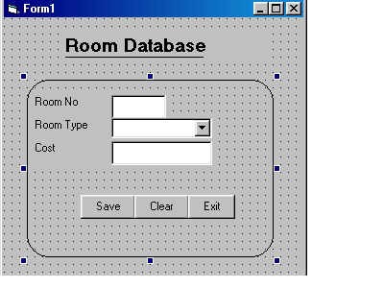 | Object name | Description
Form | frmDataEntry | The Main Form Object
Label | lblroomno  lblroomtype  lblcost
Text Box | txtroomno | to enter cost of a room
 | Txtcost | To enter cost of room
Combo Box | Cboroomtype | to select room type  (AC,NON-AC,DELUXE ,SUITE
Command Button | cmdsave | To save record to room table
 | cmdClose | To close the form rmEnquiryForm
 | cmdclear | To clear the text box and como box

- Write the code to save the record in room table [4]
(b) Write the code snippet for cmdClose Command Button if it is required to close the form on its Click event. [2]
- Write a procedure to clear the text box and combo box .and call the procedure if cmdclear button is clicked [2]
- Write a code snippet to do connection and load AC, NON AC ,DELUXE ,SUIT room type in combo box. [2]

Q5 Read the following case study and answer the questions that follows
Mr. Ravi is working as a Information Officer in Softtec Company.,he was given a task to store all his employee information in electronic form. He decided to develop a small software application to store employee’s personal data. He instructed one of his juniors to make a Form in Visual Basic to enter employee information. The form details are given in the following table

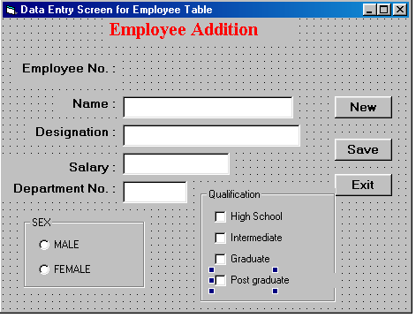

Object | Object name | Description
Form | frmDataEntry | The Main Form Object
Label | Lblempno  Lblenmae  Lblsal  Lbldesig  Lbldept
Text Box | txtempno | to enter empno
 | Txtename | To enter name
 | txtsal | To enter salary
 | txtdesig | To enter designation
 | txtdeptno | To enter deptno
Option button | Optmale  optfemale
checkbox | ChkPostGraduate  ChkGraduate  Chkhighschool  chkintermediate
Command Button | cmdsave | To save record to emp table
 | cmdClose | To close the form rmEnquiryForm
 | cmdclear | To clear the text box and como box

- Write a Code snippet on allow only numeric digit in txtempno Textbox. (2 )

(b) Write a procedure procCheck to be called in the cmdSubmit_Click event. The procedure code will perform the following action:
If the check box chkPostGraduate is checked then the procedure will automatically check the check boxes chkGraduate and chkhighschool, chkIntermediate irrespective of their initial state. Similarly if the check box chkGraduate is checked than chkIntermediate,chkhighschool should also be automatically checked. If intermediate is checked then chkhighschool should be checked (4)

( c ) Write a procedure procConvert to convert all the employee details in
txtEName, txtdesignation to Upper case character ( 2)

( d ) Calculate da 55% of salary and print the result in message box if command button cmdsave is clicked (2)

Section C
5 Answer the questions

(a) Write a SQL (DDL) query to create the following table Emp
Column Name Data Type Size Constraint Descriptiom
EmpID NUMBER 6 PRIMARY KEY
EmpName VARCHAR2 20 NOT NULL
Empcity VARCHAR2 30 check city is either agra ,delhi,
Empdob date ( not given must be taken default)
EmpSal NUMBER 9,2 check salary > 0
and empsal <=50000 ( 2)

- Write Procedure Code to insert record in Emp table ie ename,empno,sal,job,deptnor ( 4 )

( c )Write program code to declare and use an Explicit Cursor to display the
Ename,Salary from emp table (4)

6 Assume that you are provided with the following two table
Table: Dept
DEPTNO DNAME LOC
10 ACCOUNTING NEW YORK
20 RESEARCH DALLAS
30 SALES CHICAGO
40 OPERATIONS BOSTON
Table: Emp
EMPNO ENAME JOB MGR HIREDATE SAL COMM DEPTNO
7369 SMITH CLERK 7902 17-Dec-80 800 20
7499 ALLEN SALESMAN 7698 20-Feb-81 1600 300 30
7521 WARD SALESMAN 7698 22-Feb-81 1250 500 30
7566 J ONES MANAGER 7839 02-Apr-81 2975 20
7654 MARTIN SALESMAN 7698 28-Sep-81 1250 1400 30
7698 BLAKE MANAGER 7839 01-May-81 2850 30
7782 CLARK MANAGER 7839 09-Jun-81 2450 10
7788 SCOTT ANALYST 7566 09-Dec-82 3000 20
7839 KING PRESIDENT 17-Nov-81 5000 10
7844 TURNER SALESMAN 7698 08-Sep-81 1500 0 30
7876 ADAMS CLERK 7788 12-Jan-83 1100 20
7900 JAMES CLERK 7698 03-Dec-81 950 30
7902 FORD ANALYST 7566 03-Dec-81 3000 20
7934 MILLER CLERK 7782 23-Jan-82 1 300 10

- Create a View on the above tables to show Ename, Dname, Job and Sal of an employee whose department number is either 10 or 20.( 2)

- Write a SQL command to add two column jobtype,address to emp table (2)

- Write the PL/SQL trigger to display welcome if anyone try to insert record in
emp table(2)

( d ) Create a trigger that insert the old row in the archive table along with current date whenever a row is inserted in emp table ie ( empno,ename,sal,deptno and current data of transaction) (4)

Paper Submitted by:
George Thomas
Email:- geovinkenash@gmail.com
Phone No. 9837764185

