Sample Paper – 2009
Class – XII
Subject – Chemistry (CHEMICAL KINETICS)

Q1 a)What does the peak represents?
- What does the curve AC represents?
- What is the nature of reaction? Endothermic or exothermic?
- What does the arrow AB represents?

(1)

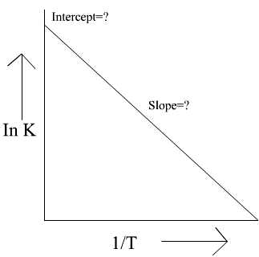
2 (i) What does the graph represents?
(ii)What is the value of slope?
- What is the value of Intercept?
- What is the effect of increase in temperature on the value of k?

Q3 What is the graph showing?

(i)Why does the peak of graph lowers in the presence of
catalyst? (ii) What is the relation between activation energy and rate?
(iii) Does catalyst also alter the value of Gibb’s free energy? (2)
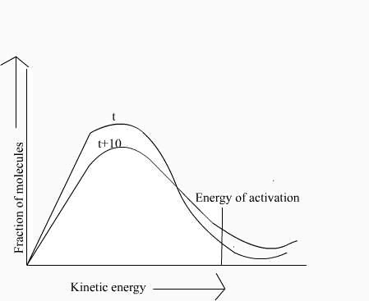
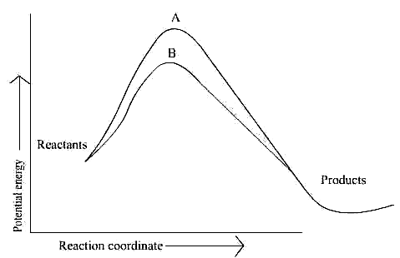

(3)

(4)
Q4 What is the name of the above curve?
- Mark the area of fraction of molecules undergoing
effective collisions.

- Why the rate of reaction doubles on increasing the
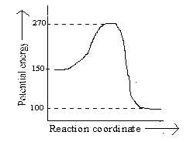
temperature by 10⁰C?
- Mark the area of fraction of molecules undergoing
effective collisions at t+10⁰C.

Q5 Look at the graph above and match entries of column I
with appropriate entries of column II.
 | COLUMN I |  | COLUMN II
A | Activation energy | P | 270 kJ
B | Threshold energy | Q | 170kJ
C | Enthalpy change | R | 120kJ
D | Activation energy for backward reaction | S | 50kJ
(5)
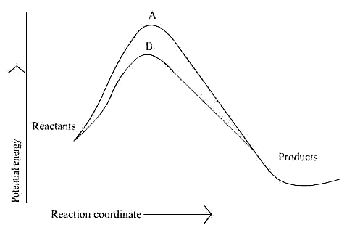



DELHI PUBLIC SCHOOL, VIJAIPUR

Paper Submitted by:
Mohini Belani
Email:- mohinibelani@yahoo.co.in
Phone No. 07544-273314

