Form of Question  Unit | VSA  (each 1 mark) | SA I  (each 2 mark) | SA II  (each 3 mark) | LA  (each 6 mark) | TOTAL
Number System | 1(1) | - | 3(1) | - | 4(2)
Algebra | 2(2) | - | 12(4) | 6(1) | 20(7)
Trignometry | 1(1) | 2(1) | 3(1) | 6(1) | 12(4)
Co-ordinate Geometry | - | 2(1) | 6(2) | - | 8(3)
Geometry | 3(3) | 4(2) | 3(1) | 6(1) | 16(7)
Mensuration | 1(1) | - | 3(1) | 6(1) | 10(4)
Statistics | 2(2) | 2(1) | - | 6(1) | 10(3)
TOTAL | 10(10) | 10(5) | 30(10) | 30(5) | 80(30)
Sample Paper – 2009
Class – X
Subject – Mathematics
BLUE PRINT OF SAMPLE PAPER SUBJECT-MATHEMATICS
KIRTI BALLABH (TGT MATHEMATICS)
Email:kirti41@gmail.com,mo.+919995908130
KENDRIYA VIDYALAYA PAYYANUR,KANNUR
KERALA- 670327
Series : KBJ

Sample Paper – 2009
Class – X
Subject – Mathematics(Code: 14/01)
Time Allotted: 3 Hrs Maximum mark:80
General Instructions:
- All questions are compulsory.
- The question paper consist of 30 questions divided into three sections A, B, C and D. Section A comprises of 10 questions of one mark each, section B comprises of 5 questions of two marks each , section C comprises of 10 questions of three marks each and section D comprises of 5 questions of six marks each.
- All questions in Section A are to be answered in one word, one sentence or as per the exact requirement of the question.
- Use of calculators is not permitted. You may ask for mathematical tables, if required.
SECTION A
- Find HCF of 867 and 255.
- Find the number of zeros of the polynomial given by the following curve.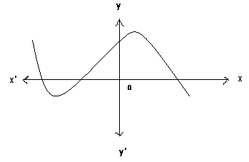
- For what value of k the following system of equations has unique solutions.
x +ky =5 , kx + 4y =10

Sin A + cos A
Sin A - cos A
- If 16 cot A = 12 , find the value of

- A man goes 15 m due west and then 8 m due north. How far is he from his starting position.

- In the adjoining fig. find AC.

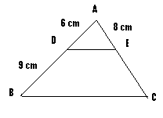
- What is the distance between two parallel tangents to a circle of radius 5 cm.
- A chord AB of a circle of radius 10 cm makes a right angle at the centre of the circle.Find the area of sector thus formed.
- What is relation between mean, mode and median.
- What is the probability of getting 53 Sundays in a leap year.

SECTION - B
- If tan 2θ = cot ( θ + 6⁰ ) ,find the value of θ.
- Find the value of y for which thedistance between the points R ( 2,-3) and S ( 10,y )is 10 units.
- In two concentric circles, prove that a chord of larger circle which is tangent to smaller circle is bisected at the point of contact.
- In fig. If AB =AC , prove that BE = EC .
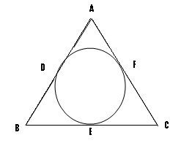
- A die is thrown twice, find the probability of getting

- Sum of two numbers 9
- First die show an even number
SECTION – C
- Prove that √3 is an irrational number.
- If sum of the squares of zeros of the quadratic polynomial f(x) = x² – 8x + k is 40, find the value of k.
- Solve the following system of linear equations graphically. Shade the region bounded by these lines and x-axis. Also find the area of the shaded region.
2x + y =6
2x - y = -2
- The 6th and 17th terms of an A.P. are 19 and 41 respectively, find the 40th term.
- Find the nth term of an A.P. whose sum of n term is given by S_{n} = 3n² + 5n.
- Prove the indentity :
(1 + sinθ)² + (1 – sinθ)² = 1 + sin²θ
2 cos²θ 1 – sin²θ
- For what value of k will the points (k,-1), (2,1) and (4,5) be collinear.
- Find the ratio in which the line 3x +y = 9 divides the segment joining the points (1,3) and (2,7).
- Draw a triangle ABC with sides BC = 6cm, AB= 5 cm and angle B = 60⁰.Than construct a triangle whose sides are (3/4)th of the corresponding sides of triangle ABC.

- Four equal circles are described about the four corners of a square so that each touches two of the others as shown in fig. Find the area of the shaded region.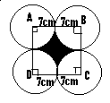

SECTION -D

- Prove that , “If a line drawn parallel to one side of a triangle intersecting the other two sides,then it divides the other two sides in the same ratio.”
Using the above , prove that the line drawn through mid point of one side of a triangle parallel to other side bisects the third side.
- A tent is made in the form of a conic frustum surmounted by a cone.The diameters of the base and top of the frustum are 20 m and 6 m respectively and the height is 24 m. If the height of the tent is 28 m , find the quantity of canvas required to make the tent.
- The angle of elevation of a cloud from a point 60 m above a lake is 30⁰ and the angle of depression of the reflection of cloud in the lake is 60⁰ . Find the height of the cloud.

- Find the mean and median of the following frequency distribution
MARKS | 0-100 | 100-200 | 200-300 | 300-400 | 400-500 | 500-600 | 600-700 | 700-800 | 800-900 | 900-1000
FREQUENCY | 2 | 5 | 9 | 12 | 17 | 20 | 15 | 9 | 7 | 4

30.In a flight of 600 km, an aircraft was slowed down due to bad weather. Its average speed for the trip was reduced by 200 km/hr and the time of the flight was increased by 30 minutes. Find the duration of the flight.
KIRTI BALLABH (TGT MATHEMATICS)
Email:kirti41@gmail.com,mo.+919995908130
KENDRIYA VIDYALAYA PAYYANUR,KANNUR,KERALA- 670327

