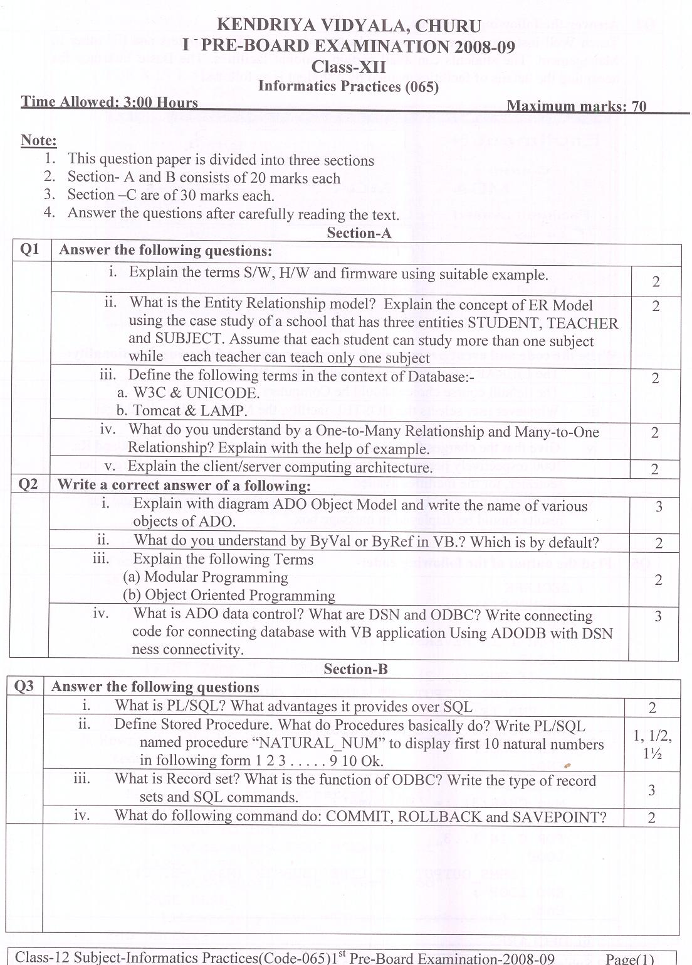
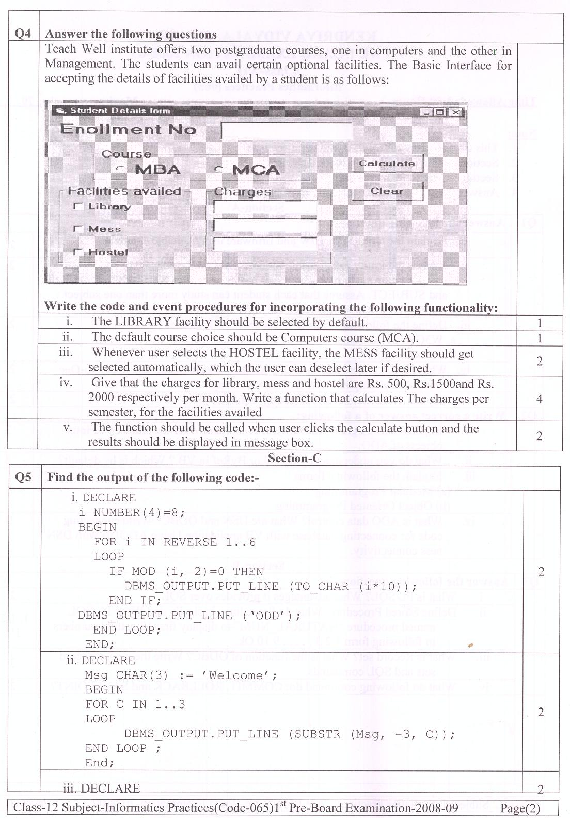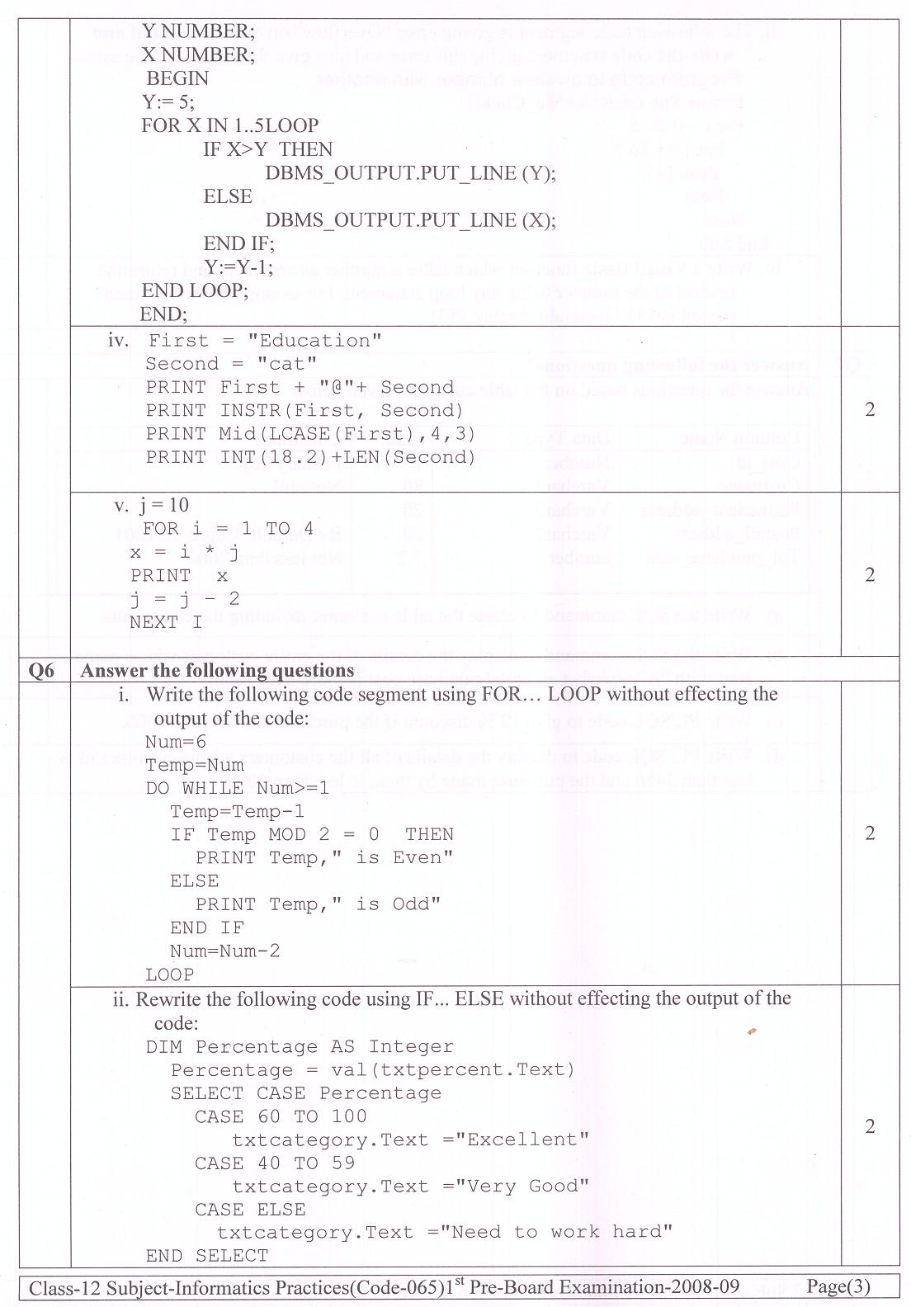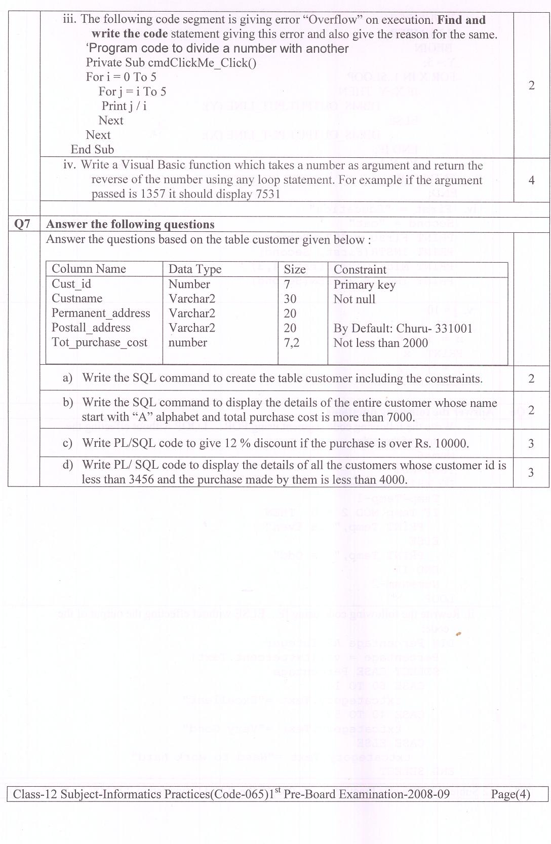I ⁻ PRE-BOARD EXAMINATION 2008-09
Marking Scheme
Class-XII
Informatics Practices (065)
Time Allowed: 3:00 Hours Maximum marks: 70

Section-A
Q1 | Answer the following questions:
 | - Give the 2 marks if correct difference. | 2
  Hardware | Software | Firmware
  Hardware is the physical tangible components of a computer system | Software is the computer programs that govern the operation of computers | Firmware is the prewritten programs permanently stored in read-only memory. These configure the computer and are not easily modifiable by the user.
 | - ER model is a high level conceptual model that describes data as entities, attributes and relationships.  (1 Marks definition and 1marks for correct diagram ) | 2
 | - Define the following terms in the context of Database:-  a. W3C & UNICODE.  b. Tomcat & LAMP. | 2
 | - One to Many type  STUDENT  COURSE  Enrols  Many to One type  School  Students  Study  (1 marks each for correct diagram ) | 2
 | - It represent a model wherein request are made in one a end i.e client end and the services are provided at another end i.e the server end.  (1 Marks definition and ½ marks for correct diagram ) | 2
Q2 | Write a correct answer of a following:
 | i.  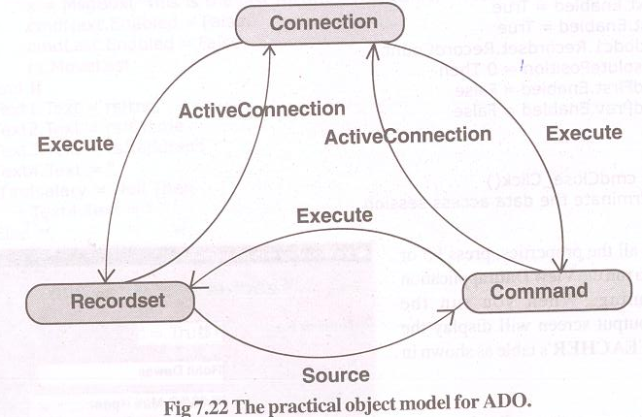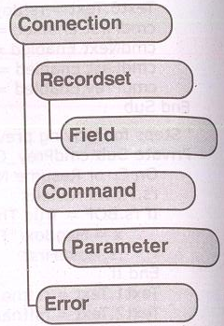  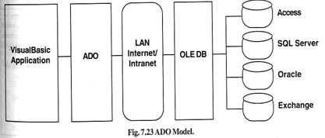  (1 marks for correct definition,1/2 for commands and 1 ½ for diagram ) | 3
 | ii. ByVal:- ByVal means that the argument is passed by value that is duplicate copy of passvalue not a original value.  ByRef:- ByRef means that the argument is passed by reference not a copy of value but the location of original values.  By default BRref.  (1 marks each for correct answer ) | 2
 | iii. Object Oriented Programming: Object-oriented programming (OOP) is a programming paradigm that uses "objects" and their interactions to design applications and computer programs. Programming techniques may include features such as encapsulation, modularity, polymorphism, and inheritance  Modular programming is a software design technique that increases the extent to which software is composed from separate parts, called modules. Conceptually, modules represent a separation of concerns, and improve maintainability by enforcing logical boundaries between components  (1 marks each for correct definition) | 2
 | iv.  ADO:- The ADO Data Control allows you to quickly create a connection to a database using Microsoft ActiveX Data Object(ADO). The ADO Data Control manages the connection between applications.  DSN:- Adds, deletes, or sets up data sources with system data source names (DSNs). These data sources are local to a computer but not user-dedicated; any user with privileges can access a system DSN.  ODBC: - Open Database Connectivity (ODBC) to access data from a variety of database management systems. For example, if you have a program that accesses data in a SQL database, Data Sources (ODBC) will let you use the same program to access data in a MS-Access database  Connection code:-  Dim con As New ADODB.Connection  Dim rs As New ADODB.Recordset  Private Sub Form_Load()  con.Open "DSN=SCOTT; ; PASSWORD=tiger; User ID= scott "  rs.CursorLocation = adUseClient  rs.Open "emp", con, adOpenForwardOnly, adLockOptimistic  Set DataGrid1.DataSource = rs  End Sub  (1 marks each for correct definition) | 3
Section-B
Q3 | Answer the following questions
 | - PL/SQL stands for Procedural Language/Structural Query Language. It is a super set of SQL.  Advantage:-  1. PL/SQL support multi line SQL statements like LOOP, Condition statement, Control statements etc.  (1 marks each for correct definition) | 2
 | - Procedure is a logical group of SQL and PL/SQL statements that performs a specific action. A stored procedure is a type of procedure because the named procedures are compiled and stored as schema objects in the oracle database. In contrast to local procedures that are compiled at the time of their execution and not saved as part of the database  Procedure Code:-  CREATE OR REPLACE PROCEDURE NATURAL_NUM AS  I NUMBER:=1;  BEGIN  LOOP  DBMS_OUTPUT.PUT(' '||I);  IF I=10 THEN  EXIT;  END IF;  I:=I+1;  END LOOP;  DBMS_OUTPUT.PUT_LINE(' OK');  END NATURAL_NUM;  /(1 marks each for correct definition and coding) | 3
 | - Record Set refers to the set of records (or simply a table) that are retrieved from an object as determined by Record Source property  Open Database Connectivity (ODBC) to access data from a variety of database management systems. For example, if you have a program that accesses data in a SQL database, Data Sources (ODBC) will let you use the same program to access data in a MS-Access database  Record Sets Type:-  - Table type record set  - Forward only record set  - Static type record set  etc.  SQL Commands: DDL(CREATE , ALTER, DROP)  DML(INSERT ,DELETE , UPDATE)  DRL(SELECT)  DCL(COMMIT, ROLLBACK, SAVEPOINT)  TCL(GRANT, REVOKE)  (1 marks each for correct definition) | 3
 | Commit:- Committing a transaction means all the steps of a transaction are carried out successfully and all data changes are made permanent in the database.  Rollback:-Transaction rollback means that the transaction has not been finished completely and hence all data changes made by the transaction in the database, if any, are undone and the database returns to the same state as it was before this transaction execution started  The SAVEPOINT statement is used to identify a point in a transaction to which you can later ROLLBACK.  OR  It is used to give a name and mark a specific point in the processing of current transaction. This marker allows ROLLBACK upto that point. i.e.the RDBMS will undo any change(s) and release locks issued after that SAVEPOINT.  OR  SAVEPOINT establishes a mark, which allows one to perform partial ROLLBACK.  Example:  SQL Statement 1;  Savepoint S1;  SQL Statement2;  Rollback to S1;  SQL Statement3;  In the above example any changes made to the database in Statement2 will be undone while changes done in Statement 1 and Statement3 will be saved.  (1/2 marks each for correct definition and ½ for example) | 2
Q4 | Answer the following questions
 | - The LIBRARY facility should be selected by default.  Private Sub form_load()  Chklib.Value = vbChecked  End Sub | 1
 | - Private Sub form_ load()  Optmca.Value = True  End Sub | 1
 | - Private Sub chkhostel_Click()  If chkhostel.Value = vbChecked Then  chkmess.Value = vbChecked  Else  chkmess.Value = vbUnchecked  End If  End Sub | 2
 | - Dim lib, mess, hostel As Integer  Function charges()  If chklib.Value = vbChecked Then  lib = 500*6  Else  lib = 0  End If  If chkmess.Value = vbChecked Then  mess = 1500*6  Else  mess = 0  End If  If chkhostel.Value = vbChecked Then  hostel = 2000*6  Else  hostel = 0  End If  End Function | 4
 | Private Sub cmdcalc_Click()  Call charges  Call display  End Sub  Function display()  txtlib.Text = lib  txtmess.Text = mess  txthostel.Text = hostel  Msgbox (“Total Charges: ” +str(lib+mess+hostel)  End Function | 2
Section-C
Q5 | Find the output of the following code:-
 | i.  60  ODD  ODD  40  ODD  ODD  20  ODD  ODD | 2
 | ii.  m  me  me | 2
 | iii.  1  2  3  2  1 | 2
 | iv. | 2
 | v.  10  16  18  16 | 2
Q6 | Answer the following questions
 | i.  Num = 6  Temp = Num  For Num = 6 To 1 Step -2  Temp = Temp - 1  If Temp Mod 2 = 0 Then  Print Temp, " is Even"  Else  Print Temp, " is Odd"  End If  'Num = Num - 2  Next | 2
 | ii.  Dim Percentage As Integer  Percentage = Val(txtpercent.Text)  Select Case Percentage  Case 60 To 100  If Percentage <= 60 And Percentage >= 100 Then  txtcategory.Text = "Excellent"  ElseIf Percentage <= 40 And Percentage >= 59 Then  txtcategory.Text = "Very Good"  Else  txtcategory.Text = "Need to work hard"  End If | 2
 | iii.  For i =1 To 5  For j = i To 5  Print j / i  Next  Next | 2
 | iv.Private Sub Command1_Click()  Dim n As Integer  n = Val(InputBox("Enter Number"))  Print "Reverse Digit: " + Str(REVERSE(n))  End Sub  Function REVERSE(x As Integer) As Integer  Dim i As Integer  While x > 0  i = i * 10 + x Mod 10  x = Int(x / 10)  Wend  REVERSE = i  End Function | 4
Q7 | Answer the following questions
 | i. CREATE TABLE CUSTOMER(  CUST_ID NUMBER(7)PRIMARY KEY,  CUSTNAME VARCHAR2(30)NOT NULL,  PARMANENT_ADDRESS VARCHAR2(20),  POSTAL_ADDRESS VARCHAR2(20) DEFAULT 'CHURU-331001',  TOT_PURCHASE_COST NUMBER(7,2) CHECK(TOT_PURCHASE_COST>2000)); | 2
 | ii. SELECT * FROM CUSTOMER WHERE CUSTNAME LIKE 'A%' AND TOT_PURCHASE_COST>7000; | 2
 | iii. DECLARE  TOTALCOST CUSTOMER.TOT_PURCHASE_COST%TYPE;  N NUMBER(5);  BEGIN  UPDATE CUSTOMER SET  TOT_PURCHASE_COST=TOT_PURCHASE_COST-TOT_PURCHASE_COST*12/100 WHERE TOT_PURCHASE_COST>10000;  END;  / | 3
 | iv. SELECT * FROM CUSTOMER WHERE CUST_ID<3456 AND TOT_PURCHASE_COST<4000; | 3

Paper Submitted by:
KENDRIYA VIDYALAYA, CHURU
Lakhan Singh Pal
Email:- lakhan_it2002@yahoo.co.in
Phone No. 9887326939

