Guess Paper – 2009
Class – XI
Subject –INFORMATICS PRACTICES (065)

TIME : 01:00 Hrs Max Marks: 30

Section – A
Q1 | Use the following structure of Customer table to answer the following questions
  Column Name | Cust_ID  (Primary Key) | Cust_Name  (Not Null) | Cust_Add1  By Default  ‘Churu-raj.’ | Cust_Add2 | Pin_Code  (Check Input no is 6 Digit long) | Cust_Phone
  Data type | NUMBER | VARCHAR2 | VARCHAR2 | VARCHAR2 | NUMBER | VARCHAR2
  Length | 7 | 30 | 20 | 30 | 6 | 10
 | (a). | Write the SQL Command to create the above table including its Constraints  Ans: SQL>CREATE TABLE Custom(Cust_ID NUMBER PRIMARY KEY,CUST_NAME VARCHAR2(20) NOT NULL,CUST_ADD1 VARCHAR2(15) DEFAULT 'Churu-Raj.', cust_add2 varchar2(10), Pin_Code number(6) check( length(Pin_code)=6), cust_phone varchar2(10)); |  |  | 3
 | (b). | Write a SQL code to modify all the CUST_PHONE numbers by joining ‘2’ before each phone number if it contains 7 characters  Ans. UPDATE CUSTOMERS SET CUST_PHONE= '2'|| CUST_PHONE WHERE LENGTH(CUST_PHONE)=7; |  |  | 3
 | (c). | Write a SQL code to modify all the CUST_PHONE numbers by removing ‘2’ if it starts with ‘2’  Ans. UPDATE CUSTOMERS SET CUST_PHONE= SUBSTR(CUST_PHONE,2) WHERE SUBSTR(CUST_PHONE,1,1)='2' |  |  | 3
 | (d) | Write a SQL Query to Modify above table structure to increase a column “Cust_Phone” size with 2 e.g. (10+2=12) and also apply a NOT NULL Constraint on its.  Ans. ALTER TABLE CUSTOMERS MODIFY(CUST_PHONE varchar2(12) NOT NULL) |  |  | 2
 | (e). | Write a SQL Query to remove above table column “Cust_Add2” structure using Alter Command.  Ans. ALTER TABLE CUSTOMERS DROP(Cust_Add2) |  |  | 2
 | (f) | Discuss database Integrity Constraint and Foreign Key  - Foreign Key:- A non key attribute, whose values are derived from the primary key of some other table, is known as Foreign Key in its current table.  - Referential Integrity:-Referential Integrity is a system of rules that a DBMS uses to ensure that relationships between records in related tables are valid, and that users don’t accidentally delete or change related data. |  |  | 2
 | (g) | What do you mean by SGA and BCNF? Discuss various Background process for Oracle Instance.  SGA  SGA:- System Global Area (SGA) is an area of memory used for database information shared by the database users. SGA consists of three major memory structures:-  - Database buffer cache  - Shared Pool  - Redo Log buffer.  Background Processes for Oracle Instance, are:-  - Database Writer (DBWR)  - Log Writer (LGWR)  - System Monitor (SMON)  - Process Monitor (PMON)  - Archiver (ARCH)  - Recoverer (RECO).  Boyce - Codd Normal Form (BCNF):-A relation R is in Boyce - Codd Normal Form(2NF) if and only if it is 3NF and all of its determinants are candidate keys .  BCNF perform following:-  - In 3NF.  - Every determinant in the table is a candidate key.  Advantage of Normalization  - It reduces data redundancies.  - It help eliminate data anomalies.  - It produces controlled redundancies to link tables. |  |  | 1  1  1
Q2 | Consider the following tables Employee and salary. Write SQL commands for the  statements (i) to (iv) and give outputs for SQL queries (v) to (viii)  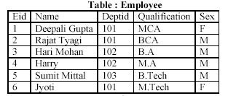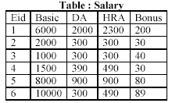
Q2 | (i) . |  |  | To Display The Total No. Of Employees Department Wise.  SQL> SELECT COUNT(*) FROM EMPLOYE GROUP BY DEPTID;  COUNT(*)  ----------  3  2  1 | 1
Q2 | (ii). |  |  | To List The Names Of Those Employees Only Whose Name Starts With ‘H’  SQL> SELECT NAME FROM EMPLOYE WHERE NAME LIKE 'H%';  NAME  --------------------  HARI MOHAN  HARRY | 1
Q2 | (iii). |  |  | To Add A New Column In Salary Table. The Column Name Is Total_Sal.  SQL>ALTER TABLE Salary ADD(Total_Sal NUMBER(7)); | 1
Q2 | (iv). |  |  | To Store The Corresponding Values In The Total_Sal Column.  Where, Tot_Sal = Basic+DA+HRA+Bonus  SQL>UPDATE SALARY SET Total_Sal= Basic+DA+HRA+Bonus; | 1
Q2 | (v). |  |  | Select Name From Employee Where Eid = ( Select Eid From Salary Where  Basic= (Select Max(Basic) From Salary));  NAME  ----------  Jyoti | 1
Q2 | (vi). |  |  | Select Max (Basic) From Salary Where Bonus >40;  MAX(BASIC)  ----------  10000 | 1
Q2 | (vii) |  |  | Select Count(*) From Employee Group By Sex;  COUNT(*)  ----------  2  4 | 1
Q2 | (viii) |  |  | Select Distinct Deptid from Employee;  DEPTID  ------  101  102  103 | 1
Section – B
Q3 | Read the following case study and answer the questions that follows:
 | With Diagram, Differentiate between.
 | a). |  | Front end and Back end  Front End and Back End:-  Front End:- A front end refers to the client side end i.e. the end at which request is made. Some popular front end software are:-  - Visual Basic (VB)  - ASP (Active Server Page)  - Visual C++  - Power builder  - MS-Access  - Back End:-A Back End refers to the server side, where the client requests are processed. Some popular back end software are:-  - SQL Server.  - Oracle  - Sybase  - My SQL etc.  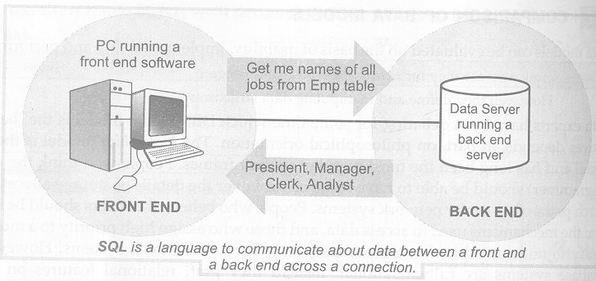 |  | 2
 | b) |  | Two tier and three tier computing model  - Client/Server model classified into two type:-  - Two-Tier Computing Model:-  - Three-Tire Computing Model  Two-Tier Computing Model  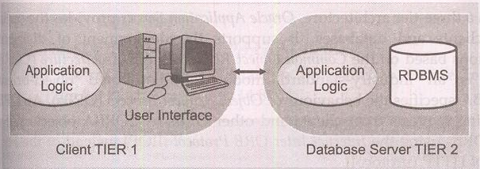  Three-Tire Computing Model  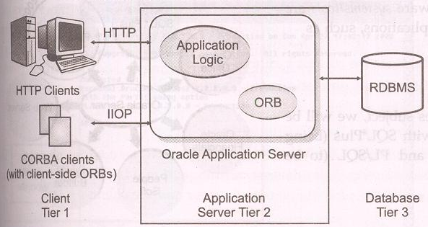  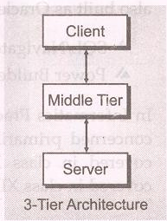 |  | 2

Paper Submitted by:
KENDRIYA VIDYALAYA, CHURU
Lakhan Singh Pal
Email:- lakhan_it2002@yahoo.co.in
Phone No. 9887326939

